

Faculty of Science and Engineering
THESIS TITLE: GPS SPOOFING DETECTION AND MITIGATION FOR UNMANNED AERIAL VEHICLES: LEVERAGING MACHINE LEARNING METHODS

Examination Board: Postgraduate Computing Award Title: MSc Cybersecurity

Dissertation Declaration

This document must accompany all dissertation document submissions. PLEASE READ THIS VERY CAREFULLY.
The University considers seriously all acts of Academic Misconduct, which by definition are dishonest and in direct opposition to the values of a learning community. Misconduct may result in penalties ranging from the failure of the assessment to exclusion from the University.

Further help and guidance can be obtained from your academic tutor or from our guide on How to avoid Academic Misconduct – available at http://www.wlv.ac.uk/skills

By submitting this document for assessment, you are confirming the following statements

I declare that this submission is my own work and has not been copied from someone else or commissioned to another to complete.

Any materials used in this work (whether from published sources, the internet or elsewhere) have been fully acknowledged and referenced and are without fabrication or falsification of data.

I have adhered to relevant ethical guidelines and procedures in the completion of this assignment.

I have not allowed another student to have access to or copy from this work. This work has not been submitted previously.
By this declaration I confirm my understanding and acceptance that –

- The University may use this work for submission to the national plagiarism detection facility. This searches the internet and an extensive database of reference material, including other students’ work and available essay sites, to identify any duplication with the work you have submitted. Once your work has been submitted to the detection service it will be stored electronically in a database and compared against work submitted from this and other Universities. The material will be stored in this manner indefinitely.

- In the case of project module submissions, not subject to third party confidentiality agreements, exemplars may be published by the University Learning Centre.

I have read the above, and declare that this is my work only, and it adheres to the standards above.

Signature: Charlotte Olivia Namagembe Date: 22/08/2023

Print Name: CHARLOTTE OLIVIA NAMAGEMBE Student ID: 2221671

I have submitted this digitally and will provide a signed copy prior to marking.

ABSTRACT

"In the Age of the Almighty Computer, drones make the best fighters. They never betray who their owners are, murder without regret, obey commands without humour.’’ Galeano, Eduardo.
The proliferation of commercial Unmanned Aerial Vehicles (UAVs) across diverse applications has ushered in transformative possibilities, revolutionizing industries such as precision agriculture, environmental monitoring, and disaster response. However, the reliance of UAVs on the Global Positioning System (GPS) renders them vulnerable to malicious GPS spoofing attacks, undermining the safety and reliability of these critical platforms. This thesis presents a comprehensive study that advances the state of the art in GPS spoofing detection and mitigation for UAVs, leveraging the power of machine learning methods. Extensive experimentation, encompassing both simulation-based assessments and real-world field trials, demonstrates the superior effectiveness and adaptability of the proposed framework. The results show that XGBOOST performs better with a training accuracy of 95.45%, testing accuracy of 93.07%, precision of 85.41%, recall of 86.91%, F1 Score of 86.14% with a training time of 595.56(s). The rest of the models were; random forest which had a training accuracy of 99.25%, testing accuracy of 89.87%, precision of 79.60%, recall of 79.80%, F1 Score of 79.70% with a training time of 238.02(s); logistic regression which had a training accuracy of 77.88%, testing accuracy of 77.92%, precision of 25.00%, recall of 27.21%, F1 Score of 21.93% with a training time of 14.96(s); decision trees which had a training accuracy of 99.25%, testing accuracy of 91.96%, precision of 84.04%, recall of 84.53%, F1 Score of 84.53% with a training time of 19.93(s). Attention is devoted to the computational efficiency and scalability aspects, ensuring that the system remains viable for deployment on UAVs with constrained computational resources.

Key Words: Spoofing, Global Positioning Systems, Machine Learning Techniques, Commercial Unmanned Aerial Vehicles.

ACKNOWLDEGMENTS

I want to convey my sincere gratitude to Dr. Md. Arafatur Rahman, who oversaw my thesis, for his steadfast support, wisdom, and tolerance during the entire research process. The knowledge and guidance of Dr. Md. Arafatur have been crucial in forming this work.
I am also indebted to my Family Mr. David Lutakome Kilabira, Mrs. Eleanor Lutakome Nakimuli my sisters; Barbra Justine Namawejje, Catherine Anne Marie Nabanja and brothers; Marvin Vicent Lutakome, Mark Marcus Kayiira for their unwavering encouragement and belief in my abilities. Their love and support sustained me during the challenging moments of this journey.
I extend my sincere thanks to my classmates Mohamad Ibrahim and Abdulmajid Abubakar. My special friends: Kudzayi Muronda Agnes, Marjorie Mukisa Kabatooro, Lulu Emmanuel Chaciga and Frendoh Alinaye Wesonga who provided both moral support and constructive feedback. Your camaraderie made the long hours of research and writing more manageable.
This thesis represents the collective effort and support of many, and I am deeply appreciative of all those who contributed to it.

TABLE OF CONTENTS

ABSTRACT 4
ACKNOWLDEGMENTS 5
LIST OF FIGURES 9
LIST OF TABLES 10
LIST OF SYMBOLS 10
LIST OF ABBREVIATIONS 11
CHAPTER 1 12
INTRODUCTION 12
  - Background & Motivation 12
  - Significance of the Research 14
  - Problem Statement 15
  - Research Aim & Objectives 18
  - Scope of the Research 18
  - Research Methodology 19
  - Organization Flow of Thesis 22
CHAPTER TWO 24
LITERATURE REVIEW 24
  - Introduction 24
  - Research Background 24
    - Structure of Commercial Drones 25
  - UAV Classification/ Categorization 25
  - GPS Overview 31
    - GPS Technical Overview 31
  - Classification of GPS Spoofing Attacks 33
    - Simplistic GPS Signal Simulator Attack 33
    - Intermediate Attack Using a Spoofer on the Receiver 33
    - Sophisticated Multiple receiver-based spoofers with several antennas 33
  - GPS and its Vulnerabilities 35
    - Vulnerabilities Detected in UAVs 35
    - Vulnerable Ports 36
  - Navigation Signal Analysis Approaches 38
    - Signal Power Processing Levels 38
    - Time of Arrival Analysis 39
    - Open Research Issues in Navigation Signal Analysis 40
  - Cryptography Message Navigation Approaches 41
    - Open Research Issues in GPS Spoofing Detection Techniques via Cryptography 44
  - Inertial Navigation System 44
    - Open Research Issues in Inertial Navigation Systems 45
  - Mobile Cellular Network based Approaches. 45
  - Machine Learning Techniques 53
    - Support Vector Machine 53
    - Convolutional Neural Network 55
    - Long Short-Term Memory 56
    - Recurrent Neural Network 57
    - Random Forest 58
    - Open Research Issues in GPS Spoofing Detection Techniques via Machine Learning 59
  - Summary 65
CHAPTER 3 66
METHODOLOGY 66
  - Introduction 66
  - Generic Framework of GPS Spoofing in UAVs 68
    - System Components 69
3.2.1.5 UAV 73
  - System Archictecture 74
  - Design and Development of GPS spoofing detection 75
  - Data Collection 76
  - Data Pre-Processing 80
  - Feature Extraction 82
  - Feature Engineering 82
  - Feature Extraction of Unstructured Data to Structured Data 83
  - Creating a Structure data and Labelled Dataset 83
  - Machine Learning Framework Algorithms 83
  - Deployment Strategy 85
  - Summary of the Methodology 85
CHAPTER FOUR 87
RESULTS AND DISCUSSIONS 87
  - Introduction 87
  - Proposed Machine Learning Algorithms 87
    - SVM 87
    - XGBOOST 87
    - Random Forest 88
    - Decision Tree 89
    - Logistic Regression 89
  - Feature Extraction 89
    - Dataset 90
    - Dataset Pre-processing 90
  - Evaluation Metrics 91
  - Results 93
    - Feature Analysis 94
    - Correlation Check 98
    - Evaluation of Models 100
  - Summary 105
CHAPTER FIVE 107
CONCLUSIONS 107
  - Introduction 107
  - Summary 107
  - Limitations of this study 107
5.3 Contributions to knowledge 107
5.5 Future work & Recommendations 108
APPENDIX 109
REFERENCES 111

LIST OF FIGURES

Figure 1: Application Sectors of Commercial Drones 12
Figure 2: Classification of Attacks 15
Figure 3: Centralized Architecture 16
Figure 4: Single Bone in a Decentralized Architecture 17
Figure 5: Research Process in the Thesis 21
Figure 6: Structure of a Drone 25
Figure 7: (A). Simplistic Attack, (B). Intermediate Attack and (C). Sophisticated Attack 34
Figure 8: Breakdown of GPS Spoofing 35
Figure 9: Taxonomy of the Literature Review 37
Figure 10:2-Dimensional Time of Arrival Analysis 40
Figure 11: Calculation of Actual and Fake Route 42
Figure 12: Attacker Guide 43
Figure 13:Multi-Antenna Calculation 46
Figure 14: Flowchart of the Methodology 67
Figure 15: Generic Framework 68
Figure 16: Outlook for HackRF 70
Figure 17: Outlook for GPS Receiver (VK-162) 71
Figure 18: Workflow for GPS Simulator (GNSS) 72
Figure 19:GNSS Simulator receiving GPS signals from Different Satellites 73
Figure 20: UAV (Potensic T25) Drone used 74
Figure 21: Proposed System Architecture 74
Figure 22: Real Outlook of the Generic Framework of the Proposed System 75
Figure 23: GPS Simulator Configuration 76
Figure 24: Out Put to start the GPS Receiver 77
Figure 25: Out Put to start the HackRF 77
Figure 26: Flowchart for Processing Technique 79
Figure 27: Flowchart for Data Pre-processing 81
Figure 28: Mixed Signal Generator 84
Figure 29: Training Algorithm 85
Figure 30: Classification of SVM 87
Figure 31: Evolution of XGBOOST 88
Figure 32: Sample of Dataset 90
Figure 33: Bar chart and Pie Chart showing Distribution of Data 93
Figure 34: Box Plot and Distribution Curve for Elevation Code 94
Figure 35: Box Plot and Distribution Curve for Carrier Phase 95
Figure 36: Density Plots of the Features used in GPS spoofing signals. 96
Figure 37: Distribution of PRN against Output 97
Figure 38: Heatmap Representation of Data 99
Figure 39: Classification Report for Random Forest Model 101
Figure 40: Confusion Matrix for Random Forest Model 101
Figure 41: Classification Report for Decision Tree Model 102
Figure 42: Confusion Matrix for Decision Tree Model 102
Figure 43: Classification Report for Logistic Regression 103
Figure 44: Confusion Matrix for Logistic Regression 103
Figure 45: Classification Report for XGBOOST 104
Figure 46: Confusion Matrix for XGBOOST 104

Figure 47: R2 Score Comparison for Testing and Training Data 105

LIST OF TABLES
Table 1: UAV Classification 27
Table 2: Summary of Works using Traditional Approaches 47
Table 3: Summary of Works in Machine Learning-Based for GPS Spoofing Detection Techniques in UAVs 60
Table 4: Description Considerations of GPS Receiver 71
Table 5: Algorithm Flow for Machine Learning Classifier 84
Table 6: List of Features 90
Table 7: Evaluation Metrics and Formulas 91
Table 8: Table 8: Confusion Matrix 92
Table 9: Summary of Classification Model Performance 100

LIST OF SYMBOLS

ρ ^{t} (t )  k r,k | Geometric Distance;
P_{k,t} ^{t} (t_{k}) | Propagation Delay in air (standard conditions)
d_{k,t}(t_{k}) | Receiver Clock Error
d_{t}^{t} (t_{k}) | Transmitter clock error
d_{k,T} ^{t}(t_{k}) | Multipath error
ε_{t} | Random measurement noise

LIST OF ABBREVIATIONS

UAV | Unmanned Aerial Systems
ML | Machine Learning
GPS | Global Positioning Systems
SVM | Support Vector Machine
LSTM | Long Short-Term Memory
RNN | Recurrent Neural Network
RF | Random Forest
CNN | Convolutional Neural Network
LightGBM | Light Gradient Boosting Machine
XGBoost | Extreme Gradient Boost
LR | Logistic Regression
DT | Decision Tree
FAA | Federal Aviation Administration
GNSS | Global Navigation Satellite System
SDR | Software Defined Ratio
PVT | Position, Velocity and Time
TOA | Time of Arrival
TOW | Time of Weight
DOA | Direction of Arrival
TTF | Time to First Fix
SWaP | Size Weight and Power
SQM | Signal Quality Monitoring
C/A | Corse/Acquisition
RF | Radio Frequency
PRN | Pseudorandom Noise

CHAPTER 1 INTRODUCTION

Background & Motivation
Unmanned aerial vehicles (UAVs), also known as drones, are used in a variety of fields of study, including the military, civil defence, border surveillance, traffic management, meteorology, firefighting, agriculture (to spread pesticides in crops), and people-finding, as shown in figure 1. A bird's eye perspective that can be used almost anywhere and at any time is now available to drone users. As a result, the market for UAVs has grown significantly, and it is predicted that it will reach USD 102.38 billion by 2030 (Unmanned Aerial Vehicle (UAV) Drones Market Size 2022-2030. 2022), see (appendix A). Furthermore, technical improvements have made it possible to operate small drones with a smartphone rather than remote controllers.

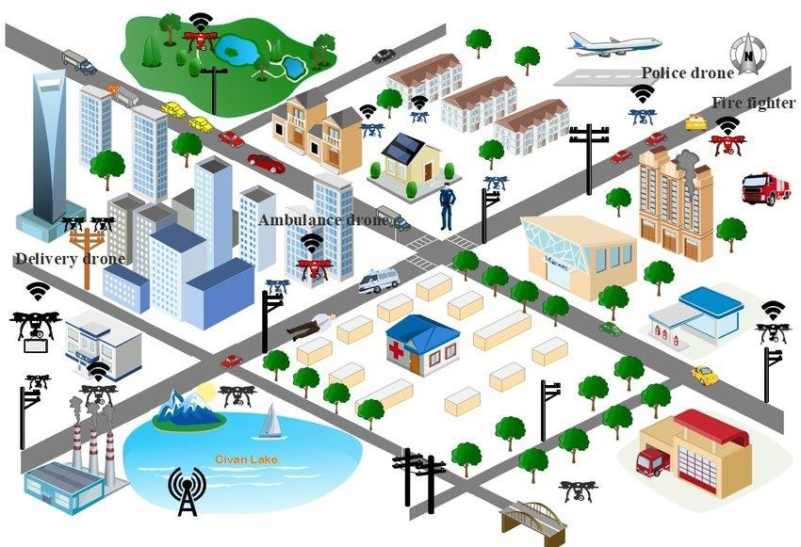
Figure 1: Application Sectors of Commercial Drones
UAVs can be misused by those with bad intentions, who utilise them to break the law or invade others' privacy (Davidovich, Nassi, and Elovici, 2022). There has been an upsurge in demand for UAVs because some of them are accessible to consumers and reasonably priced. Attackers have attempted to compromise the security of UAVs by remotely controlling drones for a variety of purposes, from spying (capturing images or films of people) to utilising them in a "kamikaze manner." Over the past 20 years, there have been significant technological advancements in design, control, and automation; nonetheless, the security component of

UAVs has received little attention. Several UAVs security incidents during hostilities and conflicts in Iran, the Ukraine, and Iraq have been documented. Malicious users transmitted false GPS signals during these attacks with inaccurate positional and temporal data that could be easily identified, leading to inaccurate navigation (Khoei et al., 2023). These signals resemble those sent out by satellites and are identical to real GPS transmissions. To prevent access to the Wi-Fi network's communication network, some UAV manufacturing companies suggest changing the network's default password. However, users usually do not do this, resulting in security lapses. However, if users do not change the password automatically or if it is changed to a well-known term, attacks against Wi-Fi technology, such as brute force attacks, can be used to try and guess the password and gain access to the network (Whelan, Almehmadi, and El-Khatib, 2022). This is due to the absence of an extra defence mechanism to thwart these kinds of attacks. Some UAV operators also take part in unlawful activities including flying over prohibited regions or coming too close to crowds of people due to their ignorance of the laws and regulations governing the usage of UAVs. Therefore, it is essential to develop methods for the identification and mitigation of the various UAV cyberattacks.
Several methods have been suggested to identify GPS spoofing attempts. These techniques can be divided into three groups based on their use of encryption, signal processing techniques, and external UAV features (Kumar et al., 2020). The GPS signals are encrypted using cryptographic methods, which need a key to be unlocked (S. Wang et al., 2020). Techniques in the second category use real GPS signals and extract their angle-of-arrival, signal intensity, phase, and discontinuities, as well as their spatial and geometrical features and physical layer characteristics. The third category is based on exterior UAV parameters like speed and acceleration, which are monitored by the UAV flight control system's sensors like the barometer, inertial measurement unit (IMU), and compass. These GPS spoofing detection techniques have some limitations that restrict their use. For instance, commercial or civil applications cannot effectively use cryptography techniques. GPS signals must be decrypted for these applications; hence they need encryption/decryption keys. The performance of real- time systems may be negatively impacted or more communication overhead required by methods based on signal processing or the external characteristics of UAVs. These methods may need additional hardware (sensors or antenna) or auxiliary equipment, modify interface specifications, or require extensive signal processing capabilities.
The error in location estimates and their covariance continue to develop without limitations, necessitating continual inertial sensor calibration for inertial navigation systems (INS) approaches. These strategies can only be employed when the quality of sensors is high in relation to size and cost for the detection of GPS spoofing attempts. As a result, it is impossible to detect small drones using such methods (M. R. Manesh et al., 2019a). Additionally, there are some restrictions when detecting GPS spoofing attacks when employing sensors like the gyroscope and accelerator. As an illustration, the accelerator can only gauge changes in velocity. The rotation around the sensor's own axis of movement is also impossible to measure with this device. In order to measure angular velocities, it must be used in conjunction with a gyroscope. Due to the accelerator's sensitivity to temperature, it can be challenging for it to function well in various UAV ambient conditions. In addition, the gyroscope is a sensor that does not detect linear motion in any direction or a fixed angle of orientation (Nayfeh et al., 2023). As a result, these two sensors cannot be utilised to detect GPS spoofing attacks on UAVs (Kwon & Shim, 2020) because they are two essential parts of INS and IMU-based approaches

and because of their limitations. To categorise and find GPS spoofing assaults against UAVs, several research based on conventional machine learning methods have been proposed. Artificial neural networks (M. R. Manesh et al., 2019a) and tree models are just two examples of such techniques. In the detection of GPS, such models offer practical solutions (Aissou et al., Dec 01, 2021).
In this thesis, machine learning (ML) modelling for real-time GPS spoofing detection and classification is the particular interest. The set of data to be gathered will be produced and signal based. A comprehensive dataset with legitimate methods is created using this data. It involves investigation and assessment to find characteristics and trends that point to GPS spoofing assaults. With an emphasis on increasing accuracy and dependability, the chosen machine learning model is trained and validated using the gathered information. Anomalies in GPS signals brought on by GPS spoofing assaults are categorised by the algorithms.

Significance of the Research

The global expenditure on commercial drones in 2020 stood at $3.73 billion, with DJI being the market leader, followed by Parrot and 3DRobotics (Laura Wood, 2021). It was predicted that the market for drones had increased to $99 billion in 2018 and an estimated $104 billion increase by 2030(Unmanned Aerial Vehicle (UAV) Drones Market Size 2022-2030. 2022). In addition, a fast-growing segment is the DIY market, where the sales are primarily in components (Nessa Anwar, 2023). The market size of drone related services is also predicted to match that of the hardware sales within the next three years. The cost of these drones can range from a minimum of $50 for micro drones and a standard DJI Phantom for $699, to the high-end Intuitive Aerial Aerigon that costs up to $250,000 and is used to shoot high-resolution videos for film production (MOST 6 EXPENSIVE DRONES. 2023) . This wide price-range represents the diversity of capabilities in commercially available drones, and in the following segment.

UAVs offer a great opportunity for equipment manufacturers, investors and business service providers. According to the PWC report (Silver et al.,), the addressable market value of UAV uses is over $127 billion. Civil infrastructure is expected to dominate the addressable market value of UAV uses, with market value of $45 billion. A report released by the Association of Unmanned Aerial Vehicle Systems International, expects more than 100,000 new jobs in Unmanned aircrafts by 2025 (Auvsi, 2020). To know how to operate a UAV and meet job requirements, a person should attend training programs at universities or specialized institutes. Global UAV payload market value is expected to reach $3 billion by 2027 dominated by North America, followed by Asia-Pacific and Europe (Eldosouky et al., 2020) . The payload covers all equipment which are carried by UAVs such as cameras, sensors, radars, LIDARs, communications equipment, weaponry and others (Davidovich et al., 2022). Radars and communications equipment segment is expected to dominate the global UAV payload market with a market share of close to 80%, followed by cameras and sensors segment with around over 11% share and weaponry segment with almost 9% (Arteaga et al., 2019).
The security and dependability of their Global Positioning System (GPS) signals are crucial given the growing use of unmanned aerial vehicles in a variety of businesses. The security and effectiveness of UAV operations are seriously threatened by GPS spoofing, a cyberattack that modifies GPS signals to trick UAVs.

With the feasibility growth in the purchase of drones as applicable to different industries, not all end users have good intentions. End users are the fine line of security if got with in bad hands, it can take several systems down. As seen in figure 2, spoofing attack carries the greatest weight of all the cybersecurity. Once a spoofing attack is successful, the attacker is command, and the 3 data integrity is breeched. Commercial unmanned aerial vehicles are systems that are under order based on the application of the end user. Their usage is on the rise, but the security is still in question as most of the manufactures never take into consideration the privacy and protection settings.
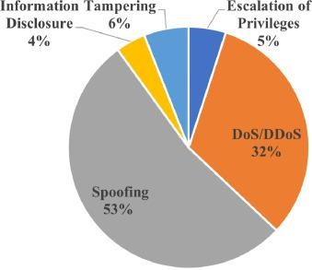

Figure 2: Classification of Attacks

There is need of an innovative technology that should confine to fit the numerous applications used in commercial UAVs applications. Detecting accurately and classification of authentic and spoofed signals for UAVs is an addition but most importantly if it is done real-time. The sections that will be positively impacted have been grouped into three categories, these include;

- Economic Impact: The widespread use of UAVs in commercial applications, such as agriculture and logistics has economic implications. The presentation of GPS Spoofing attacks protects investments in UAV technology and ensures the continuity of business operations.
- Societal Impact: Numerous UAVs are used for inspecting critical infrastructure such as power plants, pipelines and communication towers. These assets are essential for society and GPS spoofing attacks on UAVs conducting inspections could lead to dangerous consequences. Detecting and mitigating such attacks safeguards critical infrastructure.
- Industrial Impact: Reliable GPS spoofing detection and mitigation algorithms helps to prevent UAVs from operating based on falsified GPS data reducing the risk of collisions, crashes and accidents, hence enhancing security. This improves the robustness in the regulatory compliance set up by the FAA.

Problem Statement

In order to navigate and control themselves accurately, unmanned aerial vehicles (UAVs) significantly rely on GPS signals. However, spoofing attacks, in which malicious actors trick UAVs with false GPS signals, can disrupt operations and grant unauthorised access to restricted

airspace and pose a risk to safety. Commercial UAVs likewise rely on a centralised system, as shown in figures 3 and 4 respectively, making it simple for an attacker to shoot them down. According to Arteaga et al. (2019), traditional methods for spotting and countering GPS spoofing assaults are frequently ineffective and unable to keep up with new spoofing strategies. As a result, it is imperative to provide reliable and clever solutions that make use of machine learning techniques in order to recognise and counteract GPS spoofing assaults that are specifically directed against unmanned aerial vehicles (UAVs).
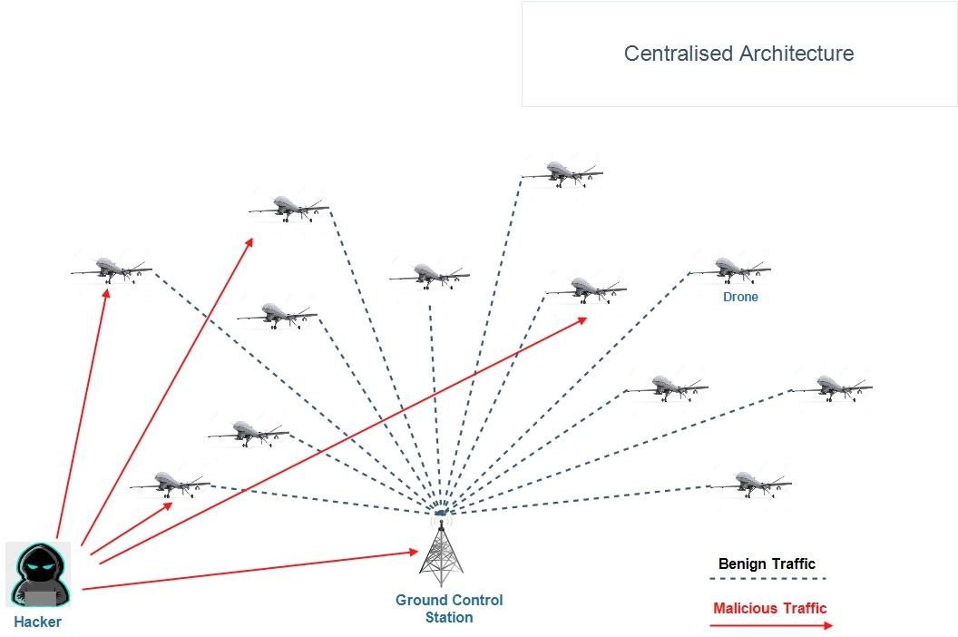
Figure 3: Centralized Architecture

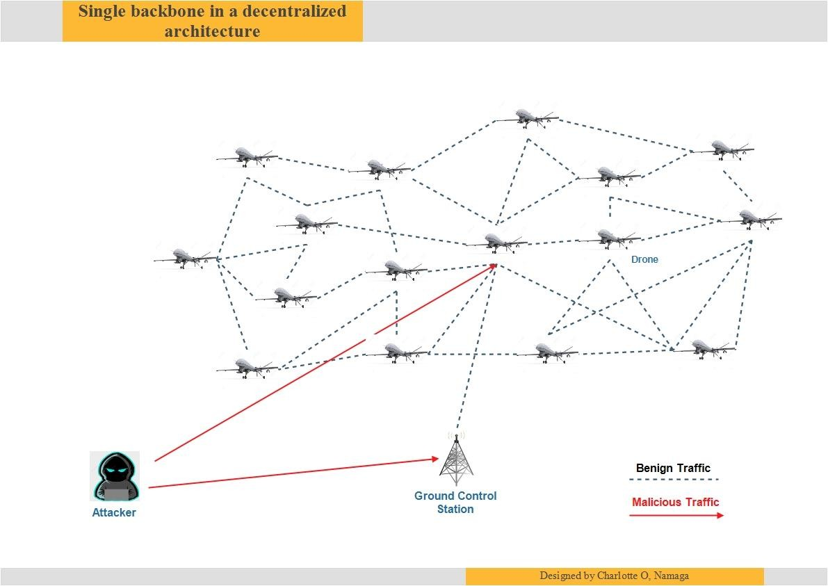

Figure 4: Single Bone in a Decentralized Architecture The issue at hand requires tackling the following major difficulties:
- Detection accuracy: Current techniques for detecting GPS spoofing in UAVs frequently produce high numbers of false positives or false negatives, producing unsatisfactory detection findings. Utilising machine learning methods and adding more sensor inputs can help to increase the precision of GPS spoofing detection mechanisms.
- Real-time processing: To quickly detect and respond to GPS spoofing attacks, UAVs operating in dynamic situations need to have real-time processing capabilities. Effective detection and mitigation depend on the creation of machine learning models and algorithms that can interpret incoming GPS data in real-time.
- Adaptability to changing methodologies: GPS spoofing methodologies are always changing, and conventional detection methodologies may find it difficult to keep up. In order to increase the resilience of UAVs against new threats, machine learning-driven systems that can adapt to and learn from new spoofing tactics must be developed.
- Response Mechanisms: UAVs must be equipped with efficient response mechanisms in case a GPS spoofing assault is discovered. In order to lessen the effects of spoofing assaults and guarantee the safety of the UAV and its surroundings, these systems ought to allow the UAVs to autonomously react, modify flight paths, and activate fail-safe protocols.
(Moustafa and Jolfaei, 2020) claim that in order to overcome these difficulties, advanced machine learning techniques must be created and put into use. These techniques must be created expressly for the detection and mitigation of GPS spoofing in UAVs. The objective is

to improve the security and reliability of UAV navigation systems and assure their safe and uninterrupted operation in the face of GPS spoofing threats. This is accomplished by utilising machine learning techniques, incorporating multi-sensor inputs, and building intelligent response mechanisms.

Research Aim & Objectives

Aim: A machine learning-based GPS spoofing detection system for UAVs is what this thesis aims to create. By enhancing the detection and accuracy of the chosen machine learning model, this will be accomplished. Making sure the model produces the fewest false positives, denoising, and the chosen features that anomalous classifies the spoof GPS signals in real time. Following is a more thorough summary of the study's primary goals:

Objectives

    - To explore the key characteristics and patterns of spoofed GPS signals that can be used as features for machine-learning based detection models in UAV scenarios.
    - To design and develop a machine learning algorithm that detects GPS spoofing attacks real time.
    - To assess the cost of resources in terms of hardware equipment capable of detecting GPS spoofing in UAVs.

Scope of the Research

This study emphasizes GPS spoofing attack for commercial UAVs encapsulating on machine learning-based approaches. Implementation based on the best performing model with the guide analysis of the metrics. Consideration of overall accuracy, precision, recall and low false negatives of the machine learning algorithm is evaluated. Numerous topics and problems are included in this refashioning process. However, the defined the key areas of boundaries and limitations within which the study is conducted includes:

    - GPS Spoofing for commercial UAVs.
    - Machine Learning-Based Approach (SVM, DT, LR, RF, XGBOOST)
    - Real-Time Detection
    - Applicability to real-world UAV Systems
    - Potential Countermeasures for Mitigation

The thesis specifically cantered on GPS spoofing attack as they pertain to commercial unmanned aerial vehicles. It aims to address the unique challenges spoofing detection in the context of UAV operations. Secondly the machine learning-based approaches shall be introduced. The research leverages machine learning methods for GPS spoofing detection. It focuses on exploring the potential of specific machine learning algorithms specifically; SVM, RF, LR and XGBOOST. The algorithms analyse GPS signal data and distinguish authentic and spoofed signals. Thirdly, the importance of real-time detection and response is emphasized during missions. The proposed framework aims to operate efficiently and promptly to ensure timely detection and mitigation. Collection and preparation of a diverse and representative dataset of GPS signals including both authentic and spoofed samples. The dataset is instrumental in training and evaluating the machine learning models. Usage of relevant performance metrics such as detection accuracy, false positive rate, computational efficiency

is some of the benchmarks. Fourthly, discussions of the applicability and potential integration to real-world UAV systems is presented. Finally, mitigation countermeasures for the effects of GPS spoofing attacks on UAVs are presented. Such as: secure communication protocols, sensor fusion techniques, system redundancies.

Research Methodology

Investigating and learning more about the topic at hand is one of the most crucial steps in a project. Prior to developing the machine algorithm, extensive research will be done on UAV GPS spoofing, methodology already in use for UAV GPS spoofing detection, as well as upcoming strategies currently being developed. With this, the gap analysis for the current study topic will be available. The importance of UAVs in the commercial sector, their security concerns, and the reasons for choosing to employ machine learning for detection will be discussed through a review of previously published material. A comparison of the machine learning algorithms providing the best accuracy metrics will be provided by the research gap analysis. The Internet of Things, commercial UAV GPS spoofing, existing detecting techniques, and machine learning algorithms will be the project's primary research sources. The reading selection will come from reliable and trustworthy sources of high impact journal articles and conference papers including IEEE, ACM, and Science Direct. assisting in the dissemination of truthful and information.

There are several methods that can be used for this project, but observation and the analysis of primary data are the ones that should be used. The researcher will be able to directly observe and get information that is tailored to the research aims by using primary data and conducting observations, boosting the relevance of the data. On the other hand, conducting direct observations and gathering information from first-hand sources will ensure the data's accuracy and dependability. Thus, any potential bias, inaccuracy, or confounding variables can be immediately analysed.

Preprocessing and data analysis come next. To determine the characteristics and patterns of faked GPS signals, the data gathered will be evaluated. Preprocessing the dataset will make it possible to eliminate noise, outliers, and unnecessary features. Extract pertinent characteristics from GPS and other sensor data that may be a sign of GPS spoofing attacks.

The selection of a machine learning model will come next. Deep learning models for GPS spoofing detection are one of the machine learning algorithms that the researcher will examine. evaluation of each algorithm's performance and applicability using parameters including recall, precision, and accuracy. According to (Diao et al., 2020), the project benefits from considering the computational effectiveness and real-time processing capabilities of the chosen models. Splitting the dataset into training and validating sets will be required for model training and validation, guaranteeing a balanced representation of both real and fake GPS signals. The chosen machine learning model will be trained using the training data, the hyperparameters and model architecture will be optimised, the trained model will be validated using the validation data, and its performance will be evaluated and adjusted as needed. The trained machine learning model will be used by the real-time anomaly detection system. The device will then be integrated with UAV navigation hardware or software to continually track GPS signals while in flight. By comparing arriving GPS signals with the predictions of the model and following predefined thresholds, anomalies can be found in real time.

Assessment and Validation. Extensive testing will be used to assess the effectiveness of the GPS spoofing detection and mitigation system. The researcher will then carry out simulated and actual trials to evaluate the mission's overall success as well as the detection rate and response times. It will then compare the system's performance to benchmark techniques. To be able to incorporate feedback into the system's design and implementation and assure its usability, efficacy, and adherence, this will in turn yield insights.

Machine learning techniques were chosen since they require little in the way of resources to provide detection signals. In contrast to the contributions made to the current trend that are already in existence (Pardhasaradhi and Cenkeramaddi, 2022), each one of them calls for hardware that is not already accessible. A dataset with details on various spoofing techniques, signal intensities, and ambient conditions will be made available if primary data analysis is chosen. Figure 5 provides a summary of the steps that affect the study methodology.

Literature Review on GPS Spoofing
Detection via ML Algorithms
Divulge Research Gap Analysis for Real- Time GPS Spoofing Techniques via ML Algorithms
Literature Review on GPS Spoofing Detection
Techniques using Real- Time Strategies
Framework for Real-Time GPS Spoofing Techniques via ML

Define boundaries of the Solution

Phase 2: System design & implementation
Implementation
System design for proposed strategy

Experiment & Analysis

Phase 3: Validation of Research
NO

Validation



Literature Review process on GPS Spoofing Detection
Techniques
Phase 1: Literature Survey and problem statement recognition

YES
Expected Solutions for Real-time ML

Phase 4: Results and Summary
Conclusion, Recommendations & Future Remarks
Evaluation of ML algorithms results
Comparison of best performing ML algorithm

Figure 5: Research Process in the Thesis

Phase 1: Literature Review and Problem Statement Recognition
A broad and detailed survey strategic literature review on existing GPS spoofing detection techniques for commercial UAVs delivers the design and deployment of a machine learning based which detects spoofed signals efficiently. This phase provides an overview of existing research, highlights key findings and identify research gaps in the domain of GPS spoofing detection and mitigation for UAVs. Furthermore, it brings forth the advancements made in GPS spoofing detection on UAVs using machine learning methods. It underscores the importance of feature extraction, multi-sensor fusion, real-time processing and response mechanisms in developing effective mitigation solutions. All the related works are categorized and presented in tabular form. Moreover, from the extensive analysis, we propose a generic framework and set the boundary of solution for our GPS spoofing detection technique based on machine learning.

Phase 2: System Design and Implementation
This phase will entail a description of the situation framework where the GPS spoofing attacks will be conducted. A scheme of the proposed implementation is defined for picturing the interaction with how the process will flow. The involvement and how communication will be analysed to depict the scenario. A technical description of the threat actor's equipment, attack plan, target unmanned aerial system's capabilities, and detection technique is provided. The data collection process including real-world GPS data to train and test the machine learning algorithms is presented.

Phase 3: Validation of Research
During this phase, validation of the performance of the selected best performing model will be selected with representation of a consumer drone. The drone is exposed to a GPS Spoofing attack in hovering mode. When a spoofing attack is manipulated, the drone should be uncontrollable. The use of numerical simulation with real-time experiment of the proposed algorithm is a provision of validation of the research.

Phase 4: Results and Summary
At this phase, presentation from the experiments including accuracy and effectiveness of the machine learning methods in detecting and mitigating GPS spoofing attacks for UAVs is made. The outcome from all the proposed machine learning algorithms is exhibited. Lastly, discussion of findings, limitations and potential future research directions in this area are presented.

Organization Flow of Thesis
This thesis consists of five chapters: Introduction, Literature Review, Design and Methodology, Results and Analysis and Conclusion.
Chapter 1 is the addresses the overview of the thesis, the motivation with supporting evidence of statistics why the area of interest was selected, the problem statement at hand, clearly defines boundaries of the research, a brief explanation of the methodology and the solution of the outcome expected.
Chapter 2 gives a thorough analysis of the literature in this area of study. Presentation of different authors who have undertaken the same subject of study, the challenges, solutions and how critics of the different solutions.

Chapter 3 provides a detailed research design, the equipment used, and the process undertaken to achieve the goal.
Chapter 4 assesses the thesis through the discussion on the results performed on the different machine learning algorithms for detecting GPS spoofing.
Lastly, Chapter 5 covers the conclusion, recommendations and future works. Potential research areas in GPS spoofing with a coverage of the main contributions and improvements of the machine learning algorithms are outlined.

Introduction

CHAPTER TWO LITERATURE REVIEW

GPS spoofing poses a serious threat to unmanned aerial vehicles since it can impair operations and result in inaccurate placement. Researchers have investigated the use of machine learning algorithms for GPS spoofing detection and mitigation in the context of UAVs in order to get around this problem. This literature review aims to provide an overview of the body of knowledge, highlight key findings, and provide areas for further research in order to detect and prevent GPS spoofing for UAVs using machine learning approaches. Each taxonomy group's works have been discussed, along with a list of outstanding issues and challenges. A critical analysis is then used to describe the advantages and disadvantages of the present solutions in relation to the new approach. This chapter also examines the communication methods now in use in state-of-the-art solutions with the goal of identifying the real-time GPS spoofing for UAVs that is both the most economical in terms of hardware and software.

Research Background
Unmanned aerial vehicle development is driven mostly by military research. Even though they were initially designed as armed vehicles to reduce the risk to human operators in hostile environments, UAV technology, capabilities, and employment have already advanced to include surveillance and the gathering of data (Arthur, Aug 2019). The use of drones changed from being primarily military to including civilian uses in the aftermath of Hurricane Katrina in New Orleans in 2005 (The Danger of Drones. 2020). Military drones with precise infrared cameras were mainly considered as a practical field asset in the enormous rescue operation that followed. As a result, the Federal Aviation Administration (FAA) granted the first licences enabling the use of military drones from the M7RQ series over commercial airspace. Like the development of other cutting-edge technology like 3D printers, drones have followed the same path as traditional aircraft. Through the creation and distribution of development tools, drone manufacturers have engaged the assistance of the open-source community. Due to the geographically distributed nature of open-source projects, modelling software was used to create most of the designs. As a result, it was straightforward to share, test, and modify the designs (Condomines et al., 2019). 3D printers were also essential to this process because they made rapid prototype and drone component manufacture possible. Anyone may download and print the 3D files, which contain the designs of certain pieces, for free from the internet (Condomines et al., 2019). Drone makers tap on the passion and expertise of the local populace to create technology that best satisfies their demands. Entry barriers have been considerably reduced for new drone enthusiasts and amateur developers thanks to the community's assistance, expertise, and availability of resources (V. V. Patel et al., 2022).
In addition to manufacturers, a new sector for drones has begun to emerge in this area: drone- related services. To build, maintain, and repair drones is the most basic of these services (V. V. Patel et al., 2022). These days, drones can be rented for an hourly or daily rate in a lot of places by both individuals and corporations. In addition to being used for real estate marketing and construction and inspection inspections, these rental drones are also used for event photography and architectural photography (Nessa Anwar, 2023).

Structure of Commercial Drones
A UAV, whether piloted remotely or automatically, is any aerial vehicle that can fly without a human pilot on board. UAVs come in a variety of shapes and sizes, from huge military drones with wingspan of around 200 feet to readily available inch-wide micro drones. While the operational range of certain commercial drone types is only a few feet, those of highly developed military drones that never land can reach distances of over 17,000 miles. Most drones on the market now have the same design as shown in figure 6. The key parts of the basic design are a lightweight plastic or metal frame, a radio receiver, an electrical speed controller, a battery, and a microprocessor (Laura Wood, 2021). The motion of four to eight motors and propellers is controlled by these parts. Gyroscopes and other sensors are also added to improve the drone's mid-air stability. You can utilise a GPS gadget for navigating. Hobbyist drones are frequently further outfitted with a camera for shooting aerial pictures and a gimbal for improved image stabilisation. Additionally, more sensors can be added, but doing so has a cost in terms of functionality and weight. Among the manufacturers are DJI, 3DRobotics, and Parrot leading hardware producers, and they sell both assembled drones.

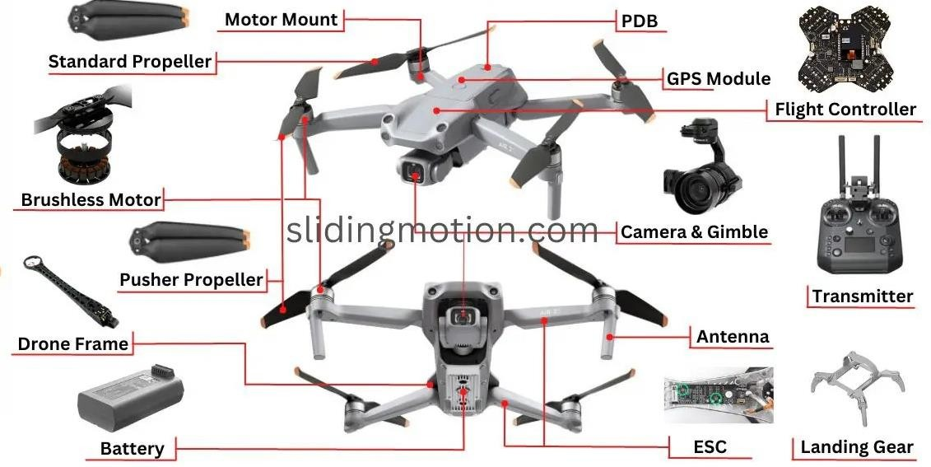
Figure 6: Structure of a Drone

UAV Classification/ Categorization
A UAV can perform as many tasks as it can while being controlled remotely, operating partially autonomously, or using a combination of these. Simple: Most commercial UAVs rely on GPS for navigation (Davidovich et al., 2022b), hence there is a direct relationship between civil UAVs and civil GPS signal. UAVs can be categorised by several elements depending on their purposes and capabilities, including maximum take-off weight, maximum flying altitude, endurance, data link range, and mission (Davidovich et al., 2022b). The classification of UAVs in Table 1 considers a variety of factors to create four broad categories: Special mission, Strategic, Tactical, and Micro or Mini.

Table 1: UAV Classification

Category of Drones | Category (Acronym) | Maximum Take Off Weight (Kg) | Maximum Flight Altitude (m) | Endurance (Hours) | Data Link Range (Km) | Example Missions | Example Systems
Mini/Micro UAVs | Micro (MAV) | 0.15 | 251 | 1.5 | <13 | Scouting, NBC sampling and surveillance inside buildings | Mosquito, Hornet, Mosquito, MicroStar, Microbat, FanCopter, QuattroCopter, and Mite
 | Mini | <33 | 150 – 300 | < 2.2 | <11 | Agriculture, pollution monitoring, surveillance inside buildings, communications relay, and electronic warfare | Tracker, DragonEye, Raven, Pointer II, Carolo C40/P50, Skorpio, R-Max, and R-50, as well as the YH-300SL and  Mikado

Category of Drones | Category (Acronym) | Maximum Take Off Weight (Kg) | Maximum Flight Altitude (m) | Endurance (Hours) | Data Link Range (Km) | Example Missions | Example Systems
Tactical UAVs | Close Range (CR) | 151 | 3001 | 2-5 | 11-31 | Mine detection, RSTA,  search and rescue, and EW | Phantom, Copter 4,  Pointer, Camcopter, Aerial and Agricultural RMax, Observer I, Mikado, RoboCopter 300,
 | Short Range (SR) | 203 | 3002 | 3-7 | 31-72 | BDA, RSTA, EW,  mine detection | Hornet, Raven, Phantom, GoldenEye 100, Flyrt, Neptune, Luna, SilverFox, EyeView, Firebird, R-Max Agri/Photo, Scorpi 6/30, Raven,  and SilverFox
 | Medium Range (MR) | 151-503 | 3004-5004 | 6-11 | 79-203 | BDA, RSTA, EW,  mine detection, NBC sampling | Armour X7, Smart UAV, UCAR, Eagle  Eye+, Alice, Extender, Shadow 200/400, Hunter B, Mucke, Aerostar, Sniper, Falco,  Armour X7
 | Long Range (LR) | - | 5002 | 6-14 | 200-500 | RSTA, BDA,  communications relay | Hunter, Vigilante 502

Category of Drones | Category (Acronym) | Maximum Take Off Weight (Kg) | Maximum Flight Altitude (m) | Endurance (Hours) | Data Link Range (Km) | Example Missions | Example Systems
 | Endurance (EN) | 504-1504 | 5007-8000 | 13-28 | >503 | BDA, RSTA, EW,  communications relay, NBC sampling | Aerosonde, Shadow  600, Searcher II, Vulture II Exp, and Hermes  450S/450T/700
 | Medium Altitude, Long Endurance (MALE) | 1003-1505 | 5001-8001 | 25-49 | >503 | BDA, RSTA, EW  weapons delivery, communications relay, NBC sampling | Eagle-1/2, Darkstar, E-Hunter, Dominator, MQ-1 Predator-IT, Skyforce, Hermes  1500, Heron TP, and Hermes 1500
Strategic UAVs | High Altitude, Long Endurance (HALE) | 2,501 –  12,503 | 15,000 –  20,000 | 24 - 48 | >2,001 | Airport security, boost phase intercept launch vehicle, communications relay, RSTA, and EW | Libellule, EuroHawk, Mercator, SensorCraft, Global Observer, Pathfinder Plus, Theseus, Helios, Predator B/C,  Global Hawk, Raptor, Condor,
Special Task UAVs | Lethal (LET) | 250 | 3,000 – 4,000 | 3-4 | 300 | infrastructure, ship, aero plane, radar, and more | MALI, Harpy, Lark, Marula
 | Decoys (DEC) | 250 | 50 – 5,000 | <4 | 0-50 | Aerial and naval deception | Flyrt, MALD, Nulka, ITALD, Chukar

Category of Drones | Category (Acronym) | Maximum Take Off Weight (Kg) | Maximum Flight Altitude (m) | Endurance (Hours) | Data Link Range (Km) | Example Missions | Example Systems
 | Stratospheric  (Strato) | TBD | 20,000 –  30,000 | >48 | >2,000 | - | Pegasus
 | Exo-strato-spheric (EXO) | TBD | >30,000 | TBD | TBD | - | MarsFlyer, MAC-1

GPS Overview
Each GPS satellite transmits information that enables a user to precisely calculate the position, speed, and time parameters using well-known triangulation techniques (S. Vatansever & I. Butun, 2017). This is done by measuring the precise distance between the selected GPS satellites and their antenna. The Global Positioning System is a constellation of satellites that determines where on Earth you are. The fact that this technology is an extremely accurate positioning technology makes it possible for most location-based apps to function. Anytime, in any weather, GPS users can obtain a 3-D location, velocity, and time fix. Within an average of 18 feet or, in the worst case, 60 to 90 feet. GPS users may pinpoint their whereabouts (S. Vatansever & I. Butun, 2017).
A constellation of 21 primary satellites at a height of 10,924 nautical miles (about 20,200 km) is necessary to provide adequate GPS coverage. Although the satellite constellation can have up to 24 satellite positions, the 24 active satellites are normally maintained. According to Sidorov et al. (2020), these 24 sites have been optimised to have the lowest possible susceptibility to a satellite failure. Each of the six orbital planes that make up the constellation of GPS satellites contains four satellites. The ascending nodes of the orbital planes are evenly spaced at 60°, and the orbital planes are inclined at an angle of 55°. The satellites are monitored by five base stations. The primary base station is in Colorado Springs, Colorado, with four other base stations located on Ascension Island (Atlantic Ocean), Diego Garcia (Indian Ocean), Kwajalein, and Hawaii (all in the Pacific Ocean) (Sidorov et al., 2020).

GPS Technical Overview
The United States Department of Defence created and developed the dual-purpose satellite navigation system known as GPS in the 1970s. It offers distinct services for military users and civilian users. The Precise Position System PPS transmitted at 1227.6 MHz (L2 signal, authenticated) and is designed to be used by the US military and some government agencies (it does not necessarily mean that it is used by all military institutions), L2 signal is in modulated by P code that offers additional encryption capabilities. The Standard Positioning Service SPS broadcasted at 1575.6 MHz (L1 signal, unauthenticated) and is intended for the use of the civilian community. The system calculates the receiver's position using the Time of Arrival (TOA) range concept and consists of a constellation of 31 satellites that excludes the earth in order to offer a continuous PVT solution everywhere in the world. The time it takes for a signal to travel from the satellite to the receiver in a certain location is measured by the TOA range concept. The distance travelled is calculated by multiplying the signal's speed, or propagation time, by the speed of light. By resolving an equation system, it is possible to find the receiver in three dimensions when the distance between more than four emitters is computed. As more satellites are used to calculate the PVT solution outputs, their accuracy rises. The measured distances are also affected by an imperfect match between the time scale of the receiver and the precision atomic clock time scale of the satellite. Each satellite uses a different range code to modulate the signal, and each of these range codes is designated by an equivalent and unique PRN number. This allows the satellites to be recognised from one another even though they all transmit at the same frequency of 1575.42 MHz.

Corse/Acquisition (C/A) code
Each satellite transmits its unique PRN code at a rate of 1.023 Megabits per second, and these codes only correspond when one satellite is almost perfectly within another. It is impossible for satellites to synchronise their PRN codes.

Navigation Message
The signals for C/A and P code are modulated at 50 Hz to produce the navigation message. To accurately compute the satellite positions and transmission timings (using the ephemeris and calendar, respectively), the information in this message is necessary. It also contains instructions on how to convert GPS system time to UTC and details on how to correct for various range measuring errors. It's possible that the equipment will need all this information to find new satellites. The message broadcast is finished after 12.5 minutes of nonstop transmission.

Signal Acquisition and Tracking Phase
The GPS reviver must go through several steps when it is turned on before it can access the signal's data and provide a PVT solution. Most of this step takes place in the acquisition phase and is therefore more challenging and resource-intensive than the tracking phase because it needs to search and match the signals across a broad spectrum. During acquisition, the receiver does a two-dimensional search. It must first locate the C/A code's start location and the Doppler offset. In order to do this, it tests each conceivable value in each of the 1023 slots of each satellite's pseudorandom number (PRN), looking for the correlation peak in the signal. It also must look in a frequency range because of the Doppler effect less than 10 kHz. The receiver then adjusts its internal clock to coincide with the correlation peak; at this point, the internal clock of the receiver and the satellite's atomic clock are synchronised. The tracking phase two loops are needed to track each satellite signal after the signals have been obtained. The FLL loop follows the Doppler carrier or pseudo-rates, while the DLL loop tracks the start of the C/A code or pseudo-ranges.

Time to First Fix (TTFF)
The time to first fix (TTFF) measures how long it takes a GPS receiver to determine its current position (fix) once the acquisition phase has started. To create a two-dimensional position, the receiver needs to know their separation from at least three satellites as well as their locations. Ephemeris data, which is very precise orbital and clock correction information for the satellite, is used to pinpoint a satellite's location. Each satellite broadcasts only that data as ephemeris information as part of a navigation message. The navigation message also contains almanack data, which the receiver uses to forecast the approximate positions of the satellites. The typical cold, warm, and hot start types used to calculate the TTFF are not explicitly defined by any formal standards. The receiver does not have almanack or ephemeris data during a cold start, nor has it saved its most recent time or position. A cold start is frequently performed when the receiver hasn't been turned on in more than two weeks or when the memory's battery backup is dead. The navigation message need not be read in its entirety. The quickest time to create a cold start is 18 seconds but given that each satellite must transmit at a rate of 50 bps in order to deliver its 900-bit navigation data message, an expected average may be around 45 seconds. When time, date, and the receiver's most recent position are saved, a warm start is performed. At least three satellites must be used to download the ephemeris data while it is still unavailable. Waiting time for this procedure must be at least 18 seconds and is the same as for a cold start.

With the aid of almanack data, which allows the receiver to anticipate which satellite signals it should be able to receive, signals can be acquired more quickly than at a cold start. A hot start happens once the GPS receiver has already saved time and ephemeris. The receiver takes in a minimum of three satellite signals and uses those to pinpoint its location. For manufacturers, 1 to 3 seconds has been stated as the norm.

Classification of GPS Spoofing Attacks
Spoofing is the deliberate transmission and injection of fake GNSS signals into a GPS receiver to provide a false Position, Velocity, and Time (PVT) solution. The purpose of GPS spoofing is to covertly compel a receiver to follow a trick signal.

Simplistic GPS Signal Simulator Attack
Due of the ease of accessibility and low cost of the required tools, it is the easiest of the attacks. In essence, it entails broadcasting GPS signals into the radio frequency range. Because the generated signals are not synchronised with the genuine GPS signals and cannot be acquired by the receiver while it is in the tracking phase, the fake packets injection cannot be used to calculate the PVT solution without the use of a forced reacquisition technique. However, if the receiver is in acquisition mode, there might be a chance for a successful attack to be launched. A GNSS simulator, which is commercially available and whose price has significantly decreased to 4,000 EUR in recent years and can be used to conduct this assault. Additionally, the price of installing a GPS simulator has decreased by roughly 400 EUR thanks to recent developments in Software Defined Radio technology and GNSS open-source freeware. This section describes the terrifying attacks that capture and replay the entire GPS frequency in the RF band. Assault is depicted in Figure 7(a).

Intermediate Attack Using a Spoofer on the Receiver
A GPS receiver and a spoofing transmitter make up this apparatus. In order to create spoofing signals that are aligned with real GPS satellites, the system first synchronises with the currently valid GPS signals and determines the approximate 3D pointing vector of its antenna towards the location of the target reception antenna. To capture the tracking point of the target receiver PLL/DLL, the spoofer must relocate its correlation peak away from the real correlation peak. The tracking technique can be tricked if the signal power is around 10% higher than the real signals. The key problem for the design of these types of devices is to project the fake signals to the target GPS receiver with the proper power and signal delay. Figure 7(b) depicts the attack.

Sophisticated Multiple receiver-based spoofers with several antennas
The most sophisticated of all attacks, it is like the intermediate attack in how it is carried out but now uses multiple coordinated spoofers to emulate the spatial signal domain, making it very difficult for a conventional signal antenna receiver to both carry out and detect the attack. The sophisticated receiver-based spoofers of this sort can transmit across a variety of antennas to circumvent DOA spoofing techniques. This attack takes advanced and intricate set ups to execute.
Because it has no lock on legitimate signals when the receiver is in the acquisition phase, it is more likely to be successfully faked. All the attacks have a high likelihood of success in this scenario, and additional variables like signal intensity and signal quality come into play. Figure 7 (c) depicts the attack.

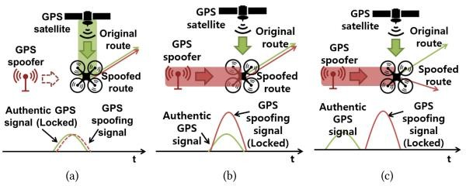

Figure 7: (A). Simplistic Attack, (B). Intermediate Attack and (C). Sophisticated Attack
In figure 7, a spoofer (a) generates a spoofing signal aligned with the authentic signals, (b) increases the spoofing signal strength, and (c) moves the spoofed route away from the original route.
The chances of a successful attack, however, are reduced if the receiver is in the tracking phase because a higher correlation peak will not affect the tracking process and the receiver will remain locked to the genuine signal unless the counterfeit correlation peak is situated very close to the genuine one. To the receiver, the spoofing signal will appear to be noise. When the receiver is in tracking mode in this situation, two different sorts of attacks can be carried out (Meng, Q., Li-Ta, Xu, Luo, & El-Mowafy, 2019).
Synchronous: By precisely understanding the three-dimensional pointing vector from the transmission antenna in direction of the antenna of the reception with few centimetres of precision, the spoofer signal carrier phase must be matched with the original signal carrier phase (Meng, Q. et al., 2019). The spoofer should also be aware of the true signal strength at its intended target receiver. When the target is a UAV that is flying beyond the attacker's line of sight, these parameters are particularly challenging to meet in real-world spoofing scenarios.
Asynchronous: In this instance, the spoofer has a general idea of where the victim's reception antenna is located. A stronger correlation peak will be produced during an asynchronous attack, and it will migrate along the signal to align with the real correlation peak's position. Compared to the synchronous attack, this scenario is more realistic, but it has the downside that the noise that is generated before to locking may signal aberrant circumstances (S. Vatansever & I. Butun, 2017).

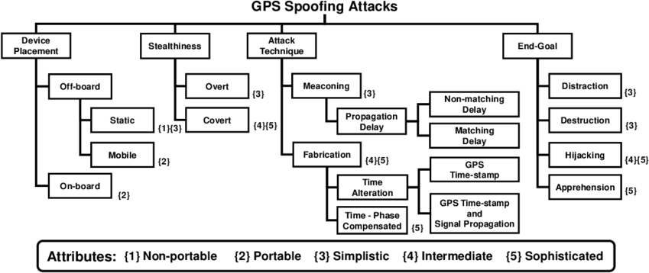

Figure 8: Breakdown of GPS Spoofing

GPS and its Vulnerabilities
According to J. Aru Saputro et al. (2020), GPS is an all-weather, satellite-based navigation system that continuously offers position, velocity, and time (PVT) services to military and civilian users throughout the world who are at or near the Earth's surface. The four active GNSS are the United States' GPS, Russia's GLONASS, China's Bei Dou, and the European Union's Galileo. Satellite navigation systems with global coverage are referred to as GNSS (Full Format of GNSS). Regional satellite-based navigation systems exist for Japan and India (J. Aru Saputro et al., 2020). Since it was the first to be fully functioning and cost-free, GPS has seen extensive commercial use. All GPS receivers produced up to this point are L1 frequency compatible. Furthermore, L1 frequency is the only one that over 70% of GPS receivers can use. Civilian GPS signals are vulnerable due to three reasons.
- Technology transparency. Due to this, it is possible to create software that generates signals like GPS (as well as commercial GPS/GNSS) simulators, which are all readily available (GNSS SDR, 2023).
- The civilian L1 GPS signal has no authentication mechanism, making it susceptible to spoofing.
- The weak GPS signals that are received render them susceptible to spoofing (being overpowered).

Vulnerabilities Detected in UAVs
Assaults on the drone's communication system and the operating system, which regulates its fundamental activities, are among the vulnerabilities and drone-related assaults that are currently most utilised. These assaults allow you to take control of the drone and give it new commands, or you can abduct it and steal the owner's personal information. However, most of these assaults target Parrot drones because they are among the most widely used drones right now and can be purchased by any user due to their inexpensive cost. C or C++ is the programming language used by most drones. Since they were written in these languages, many commercial and government drones contain security issues. One of the businesses that has programmed drones utilising these hacker-friendly development platforms is 3D Robotics.

Drones that can hack into other drones are now being developed by hackers. Maldrone, a malware created expressly to hack drones via Internet connections, has also been created by them. Like malware that targets computers, maldrone targets drones. A physical attack vector and a logical attack vector are two different ways that drones can be attacked [9]. The physical assault vector happens when the aircraft is physically contacted, such as when an unmanned aircraft is shot at with a gun, collides with another unmanned aircraft, or is captured using other physical tools. In contrast, a drone is attacked analytically by hackers using the logical attack vector. In order to interact with the operator and choose their flying characteristics, such as speed, altitude, etc., drones rely on a variety of technologies. The drones will respond to an attacker's command if these parameters are affected by an attacker. The Drone Defender invention by Ohio-based nonprofit research and development company Battelle is the best illustration of a rational attack vector. Without causing any collateral harm, Drone Defender gives drones a remote control and disables their GPS up to 400 metres away. The following list includes a few of the drone-related attacks.

Vulnerable Ports
Nmap displays two ports that an attacker could utilise while performing a port scan on the drone. Among other ports that are relevant to drone operation, these include ports 21 (FTP) and 23 (Telnet).
- File Transfer Protocol: A file injection attack or firmware upgrade can be performed by targeting file transfer protocol (FTP) services. The drone is connected to a USB stick, giving the attacker access to it. The attacker can use this to read, change, and delete files.
- Telnet: When a hacker connects to a drone system using telnet, he has complete access to the system and can change important system files and Shell scripts, which employ the Parrot to inflict damage. The drone can be restarted by the attacker while it is in flight, which will turn off the drone's engines and cause it to crash to the ground.

Signal Power
Procesing Levels
Navigation Signal
Analysis
Time of Arrival
Analysis (TOA)
Signal
Authentication
Cryptography
Digital Signatures
Inertial
Navigation
Systems
GPS Information
Verification
GPS Spoofing
Detection Techniques
Position Solution
Navigation Level
Mobile Cellular
Network Based Application
Signle Network
Antenna
Multi-Layer
Network Antenna
SVM
XGBOOST
Machine
Learning-Based
Techniques
Random Forerst
Decision Tree
Logistic
Regression

Figure 9: Taxonomy of the Literature Review

Over the past ten years, the GPS spoofing problem has drawn a lot of scientific interest. The suggested additions can be categorised into the five categories listed below. A classification of the various GPS spoofing detection methods used by UAVs is shown in figure 9. Those literary works' major themes have been used to group the approaches. First, research on navigation signal analysis has been rather extensive. Three different types of signal analysis that are frequently encountered in literature are covered in this section. Second, the widely used cryptography approach is presented, emphasising the usage of encryption. Signal authentication and digital signatures by prominent writers are presented in this section. In the third section, the inertial navigation system is discussed together with GPS information verification and navigation level position solution. The network-based detection method is the following. Different authors discuss the expense of the antenna procedure and its prognosis in detail. The suggested debate strategy for this thesis' motivation is then offered. There are many studies that discuss machine learning-based techniques for detecting GPS spoofing. Although there are many machine learning techniques, SVM, Random Forest, Logistic Regression, Decision Tress, and XGBOOST are used in this thesis.

Navigation Signal Analysis Approaches

In order to determine whether the GPS has been tampered with, GPS navigation signal analysis is routinely used to analyse GPS navigation signal data. To distinguish between real and fraudulent GPS signals, the authors in devised a multi-antenna spoofing detection method that examines the DoA of GPS signals. If the signals come from the same source in space, they are regarded as spoofing. In the study in (Dang et al., 2022) a technique mimicking spatial signal processing is presented for the goal of identifying and preventing GPS spoofing. The method makes use of null-steering and multi-antenna reception to find and eliminate phone GPS signals. The usage of many antennas is required when the methodologies are used, which increases the computational load on the GPS receiver (K. Jansen et al., 2018)

Cross-correlation is used in the methods in (M. L. Psiaki et al., 2022) and (O'Hanlon et al., 2020) to distinguish between GPS signals that have been falsified and military communications that have been encrypted or received by a trusted receiver and the receiver that is being protected. An assault by spoofing is occurring if the cross-correlation is poor. Even though these strategies don't need a multi-antenna GPS receiver, a communication link is still required to do the cross-correlation between the defended receiver and a secure receiver.

Signal Power Processing Levels
Among the characteristics of the GPS L1 signals that are known to the general public include their modulation type, Doppler range, PRN signals, frequency, bandwidth, signal intensity, and a variety of other parameters (IS-GPS-200G & IS-GPS-705C). A spoofer can therefore produce fake GPS signals that mimic the real thing in order to fool its target GPS receivers by understanding the structure and principles of how civilian GPS systems function. Signal Quality Monitoring (SQM) techniques and power-based methods are two examples.
(Diao et al., 2020) asserts that they offered a signal-to-noise ratio (SNR)-based remedy for GPS spoofing. The method suggested involves filtering out real and false signals based on which GPS signal has a higher efficiency ratio. The ratio of decrement bases up the available GPS signals and filters out those that are either weak or too powerful to keep up, increasing the

model's accuracy. The solution's drawbacks include the data's biases, real-time processing capability, and the tools used to get the answers.

Time of Arrival Analysis
Time of Arrival approach measures the differences in data bit latencies over intervals of more than 20 microseconds between the real GPS signal and the spoofer's inevitable delay caused by the creation of a false data bit structure. In 2-D, TOA establishes the position of the receiver based on the intersection of three or more circles, the radii of which represent the separation between the respective transmitter and the receiver (Guo et al., 2019). As shown in figure 10 (Kapoor et al., 2017), inaccurate measurements cause a receiver location uncertainty zone. The receiver must either have prior knowledge of the transmitter locations or the ability to receive transmit time and transmitter ephemeris data (Kapoor et al., 2017). However, synchronising the clocks of the transmitters and receivers is still difficult. By utilising LSA to solve the system of nonlinear equations for an overdetermined system, trilateration can be used to identify the coordinates of the receiver. The receiver coordinates in three-dimensional instances are determined by the intersection of spheres, with the transmitters situated at their intersection. This method's predictability of GPS signal structure due to the low frame update frequency is a disadvantage (Andres et al., 2016). A general expression for range measurement R_{k} is given by;

R ^{t} (t ) = ρ ^{t} (t ) – (dt – dt^{t})v + P ^{t} (t ) + d ^{t}(t ) + d ^{t} (t ) + d (t ) + ε
k k k r,k k k,t k k,T k t k k,t k t

where;

ρ ^{t} (t ) = Dimensional Distance;
k r,k
P_{k,t} ^{t} (t_{k}) = Air Propagation Delay (Unique Conditions);
d_{k,t}(t_{k}) = Error in Receiver Clock; d_{t}^{t} (t_{k}) = Incorrect transmitter clock. d_{k,T} ^{t}(t_{k}) = Multipath mistake;
ε_{t} = Unpredictable measurement noise.

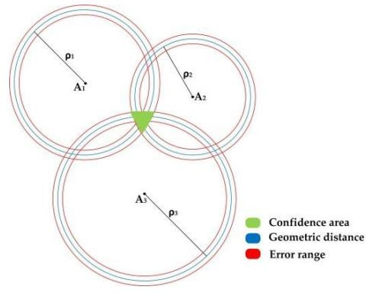

Figure 10:2-Dimensional Time of Arrival Analysis

Open Research Issues in Navigation Signal Analysis
GPS spoofing detection techniques using navigation signal analysis have made significant advancements but there are still several open issues and challenges that researchers and practitioners need to address. Some of these open issues include:
- False Positive and False Negatives: Striking a balance between minimizing false positives (incorrectly flagging legitimate signals as spoofed) and false negatives (failing to detect actual spoofing attacks) is challenging. Detection algorithms need to be fine- tuned to achieve an acceptable balance.
- Sophisticated Spoofing Techniques: As GPS spoofing attacks become more sophisticated, spoofers may employ techniques that mimic legitimate GPS signals more accurately. Detecting these advanced spoofing methods poses a challenge, requiring more robust and adaptable detection algorithms which navigation signal analysis cannot handle.
- Real-Time Detection: Many navigation signal analysis techniques require post- processing and complex calculations, which can result in a delay in detecting spoofing attacks. Developing real-time detection algorithms that can identify spoofing attacks promptly without compromising accuracy is a pressing challenge.
- Resilience to Noise: Navigation signal analysis are highly affected by natural noise and intentional jamming. GPS spoofing detection techniques need to be resilient to various sources of interference to accurately distinguish between genuine and spoofed signals.
- Localization in Urban Environments: Urban environments with multipath reflections and signal obstructions pose challenges for accurate GPS localization and spoofing detection. Techniques that account for urban signal characteristics are needed.

Cryptography Message Navigation Approaches

To protect civil GPS systems against spoofing efforts, the techniques in this category either consider the encryption or the authentication of the navigation messages. The navigation message encryption techniques protect the confidentiality of the navigation message by encrypting its content. To put the navigation message encryption techniques into practise, the GPS interface specifications must be modified. Navigation message authentication techniques strive to guarantee both the integrity of the navigation message and the reliability of its source by digitally authenticating its content. Wesson et al. combined a statistical hypothesis test with signature-based authentication to identify phoney GPS navigation messages. By utilising SM cryptographic techniques, Wu et al. verified the BeiDou-II navigation signals. Similar to this, the work in (Kerns et al., 2021) presented a BeiDou-II navigation message authentication technique based on digital signatures produced by an elliptic curve digital signature algorithm. To prevent message forgery, the production of GPS messages that were cryptographically signed was done in (Su et al., 2020) in a trusted execution environment. The European Galileo global positioning satellite system will provide an open navigation message authentication service based on an adaptation of the Timed Efficient Stream Loss-tolerant Authentication (TESLA) method. Combined transmission of the navigation message with a message authentication code, OS-NMA allows for source verification and message security. The one- way hash chain serves as the foundation for the message authentication code key, which is released after a predetermined period. The use of navigation message authentication techniques results in a significant computational cost and latency due to signature verification, even though they are a useful and effective defence against GPS spoofing assault. Some of them also require loose time synchronisation to operate (such as OS-NMA). Furthermore, systems relying on navigation message authentication are susceptible to replay attacks.

Cryptographic methods heavily rely on the unpredictable nature of security codes like P(Y), which alter the GPS signal (M. R. Manesh et al., 2019a). A spoofer would need to perform a meaconing attack, which involves recording and replaying the GPS signal's entire spectrum or estimate the unpredictable chips on-the-fly. It should be noted that since the verification of GPS signals is probabilistic, it is not completely safe. Non-cryptographic detection, on the other hand, does not rely on digital signatures, encryption, or GPS signals that have been enhanced for security. (Eldosouky, Ferdowsi and Saad, 2020) used a game theoretic countermeasure in the detection for the spoofed GPS for UAVs. The author uses a stochastic approach underlying his technique. The application in real-life UAVs gets limited with this approach as most adversaries already know the loopholes.

In the work of (Eldosouky et al., 2020), they presented the signal authentic calculation of spoofing encryption based on probability. In order to trick the UAV navigation system into believing it is in a different position, the GPS spoofer attempts to gain control of the UAVS GPS antennas and then transmits customised GPS signals. Attacks carried out by the spoofer can be overt or covert. In an overt attack, the spoofer doesn't try to conceal its attack; instead, it sends out phoney GPS signals that are stronger than the real ones. Contrarily, a covert attack necessitates precise surveillance of the intended UAV and the delivery of false GPS signals with precise power needs in order to avoid being instantly discovered by the UAV. Here, the author considered a spoofer that wishes to keep its attack undetected by varying the transmission power of the fake GPS signals. These power needs' realistic values were covered in (Su et al., 2020). Additionally, the attacker will be constrained in the adjustments it can make to the UAV's location each time, preventing the fault detectors inside the UAV from being

triggered by these forced locations (Kerns et al., 2021). The instance drifting distance is the separation between the present location and the imposed location.

It is important to note that imposing an attacker-desired position on a UAV does not change theUAV’s location; rather, it changes the UAV’s perception of its location. This means that the UAVwill remain in its original location, but its navigation system will believe it is somewhere else. The UAV will then need to identify a new optimal controller, i.e., new force components, in order to gofrom its current location to its eventual destination. As indicated in figure 11 and 12, there will be two ways in this scenario. The higher path is the bogus route along which the UAV believes it is travelling. Thispath leads from the attacker’s-imposed location to the true destination of the UAV. The UAV, on theother hand, will travel on the lower path toward the attacker’s desired destination.

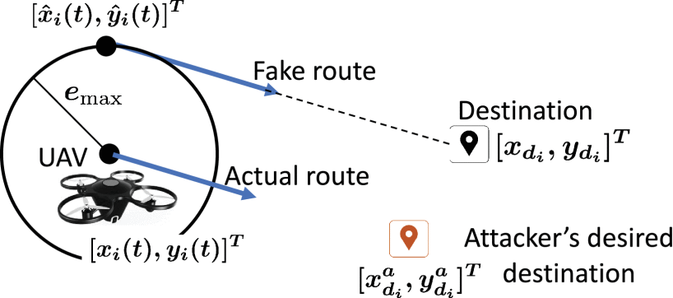
Figure 11: Calculation of Actual and Fake Route

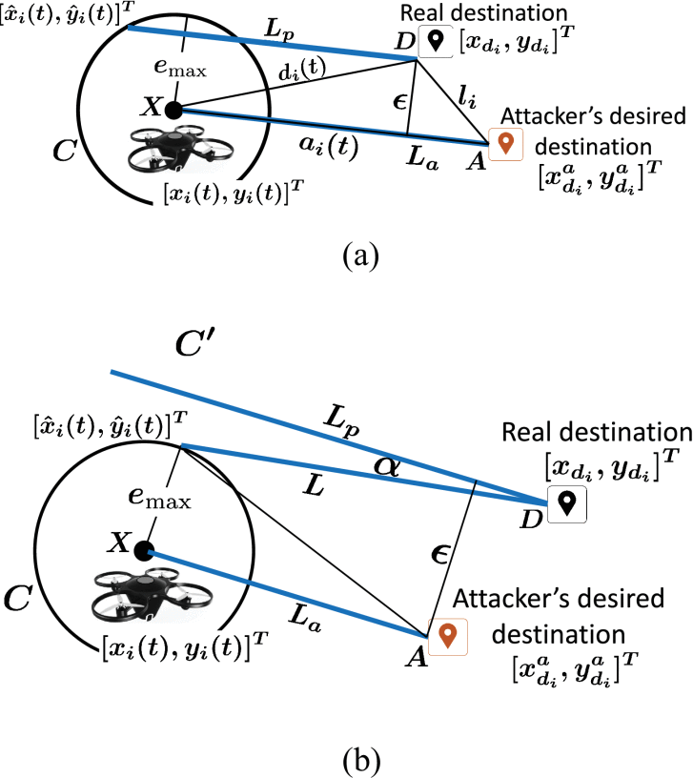

Figure 12: Attacker Guide

The attacker's enforced location won't take the UAV exactly where they want it to go in figure
12. As a result, the attacker may need to place the UAV at more than one spot along its projected course. Theorem 1 can be used to determine each new imposed location regarding the new location of the UAV. Theorem 1 states that the enforced position will be the farthest point in the circle with the same direction once the attacker can guide the UAV in the desired direction. The UAV's deceived route is then examined considering the attacker’s-imposed location.

Open Research Issues in GPS Spoofing Detection Techniques via Cryptography.

The use of cryptography for GPS spoofing detection in Unmanned Aerial Vehicles presents a promising avenue to enhance the security and reliability of navigation systems. Addressing these issues can lead to the development of more secure and reliable navigation systems for UAVs operating in potentially hostile environments.

- Multi-Factor Authentication: Investigating the integration of muliti-factor authentication methods into cryptographic GPS spoofing detection systems. This will boost the involvement of combining cryptographic techniques with other sensor data or authentication mechanisms to enhance overall security.

- Key Management and Distribution: Developing efficient and secure methods for key management and distribution in UAV’s cryptographic systems. UAVs are often resource- constrained and designing lightweight key management protocols is a challenge.

- Threshold Challenge: Exploring threshold cryptography to enhance the security of GPS spoofing detection. Threshold cryptography divides cryptographic keys among multiple UAVs, requiring a certain threshold of them to collaborate to verify the authenticity of GPS signals.

- Secure Time Synchronization: Time stamps in tracking GPS spoofing detection attacks is an essential feature. Accurate time synchronization is essential for GPS signal verification and spoofing detection. The techniques for secure time synchronization among UAVs is tedious based on the available equipment.

- Resilience against Advanced Attacks: There is still lack of knowledge of cryptographic techniques that can withstand sophisticated GPS spoofing attacks. Adversaries might employ advanced methods to manipulate cryptographic protocols and designing systems that can detect and mitigate such attack is crucial.

Inertial Navigation System

An INS uses an IMU made up of multiple inertial sensors, such as magnetometers, gyroscopes, and accelerometers, to help with navigation. The INS-based techniques identify GPS spoofing attempts by cross-validating the reported GPS position using the position inferred from the IMU data. In order to identify spoofing GPS signals, Lee et al. employed a fixed probability of false alarms and the root mean square error between the accelerometer outputs and the acceleration inferred from the GP outputs. The probability density function was used in (Magiera & Katulski, 2021) to make the decision to spoof GPS signals, and the accelerometer data were used to detect those signals. To assess whether a UAV has been taken over by GPS spoofing, Feng et al. employed data from the on-board gyroscopes.

As a result of not relying on any outside signals, the INS has the advantage of being protected from spoofing assaults. The biggest problem with INS, however, is the IMU measurements' accumulating errors over time, which might impair the detection's accuracy.

Open Research Issues in Inertial Navigation Systems

GPS spoofing detection techniques using Inertial Navigation Systems (INS) in commercial UAV have shown promise but there are several open issues and challenges that researchers and practitioners need to address to ensure the robustness and reliability of these techniques. Some of the open issues include:

- Sensor Integration and Fusion: Integrating INS data with other sensors such as GPS, barometers, magnetometers and cameras can improve the accuracy of spoofing detection. However, achieving seamless sensor fusion and handling the complexities of multi-sensor data integration remains a challenge.
- Error Accumulation and Drift: Inertial sensors such as accelerometers and gyroscopes are prone to measurement errors and drift over time. Developing techniques to mitigate the error accumulation and drift in INS, especially in prolonged UAV missions is essential for accurate spoofing detection.
- Multi-Frequency GNSS Receivers: Modern GNSS receivers support multiple frequency bands (L1, L2, L5, etc.). Exploiting the benefits of multi-frequency GNSS data to enhance INS-based spoofing detection is a challenge that requires specialized algorithms.
- Environmental Factors: Environmental conditions such as temperature changes and humidity can affect the performance of inertial sensors. Techniques that adapt to varying environmental factors and maintain accuracy are needed.
- Signal Degradation and GNSS Outages: In scenarios where GPS signals are weak or unavailable (e.g., urban canyons or indoor environments), INS becomes more critical. However, INS may suffer from inaccuracies during extended GNSS outages. Developing methods to reliably detect spoofing during signal degradation is important as its still lacking with the INS approach.

Mobile Cellular Network based Approaches.
A new class of anti-GPS spoofing techniques has recently been developed that uses the mobile cellular networks' capacity to localize the target and distinguish between real and fake GPS positions within the range of the base stations. The work in (Rahman et al., 2021) used a 2G cellular network's base station signals' strength to determine the position of the vehicle. The GPS position of the vehicle is then compared to the estimated position to ensure accuracy. The authors in (Mistry & Dahiya, 2017) employed position estimates derived from data relative to (Sidorov et al., 2020)surrounding cells to verify the accuracy of a smartphone's GPS position. In contrast to the options, the research in looked at the use of data from a 5G network to identify fake UAVs UTM received GPS position reports. The suggested method makes use of the Received Signal Strength (RSS) data gathered from three base stations to determine the trust zone where the GPS position should be situated in order to be taken seriously.

According to (Shrestha et al., 2021), GPS spoofing can detect using intrusion detection systems. They suggest a 5G network security strategy based on UAV and satellite technology that can effectively detect weaknesses and intrusions. The resources needed to achieve the comparison of the different machine learning algorithms are unavailable.

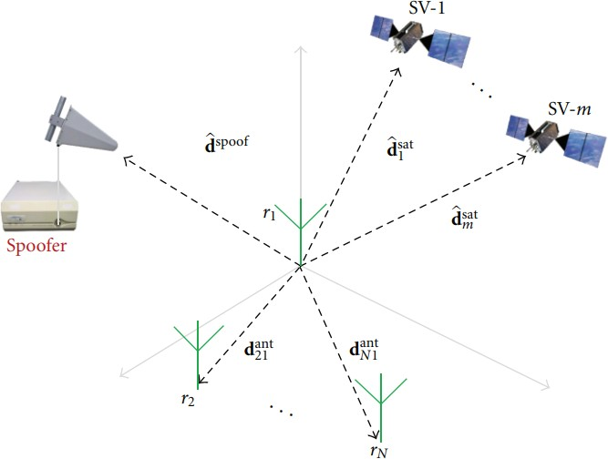

Figure 13:Multi-Antenna Calculation

Table 2: Summary of Works using Traditional Approaches

Feature | Description | Encrypted | Network Based or Standalone | Single or Multi Antenna | Navigation Layer Analysis | GPS Receiver required capability | Limitations
Using a Multi- Antenna Array, a Low- Complexity GPS Spoofing | Estimates the direction in which each spoofing pseudo random noise code is delivered, considering that they all originate from the same  space-based source and steering a null value in that  direction. | × | √ | √ | √ | Multi receiver antennas | Highly interfered with noise

Feature | Description | Encrypted | Network Based or Standalone | Single or Multi Antenna | Navigation Layer Analysis | GPS Receiver required capability | Limitations
Data Bit  Latency Defense | The target  receiver keeps track of the bit lock in the C/A code length and continuously scans for changes in the  data bit sign. | × | √ | × | × | Keeps track  of the bit lock for the C/A code length. | Code  scanning of the generated signal takes long
Joint attitude estimation using antennas | Classifying genuine GNSS signals from spoofing signals using the predicted TOA. | × | √ | √ | × | Array of tiny antenna | Time of Arrival of signals
Vestigial Signal Defense | Verifies whether valid vestige signals are present | × | √ | × | √ | Remove any lingering genuine GPS signals | Expensive equipment

Feature | Description | Encrypted | Network Based or Standalone | Single or Multi Antenna | Navigation Layer Analysis | GPS Receiver required capability | Limitations
Distribution of  correlator output analysis | Identifies if the  distribution of the correlator output significantly differs from the distribution of the original signal. | × | √ | × | √ | Keep an eye  on how the output of the correlator is distributed. | Correlator  analysis distribution analysis easily interferes
GPS signal spoofing detection at the code and carrier tracking levels | Observes the signal lift-off distortion that occurs during intermediate  spoofing assaults | × | √ | × | √ | Need advanced signal processing skills. | Code tracking requires advanced skills
Using absolute signal processing power to spoof | Using a 2dB uncertainty, measures signal power between the average and  maximum levels. | × | √ | × | √ | Absolute received power and noise floor should be able to be  deflated by the receiver. | Deflating in power signal strength
INS GPS  spoofing | Monitors differences  between the | × | √ | × | √ | Installation of IMU sensors  is required. | IMU sensors equipment is  expensive

Feature | Description | Encrypted | Network Based or Standalone | Single or Multi Antenna | Navigation Layer Analysis | GPS Receiver required capability | Limitations
Inertial Navigation System and the
fake GPS.
Monitor relative GPS signal strength | During spoofing assaults, keep an eye out for sudden variations in signal strength | × | √ | × | √ | Signal strength monitoring | Sudden Variations in signal strength
Satellites Signal strength based | Track each satellite's received signal strength | × | √ | × | √ | Signal strength monitoring | Equipment is not accessible
Time Arrival Analysis | Every satellite signal acquisition should be verified for timing gaps. | × | √ | × | √ | Observe the temporal gaps between SV fix times. | Timing gaps analysis requires calculations which might  not take time to come in

Feature | Description | Encrypted | Network Based or Standalone | Single or Multi Antenna | Navigation Layer Analysis | GPS Receiver required capability | Limitations
L1/L2 Power  Level Comparison | Examine the  L1 and L2 bands' power signal differences. | × | √ | × | √ | Receivers  must process L1/L2 bands | Differences in  L1 AND L2  bands
Multi-antenna based | Numerous beam outputs are subjected to GPS correlators in order to identify and pinpoint  spoofer. | × | √ | √ | √ | Multi receiver antennas | Failure to identify pinpoint spoofer
Using digital signatures to fake GPS | Transmission of a created digital key | √ | √ | × | √ | GPS IS  modification: L1C Data Channel Spreading Code | Fake digital key signatures

Feature | Description | Encrypted | Network Based or Standalone | Single or Multi Antenna | Navigation Layer Analysis | GPS Receiver required capability | Limitations
GPS spoofing  based on navigation message authentication | GPS  commercial navigation message insertion of a public key digital signature | √ | √ | × | √ | 2 New CNAV  Messages are a GPS  modification. | Tap in  message delivery
Received Ephemeris Consistency Check | Ephemeris data from several satellites that have been derived have  contradictions | × | √ | × | × | Keep track of and contrast ephemeris | Data contradictions from Ephemeris

Machine Learning Techniques

The recent trend of utilizing ML approaches for GPS spoofing detection in UAV contexts is motivated by the potential of ML to learn from past data to reveal hidden patterns. In this vein, various ML techniques have been put forth to identify GPS spoofing either by directly classifying the faked GPS signal (Zhang et al., 2019) or by supplementally confirming the GPS information (Xue et al., ). While the GPS information verification methods utilize ML- based location recognition techniques to establish the veracity of the GPS locations, the GPS signal classification methods use ML classifier approaches to distinguish between the false GPS signal and the real GPS signal. In this thesis, the machine learning approaches put into consideration include: Support Vector Machine, Random Forest, Logistic Regression, XGBOOST and Decision Trees.

Support Vector Machine

The support vector machine algorithm was first proposed in the work of (Panice et al., Sep 2017). In their work, the GPS spoofed signals were classified in two groups of anomaly and normally signals. The trained and validated sets of data with signals had a standard of the characteristics of selection. With this approach, the classification of false positives s an increase. Detection and accuracy with the use of this approach is still an open problem as misclassification is highly possible. In order to assess the functionality and efficiency of One Class SVM applied to navigation data, a detection system and a simulation environment for GPS spoofing assaults were constructed in this study (Shrestha et al., 2021). This approach enables you to assess missed detection likelihood, which is crucial for aviation applications. This strategy differs from the others in that it may be installed on small UAVs without the need for additional gear. On the other side, it was shown that the spoofer will be able to avoid detection by the system while causing significant location inaccuracies provided, they have complete information of the user's trajectory. However, it was demonstrated that the danger was negligibly small, implying that the system can identify any spoofing attempt, however this was because the real trajectory was unknown. The system also performs similarly to traditional systems (RAIM), even though the fusion algorithm (Shrestha et al., 2021) is intimately tied to it, which causes it to degrade more quickly than the others. On the other hand, if the aeroplane has additional sensors (such a magnetometer), the proposed technique might perform better and offer more features.

Spoofing occurs by injecting fake signals into the sensors (Shafique et al., 2021). In their work, they propose a methodology by incorporating a machine learning algorithm such as Support Vector Machine. A detailed analysis of several learning algorithms is also carried out to choose the suitable learning algorithm for the proposed work. Once the suitable ML algorithm is selected, we perform K-fold analyses to develop other learning models by choosing different values of K-folds thus we called them K-learning models (Zhao et al., 2022) . The purpose of developing K-learning models is to apply voting techniques to the developed K-learning models. Moreover, the signal features used in the proposed work are jitter, jitter (absolute), jitter (local), jitter (RAP), jitter (ppq5), shimmer, shimmer (local), shimmer (dB), shimmer (apq3), shimmer (apq5) and frequency modulation. Based on these features of the signal, we train our proposed model for the detection of counterfeit GPS signals (Talaei Khoei et al., 2022). To gauge the performance of the proposed model, they performed different experimentation analyses such as accuracy, precision, recall, and F1-score. The results and analysis show the effectiveness of the proposed work over existing techniques. deployed in order to select a suitable classification algorithm. To achieve the desired task, we have used

GPS signal characteristics as features. Based on the feature specifications, the proposed model detects whether the signal is sent by the attacker or a legitimate entity.

Advancedly, the authors in (S. Semanjski et al., 2019) presented an approach of monitoring the cross-correlation of multiple GPS observables and measurements as an input for supervised machine learning based approach to detect potentially spoofed GPS signals. The three synthetic spoofing datasets were combined for the SVM, and the effects of the most deliberate clock drift modification values on classification were looked at. For this test, one of three datasets with a time-pulling attack rate of 0.3 ns/s was specifically chosen. In this dataset, the spoofer's clock drift in relation to the real signal was just 0.3 ns/s, or 0.3 ppb (0.0003 ppm), which is near to the oscillator's Allan deviation and less than the noise on the clock drift. In this instance, spoofing detection that relies on clock drift observation as the independent variable would not be feasible (despite being observable in its C/N0, which is much too regular for a "real" signal, due to a systematic succession of positive and negative interference between the spoofer and the genuine signal). As the fake chip distances itself from the real chip, the amplitude gradually drops. Correlation results demonstrate that, even at this level of clock drift manipulation, it is still possible to classify fake and real signal variables.

In the work of (Aissou et al., Jan 26, 2022), the authors compared the performance of five instance-based learning models for GPS spoofing attack detection in terms of accuracy, probability of detection, chance of false detection, probability of false alert, processing time, and memory size. They extracted features from acquired commercial GPS data in real time. Spoofing attacks were simulated using attack signatures obtained from information. Then, for each sort of spoofing assault (basic, medium, and sophisticated spoofing attack), they choose the relevant attributes. The simulation results demonstrated that the Nu-SVM outperforms the other learning models across all assessment criteria, with a chance of misdetection of 8.73%, which is a moderate outcome in the cybersecurity sector. This misdetection rate was due to sophisticated attacks being perfectly synchronised and adjusted with real GPS signals. The Nu- SVM is also proven to be faster and utilise less memory during the detection phase than the other versions.

The model in question shows the detection accuracy and probability of the specified ML models is the source of the performance. Because the Nu-SVM uses the "nu" parameter, which limits the amount of support vectors, it narrowly exceeded the C-SVM with an accuracy of 92.78% and a chance of detection of 91.26%. Because they use 5th degree polynomial kernels to resize the data into higher dimensional relationships. The Nu-SVM and C-SVM beat the linear SVM and the distance-based models. The linear SVM has the worst performance in terms of the two metrics as it is based on linear kernel function kernel which results in a rough estimation. In terms of probability of misdetection and probability of false alarm, the C-SVM and Nu-SVM show good performance results, with a probability of misdetection of 11.13% and 8.73% respectively. This misdetection rate is the result of undetected sophisticated attacks affecting slightly the correlator amplitude, which is naturally varying in response to satellite and receiver motion. Only a severe distortion in the correlators’ function or a large quadrature accumulation shift is detected correctly as a result of a spoofing attack. However, the Radius Neighbour, Linear SVM, and KNN have very low-performance results with a probability of miss detection of 58.29%, 37.91%, and 29.24% respectively. This high misdetection probability indicates that the system has not been able to detect attacks, particularly intermediate and advanced attempts. With a chance of miss detection of 58.29%, 37.91%, and 29.24%, respectively, the Radius Neighbour, Linear SVM, and KNN exhibit very poor

performance outcomes. This high misdetection probability indicates that the system has not been able to detect attacks, particularly intermediate and advanced attempts.

Convolutional Neural Network
(Kiranyaz et al., 2021) states that their study suggests a spoofing technique based on deep learning and outfitted with a 1D convolutional neural network. The suggested approach is portable and low power, allowing for real-time detection on mobile devices. Furthermore, by boosting training data and changing the network design, our approach's performance can be improved. We assessed the power use and inference time of our algorithm on a drone's embedded board. The proposed method outperformed the support vector machine in terms of precision, recall, and F-1 score. The method was effectively able to detect GPS spoofing assaults in a flight test.

(Dang et al., 2022) The approaches for detecting GPS spoofing on unmanned aerial systems using CNN and transfer learning were introduced in this research. By comparing the difference between theoretical and actual path losses at the base station, the CNN model installed on the edge server enables the verification of UAV locations. Convolutional layers can then extract deep features from the path loss differences, which are then used by fully connected multilayers to detect GPS spoofing. A further reduction in CNN training time and an improvement in CNN detection accuracy are achieved with the application of the transfer learning method. With transfer learning, the simulation results demonstrate the great efficiency of our suggested approach in identifying fake GPS positions with a rate of above 88%. We want to test the effectiveness of the suggested method in the future using a UAV and many 5G BSs as part of a real-world experimentation testbed.

(Borhani-Darian et al., 2020) identifies GPS spoofing threats using deep learning techniques. The three deep learning techniques chosen are MLP, simple-CNN, and complex-CNN. Three convolution layers and three fully connected layers are the basic building blocks of a CNN. 13 convolutional layers and 3 fully connected layers make up the construction of a complicated CNN. All three approaches rely on the ReLU activation function. The methods that have been put into practise use optimizers called stochastic gradient descent with momentum (SGDM) and adaptive moment estimation (Adam). The training procedure makes use of 10,000 artificially produced samples. The complex-CNN has produced better outcomes, according to experiments that have been conducted. In addition, each technique has yielded better Adam Optimizer accuracy. Compared to other programmes, MLP has had subpar performance.

(Abdullayeva & Valikhanli, 2022) a claim that a solution for detecting GPS spoofing attempts is put forth that is CNN-based. The study of log files that the UAV recorded throughout the flight is the foundation of the suggested method. Since the dataset contains known instances of the classes (normal and GPS spoofing), supervised machine learning is employed for detection. The suggested approach makes use of Adam as an optimizer and ReLU and Sigmoid as activation functions. Despite the suggested method's great accuracy, there are situations when detection may not be possible. This is brought on by the ongoing development of fresh forms of GPS spoofing assaults. It is preferable to use additional techniques in addition to machine learning and deep learning to produce a better detecting system. Thus, if one approach is unsuccessful, others will still offer the detections.

Long Short-Term Memory

In the work of (R. Calvo-Palomino et al., 2020) the authors suggested developing a GNSS spoofing detection system that could be used with spectrum sensors that had software-defined ratio (SDR) capabilities and less expensive hardware. In order to identify the presence of anomalies or malicious attackers, the approach takes advantage of the predictability of the Doppler characteristics of the received GPS signals. The outcome of their technique allows for extremely accurate Doppler shift prediction of GPS signals as well as the identification of spoofing transmitters (Demars et al., 2018) . The algorithm can spot static spoofers with Doppler shift variations larger than 4 Hz and mobile spoofing devices at higher speeds of 2.5 km/h. It can also spot GPS abnormalities by examining the signal flaws.

According to (Meng et al., 2021) discussion the detection model of UAV anti-GPS spoofing and proposes the linear regression spoofing model underlaying on an LSTM algorithm. The flight trajectory prediction model of UAV is obtained by fitting the flight log of UAV with LR model, and the prediction accuracy is relatively high among all the methods. The model not only realizes the safety detection of UAV flight status in the process of mission but also uses the decision fusion of sensor information to accurately detect the deception signal, to achieve the purpose of anti-spoofing interference. At the same time, when the UAV is cheated, it can also achieve deception mitigation, to ensure the smooth completion of the flight mission (Zhi et al., 2020). This method differs from conventional anti-spoofing detection techniques or those based on neural networks in that it not only has high accuracy and doesn't necessitate the purchase of more expensive auxiliary equipment, but also has a quick linear regression modelling speed and doesn't necessitate the use of a small computing board carried by a UAV with high computing power. Basically, the LR anti-spoofing model may successfully produce the impact of anti-GPS spoofing in the scene of UAV flying.

Similarly in the work of (S. Wang et al., 2020) they proposed LSTM. In order to improve the detection ratio of GPS spoofing attacks, they fly the UAVs according to the path specific shape to accurately detect the attack. This in turn helps to achieve detection accuracy in a short time. The detection rate of accuracy is 78% as the benchmark used in the evaluation metrics. The method only utilizes the sensor equipment of the UAV itself except the GPS. The downside caused the flow of the algorithm is that there will an error rate when the flight path of UAV is too complex, the flight trajectory of UAV which determines the terminal point in actual flight becomes so complicated. Standard long short-term memory (LSTM)-based models are widely used for sequence modelling due to its long-term memory, yet they are unable to fully model the relationship between extracting crucial co-occurrence features from different levels (S. Xu et al., 2021). To handle this shortcoming, we propose an attention-based multilevel co- occurrence graph convolutional LSTM (AMCGC-LSTM). By integrating graph convolutional networks (GCNs) into LSTM which requires high equipment for implementation

According to (Agyapong et al., Dec 05, 2021), they created two different kinds of detectors: an LSTM autoencoder-based one class classifier (OCC) and a Long Short-Term Memory (LSTM) binary classifier. They contrasted two variants for each type: a UAV-specific detector that is tailored for various UAV types and a UAV-generalized detector that can operate with any model of UAV. In simulation, they evaluated and contrasted the effectiveness of the detection models. Using IntelR NCS2, hardware validation tests were also conducted. The findings for the binary classifier showed a detection accuracy of 97.79% for the UAV- generalized detector and up to 99.56% for the UAV-model-specific detector. In contrast, the OCC yields 94.98% for the UAV-generalized detector and up to 99.24% for the UAV-model-

specific detector. On the downside of this model is that the autoencoders for specificity used with the processing time take a lot of time. Processing time is lag with a lot of epochs in question.

(Xiao et al., May 2019) using the Gazebo simulator as the simulation platform, we offered a benchmark telemetry dataset in this study that was derived from UAV flights. In order to emulate drones in both SITL and HITL modes, we used PX4 Autopilot firmware. Using the QGroundControl App, we organised and carried out mission flights. In order to gather malicious data, GPS spoofing was used during some missions, but not during others, which were benign. We train a variety of deep learning models using this information. We also evaluated the inference time to confirm the overhead the models on IntelR NCS2 imposed. The outcomes demonstrate the models' ability to identify deviations brought on by GPS spoofing with competitive accuracy and minimal overhead. Through this effort, it will be possible to identify GPS spoofing attempts using telemetry data that is readily available during flight operations. Future work will include making suggestions for efficient ways to react when a GPS spoofing assault is discovered.

In the work of (Khoei et al., 2023) provide three supervised deep learning algorithms in this paper—Deep Neural Network, U Neural Network, and Long Short-Term Memory—to close this gap. Evaluation criteria for these models include accuracy, detection rate, misdetection rate, false alarm rate, training time per sample, prediction time, and memory size. With an accuracy of 98.80%, a probability of detection of 98.85%, a misdetection rate of 1.15%, a false alarm rate of 1.8%, a training time per sample of 0.22 seconds, a prediction time of 0.2 seconds, and a memory size of 199.87 MiB, the simulation results showed that the U Neural Network outperforms other models. Additionally, these data showed that the Long Short Term Memory model performs the least well for identifying these attacks on UAVs. In (S. Wang et al., 2020), The authors also suggested the LSTM supervised DL model, which uses this DL model to monitor the obtained PVT data from the GPS signal. In (Xue et al., ), To detect GPS spoofing assaults using the satellite imagery matching method, the authors utilised a supervised CNN- based model called Residual Neural Network. The performance of the DL-based detection techniques mentioned above has improved as compared to ML-based detection techniques, particularly in terms of lowering the false alarm rate. However, they continue to have a significant percentage of false positives. Many factors can contribute to this, including the difficulty of the detection task, the quantity and quality of training data, and the unique architecture and hyperparameters of the DL models. Artificial neural network (ANN), convolutional neural network (CNN), and recurrent neural network (RNN)-based models are the three categories into which DL-supervised learning models are divided in this research. These models are chosen to train, test, and validate the given data, respectively, from each of the categories: Deep Neural Network (DNN), U Neural Network (U-Net), and Long Short- Term Memory (LSTM). Additionally, we assessed the models' precision, detection rate, misdetection rate, and false alarm rate. In order to address the problem of taking SWaP into consideration, the article additionally includes the Training Time per Sample, Prediction Time, and Memory Size to the assessment criteria.

Recurrent Neural Network

The applicability of neural network is a new block technique on the market. In the work of (M.
R. Manesh et al., 2019b) they proposed a supervised machine learning method based on the recurrent neural network to detect GPS spoofing signals. The data collection was done using real GPS signals received from a software-defined radio. The signals were received using the

RTL-SDR V.3 RTL2832U. The antenna used was an active GPS SMA antenna. The software used was open source gnsssdrgui.exe and open source rtknavi.exe. There are three main steps to receiving data: configure, enable antenna, and enable software. The RTL-SDR was set up with a centre frequency of 1575.42 MHz, sampling frequency of 2.048 MHz for the I/Q signals and looking for all GPS satellites. Different features such as pseudo range, Doppler shift, and signal to-noise ratio (SNR) are used to perform the classification of GPS signals. They examined and compared the efficiency of one- and two hidden-layer neural networks with various numbers of hidden neurons. The results showed that the proposed method provides a high probability of detection and a low probability of false alarm.

Random Forest

(Shoufan, Oct 2017) establishes a method for the continual authentication of flight data based on the actions of the UAV operator who controls the aircraft manually. The advantage of this method over one-time authentication is that it enables real-time detection of malicious commands intended to control, hijack, or crash the UAV. The drone's flight commands are given in order using a typical radio control transmitter, and this determines how the operator will behave. This is predicated on the presumption that each UAV operator has a unique pattern for manipulating a UAV with a transmitter's levers or joysticks. We recorded 22,402 orders from five separate operators who used a small multicopper UAV and a typical flight transmitter to confirm this presumption. A random forest classifier was trained using machine learning. The findings indicate that in a 10-tree setup, the UAV operators can be recognised with an accuracy of 88%. Once more, this is a fascinating issue that merits more research in order to determine the ideal number of features a minimal set of features that does not materially impair classification accuracy.

Reducing the feature set is crucial since it might significantly aid in reducing the size of random forest trees, allowing for more effective implementations of onboard classifiers. The following arguments suggest that behavioural analysis of UAV flight data is a very promising strategy. The transmitter signals from the flight data are first recorded. This implies that the methodology is somewhat flexible and not wholly dependent on the specific type of UAV employed in this study. To put it another way, different UAVs can be controlled by the same transmitter. Naturally, how a UAV responds affects how an operator controls it. This does not, however, imply that the way a UAV operator uses the transmitter's sticks will vary in reaction to the UAV's response. Second, the status of the drone as given by the motion sensors on the drone might be added to the feature set or even taken only into consideration in the data analysis. However, this might result in a significant security problem: Relying on sensor data to detect malicious behaviour implies that harmful directives have already been sent to the onboard flight controller and have had an impact. The security level backed by the proposed technique, which screens out malicious commands before they reach the flight controller, would be significantly weakened as a result.

In the work of (Aissou et al., Dec 01, 2021), in order to choose the best model for UAV, the study suggested comparing several tree-based machine learning models for detecting GPS spoofing attempts. RF, Gradient Boost, XGBoost, and LightGBM are the models that were implemented. The findings demonstrate that in less than 22 milliseconds, all models can efficiently identify GPS spoofing assaults. However, the accuracy, detection speed, and memory size of XGBoost's performance outperform those of the other models. Given the Size, Weight, and Power (SWaP) criteria, this model is appropriate for UAV because it performs three times faster and uses two times less memory during the detection phase than the other

models. Random Forest was used as a comparison model, though XGBoost was outperforming the rest of the models, the downside to the model is that tree selection used as features require a lot of trimming.

Open Research Issues in GPS Spoofing Detection Techniques via Machine Learning.

GPS spoofing is intensely relying on deliberate manipulation of GPS signals to deceive a GPS receiver’s location estimation. The development of detection techniques for GPS spoofing in UAVs is a very challenging task as the overall performance is influenced by the failure of sensor activities due to their hardware constraints, environmental conditions, mode switch limitation in location. The field of GPS spoofing in Unmanned Aerial Vehicles (UAVs) using machine learning techniques is an area of active research with several open issues that researchers are exploring. The following are some of the open research issues in this domain.

- Feature Engineering: Feature selection and engineering are crucial for the effectiveness of machine learning models in detecting GPS spoofing. Identifying relevant features from raw GPS data and incorporating auxiliary sensor data helps to

improve the accuracy of detection. This is a very highly tasking task and takes wholesome knowledge.

- Real-time Detection: Real-time detection of GPS spoofing attacks in UAVs is critical for preventing potential disasters. Research needs to focus on developing efficient and low-latency machine learning models that can quickly detect spoofing attempts. UAVs spoofing hardware operates better to capture real-time GPS spoofing attacks in open space meaning real-time attacks within a building cannot be detected.

- Energy Efficiency: UAVs often operate limited energy resources. Developing energy- efficient machine learning algorithms for GPS spoofing detection is essential to minimize the impact on UAV operation.

- Online Learning: Investigating online learning approaches that can adopt and update the detection model in real-time as new data becomes available is an important aspect. This helps the model to remain effective against evolving attack strategies. The challenge for the switch in states from online to offline and vice versa gives adversaries and lee way for attack.

- Multi-Sensor Fusion: Integrating data from multiple sensors, such as accelerometers, gyroscopes and magnetometers along with GPS enhances the resilience of detection systems against GPS spoofing attacks. The challenge is the hardware implementation as it is very costly and expensive.

An overview of the previous works for GPS spoofing detection via machine learning techniques is presented in table… Our extensive investigation has included the most common and generic promising features and areas of an inclusive GPS spoofing detection mechanism in UAVs. This table compares the features of different works in related literature and discusses their pros and cons. This comparison has been made to justify the demand for extra features exposing the fragility of the existing ones to perform better as a whole.

Table 3: Summary of Works in Machine Learning-Based for GPS Spoofing Detection Techniques in UAVs

Author | Approach | Category | Hardware Equipment Cost Analysis | Sensor  Configuratio n | Data Rate | Detection Accuracy | Advantages | Limitations
(M. R.  Manesh et al., 2019b) | Artificial Neural Network- based | Artificial Intellige nce | Affordable | Highly Required | High | High | - Provides an accuracy of 98.3%, a probability of detection of 99.2%, a probability of misdetection of 2.6% and a probability of false alarm of  0.8% | - Uses a dataset with only 5 features
(Meng et al., 2021) | Linear regression- based and long-short term memory | Machine Learning | Affordable | Not a requirement | Mediu m | Low | - Works effectively in a case of UAV flying along the specified route | - Lack of optimization methods from the perspective of UAV sensor integrated navigation and UAV altitude  control.

Author | Approach | Category | Hardware Equipment Cost Analysis | Sensor  Configuratio n | Data Rate | Detection Accuracy | Advantages | Limitations
(Majidi  et al., 2020) | Prediction-  discrepancy based | Machine  Learning | Expensive | Not a  requirement | Low | Low | - Reduces the  effects of spoofing errors and estimates the true position of the UAV in the presence of  GPS Spoofing attacks. | - Evaluated  only based on accuracy and redundancy
 | RNN
(E.  Schmidt et al., 2020) | Least Absolute Shrinkage and Selection Operator | Deep Learning | Expensive | Highly Required | High | Medium | - Provides a 0.3% detection error rate for a spoofing attack in nominal signal-to-noise ratio conditions and an authentic-over- spoofer power of 3 dB | - Uses a public old dataset, namely, Texas spoofing test battery as benchmark  - Lack of using common evaluation metrics, such as the  probability of misdetection.

Author | Approach | Category | Hardware Equipment Cost Analysis | Sensor  Configuratio n | Data Rate | Detection Accuracy | Advantages | Limitations
(A.  Shafique et al., 2021) | K-Learning  based | Machine  Learning | Expensive | Not a  requirement | Mediu  m | High | - Provides an  accuracy of 99%, a  precision of 98%, a recall of 99%, and F-  score of 98% | - Uses only  Shimmer and Jitter as features in the dataset.
(Yoon et al., 2019) | Resilient State Estimation | Machine Learning | Expensive | Not a requirement | Mediu m | Low | Addresses the sensor drift problem. | - Evaluated only based on estimated error and statistics of  attacks
(Panice et al., Sep 2017) | Support Vector Machine | Machine Learning | Affordable | Highly required | High | Medium | - Improves the performance in case of using magnetometer sensors. | • Performance degradation during long attacks
(Y.  Dang et al.,  2020) | 5G- assisted position monitoring | Machine Learning | Expensive | Highly required | High | High | - A detection rate of 95% and F1-score  of 88% | - Lack of several evaluation  metrics

Author | Approach | Category | Hardware Equipment Cost Analysis | Sensor  Configuratio n | Data Rate | Detection Accuracy | Advantages | Limitations
(M. R.  Manesh et al., 2019b) | Long-Short  Term Memory | Deep  Learning | Affordable | Highly  required | High | Low | - A  comprehensive comparison with encryption- based detection techniques in terms of detection rate and time cost. | - Detection  rate of 78%and a time cost of 3s.  - Detection rate is high when the flight trajectory is not  complicated.
(Feng et al., 2020) | XGBoost | Machine Learning | Expensive | Not a requirement | Mediu m | High | - Extensive study of different learning parameters training onboard  - Detection rate of 96.3% | - The proposed method can only detect attacks with similar behaviors during training.  - Uses published  sensor data.

Author | Approach | Category | Hardware Equipment Cost Analysis | Sensor  Configuratio n | Data Rate | Detection Accuracy | Advantages | Limitations
(Dang et  al., Oct 2021) | Multi-Layer  Perception | Deep  Learning | Expensive | Not a  requirement | Mediu  m | Medium | - Accuracy rate  that is above 93% with three base stations and can reach 80% with only  one base station | - The data  collected from a real- world classification does not fit  ensemble methods
(Aissou et al., Jan 26,  2022) | Nu-SVM | Machine Learning | Affordable | Highly Required | High |  | - Detection rate is very based on the speed | - The parameters required are very limited
(Aissou et al., Jan 26,  2022) | LightGBM | Machine Learning | Affordable | Highly Required | Low |  | - The optimization model used is accurate | - Not in selection of all the parameters
(Diao et al., 2020) | Signal Noise Ratio | Deep Learning | Affordable | Highly Required | High |  | - Detection ratio is high | - The signals are dependent on noise and environmenta  l limiting

Summary
Addressing open issues requires interdisciplinary collaboration between experts in signal processing, machine learning, cybersecurity policies to encapsulate the UAV technology. As the UAV landscape evolves and GPS spoofing techniques become more advanced, continuous research and innovation are crucial to ensuring the security and integrity of UAV operations. This chapter examines the research that has already been done on several GPS spoofing detection techniques for commercial UAVs and emphasises the importance of real-world problems and difficulties. The study highlights the paucity of attention given to machine learning techniques based on literature that can be used to spoof GPS signals. There are opportunities for the exploitation of the GPS spoofing detection machine learning based solutions. Whereas cryptography or inertial navigation-based systems are individually hindered by extensive implementation cost, dwelt mathematical calculations, fluctuating requirements, and delayed accurate signal detection. In order to develop a foundation for a real-time GPS detection system, this chapter compares the previous studies from several perspectives. We also think that choosing affordable hardware and software can help to curb down GPS spoofing significantly.

Introduction
CHAPTER 3 METHODOLOGY

The significant research efforts to enhance the detection of GPS spoofing in UAVs were summarised in Chapter 2's general section. The creation of a real-time, precise, and inexpensive machine learning model for GPS spoofing in commercial UAVs is the specific topic of this thesis (based on hardware). Due to their high hardware and software costs and cyclical changes in the necessary requirements, the current detection models are compromised. The increased use of commercial drones in numerous industries justifies the need to strengthen cybersecurity. On the other hand, it is yet unknown which machine learning model performs better in terms of metric evaluation and can be used in practise as opposed to only in theory.
The goal of this study is to develop a general framework for GPS spoofing for commercial drones with the least expensive hardware and software by investigating and analysing the current works through a thorough literature review in Phase 1. Following the discovery of the solution's bounds with the use of this general framework, we move on to filling in the literature's gaps. Figure 14 methodology flowchart serves as an illustration of the model that was created to verify the suggested thesis. This stage allows us to establish the thesis's goals and objectives.
By considering the accessibility of the tools required for GPS spoofing, phase two design and development of the system addresses the shortcomings of earlier studies. Three distinct objectives are accomplished by the system's design and implementation. The first suggestion made in this thesis is to employ a machine learning algorithm to adjust to the growing need for arguments in favour of UAVs' technological improvement. This study suggests a precise machine learning model that meets the requirements for the gaol while still passing all other necessary criteria. In comparison to network-based systems, cryptography-based systems, and inertial navigation systems, the suggested system is anticipated to perform better. Next, a machine learning method with low epochs is suggested in comparison to others.

Development Phase |  | Outputs
Literature Review process on GPS Spoofing Detection Techniques  Literature  Review on Divulge Research Gap Analysis Literature  GPS Spoofing for Real-Time GPS Spoofing Review on GPS Detection via Techniques via ML Algorithms Spoofing  ML Detection  Algorithms Techniques Framework for Real-Time GPS using Real-Time Spoofing Techniques via ML Strategies  Phase 1: Literature Algorithms  Survey and problem  statement  recognition Define boundaries of the Solution |  | - Significance of the Project  - Aim and Objectives  - Problem Statement  - Research Gaps  - Research Scope

Phase 2: System design & implementation
Phase 4: Results and Summary
Evaluation of ML algorithms results
Implementation
System design for proposed strategy

- System Design
- Implementation
- Network Architecture

Experiment & Analysis

Phase 3: Validation of Research
NO
Validation

- System Design
- System Architecture
- Testbed and Simulation
- Implementation of GPS Data Collection
- Algorithm Flow for Machine Learning



YES
Expected Solutions for Real-time ML

    - Components for Result Extraction using ML Algorithms
Comparison of best performing ML algorithm
- Algorithms Performance
- Validation of Algorithm Performance
Conclusion, Recommendations & Future Remarks
- Future Recommendations

Figure 14: Flowchart of the Methodology

The thesis validates the proposed system in phase 3 through analytical cost of affordable hardware equipment that is used to collect the GPS spoofed signals, and numerical simulation of machine learning models. Finally, phase 4 discusses the results of the different machine learning models encapsulating a set of yard sticks such as model metrics are used in performance validation. Voting of the best algorithm is chosen with guidance of detecting accurately the spoofed GPS signals. Presentation of mitigation strategies are outlaid concluding with future recommendations.

Generic Framework of GPS Spoofing in UAVs

Detecting GPS spoofing in Unmanned Aerial Vehicles (UAVs) is crucial for ensuring their safe and reliable operation. GPS spoofing occurs when malicious actors manipulate the GPS signals received by UAV causing it to misinterpret its location and potentially leading to unsafe or unintended behaviour. Figure 15 depicts the path fabrication how a fake GPS signal is sent from the ground station to the UAV, since by nature UAVs are designed to follow orders, they take the fabricated signal sent by the attacker. Most of the previously mentioned works in chapter two require expensive hardware and software requirements for implementation of GPS spoofing. This section presents the hardware and software equipment used which is accessible and affordable in collection of real-time GPS signals from multiple satellites. Machine learning algorithms flow are presented considering all the issues and challenges from the other algorithms based on literature.

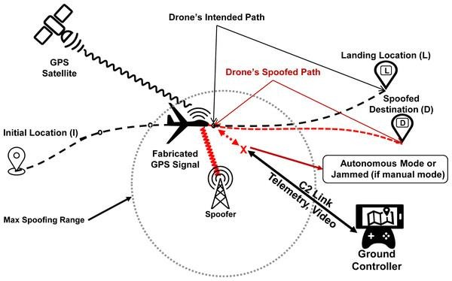

Figure 15: Generic Framework

System Components

The system project must consider all probable situations, whether they be meteorological or human, in response to the needs specified above in all real-world difficulties and solutions. Detecting GPS spoofing in UAVs involves a combination of hardware and software components to ensure accurate and reliable detection and response. The system integrates key essential features for the collection of GPS signals from multiple satellites which are: GLONASS, BeiDou, Galileo to be specific. The hardware components used are discussed briefly with a proposed system in figure 21 and the actual set up with the different components in figure 22. The system components include: HackRF (GPS Spoofer), GPS Antenna, GPS Receiver, GPS Simulator (GNSS), UAV.

GPS Spoofer HackRF

A Software Defined Radio (SDR) peripheral cable known as the HackRF one is used for radio frequency signal transmission, receiving, or manipulation of signals from 1MHz to 6HZ. Conceived to facilitate the testing and development of contemporary and next-generation radio technology. For standalone operations, a USB accessory was utilised in conjunction with the open-source hardware platform known as HackRF. In essence, a software-defined radio is a radio communication device that uses software rather than the commonly used hardware (mixers, amps, and modulators). Using SDR, radio waveforms are subjected to digital signal processing. It is comparable to the software-based digital audio solutions that have been around for a while. Software radio peripherals digitise radio waveforms similarly to how a sound card in a computer digitises audio waveforms and radio waveforms. HackRF acted in just a way that it’s an enclosure of SDR.

The software (GPS-SDR-SIM. 2023)was used to access the entry used for the configuration. It was created in Japan, and it provides data streams in the GPS utilisation band that can then be translated to RF using HackRF, which is software defined radio in this circumstance. The access point for a release file was (GPS-SDR-SIM. 2023), and the additional configuration is done using visual studio done on a Windows system. The software needs the constellation of GPS satellites via a GPS emission ephemeris file in order to produce the required signals. The latest daily GPS broadcast ephemeris file (brdc) is created by combining the navigation data of many sites into a single file. This sort of file is required to produce the aforementioned pseudorange and the simulated Doppler for the GPS satellites visible. Following that, the digitalized I/Q samples for the GPS to broadcast from HackRF are created using this simulated range data. Access was made to the ephemeris files through(NASA, 2023)

Using hackrf_tranfer.exe, a programme built from the source code of the HackRF device, we can communicate with the HackRF device from our Windows PC and transfer the created file (Blum Josh, 2020). Figure 16 depicts the hardware equipment of the HackRF with a peripherical USB connected to the computer.

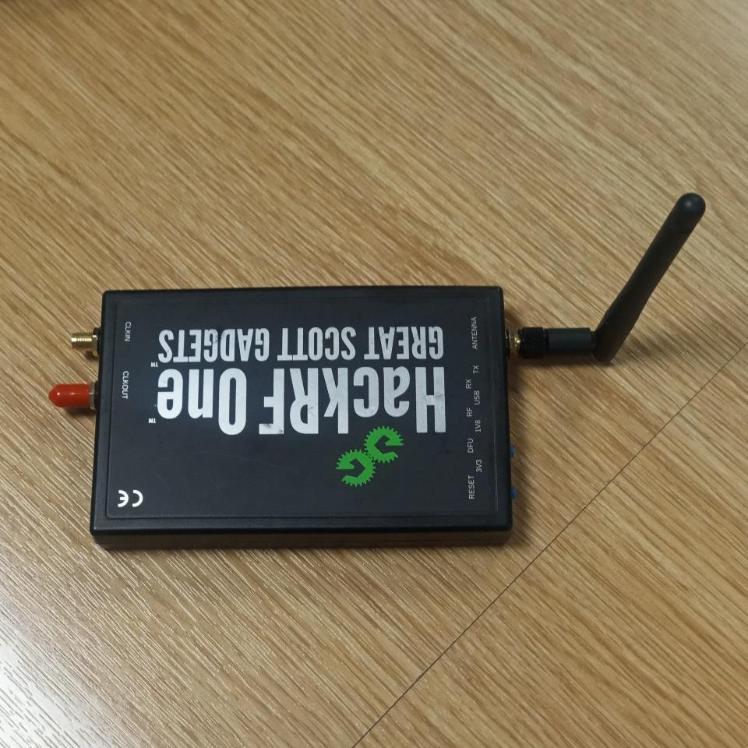
Antenna

GPS Antenna
Figure 16: Outlook for HackRF

There is a connected antenna on the HackRF that helps in the transmission of the GPS signals both authentic and spoofed.

GPS Receiver (VK-162)

VK-162 GMOUSE USB External GPS Navigation Module (u-blox) (u-center, 2023)is an external GPS receiver dongle for computers and Raspberry PI seen in figure 17. It can support google earth platform under the Window and Linux family, but not the operating systems for Android and iOS. This GPS receiver can be used as a standalone GPS receiver and is a small, inexpensive module with great accuracy and sensitivity. This module can be plugged into any USB port on a PC and used immediately to receive GPS data in the Standard NMEA Protocol format without the need for installation. The American GPS satellite, the European Galileo satellite, and the SBAS (WAAS, EGNOS, MSAS, GAGAN) satellite can all transmit GPS signals to it.

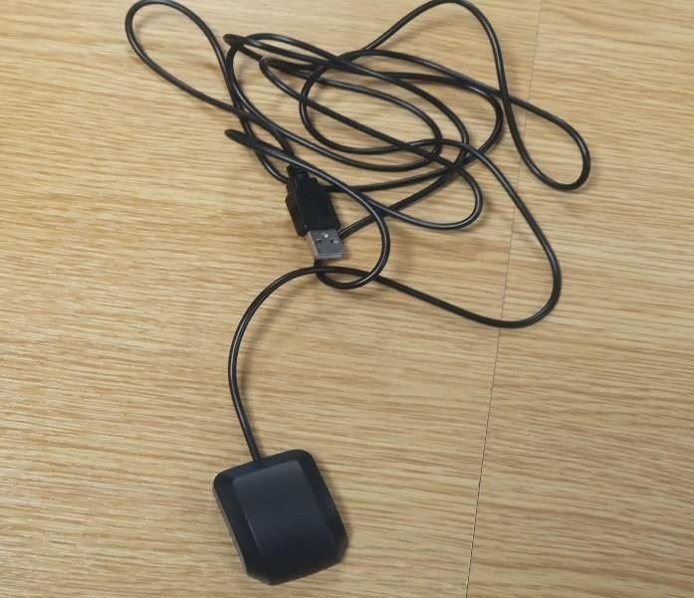

Figure 17: Outlook for GPS Receiver (VK-162)

In order to acquire a clear anti-interference picture of the cosmos, the bottom casing of the tiny GPS receiver has a magnetic plate that may be attached to ferrous surfaces like car roofs and boot roofs. The satellite signal can be picked up by the G-Mouse GPS.

Table 4: Description Considerations of GPS Receiver

Chipset properties: | Positioning performance: | Electrical properties: | Temperature | Protocol: | Dimensions:
Main chip: u-blox | 5m [average] in 2D plane | Tracking sensitivity: - 162dBm | Operating: - 40°C ~ 80°C | NMEA  0183 is the default GPS  protocol. | USB Cable length: 2m
C/A code: stream at  1.023 MHz | 3.5m  [average], DGPS  auxiliary, 2D plane | -148dBm  Acquisition Sensitivity | Storage : - 40°C ~ 85°C | Command GGA, GSA, GSV, RMC,  VTG, and GLL in the GPS output  data | Size: 49mm x 38mm x 16mm
L1 [1575.42MHz] is the receive frequency. | Drift: <0.02m  / s | Cold start time: 32s [average] | Humidity : < 95% non- condensing | Transfer rate for GPS: Auto-  Baud
Tracking Channels: 50 | Timing Accuracy: 1us | Warm-up time: 32 seconds (on  average)
Provide DGPS support (WAAS, EGNOS, and MSAS) | WGS-84 is  the standard coordinate  system. | Typical hot start time: 1s

Highest point: 18,000 meters 500 m/s is the top speed.4 g of  acceleration | Average Recapture Time: 0.1s

GPS Simulator (GNSS)

An open-source project called GNSS-SDR uses C++ to construct a software-defined receiver for the global positioning system (GNSS SDR, 2023) . With the aid of GNSS-SDR, users can construct a GNSS software receiver by drawing a graph in which the nodes correspond to signal processing units and the connections between them show the flow of data. The programme implements the entire receiver's chain up to the navigation solution and offers an interface to several compatible RF front ends. Its design enables any level of customisation, allowing for the interchangeability of signal sources, signal processing methods, interoperability with other systems, and output formats, in addition to providing interfaces to all intermediate signals, parameters, and variables.
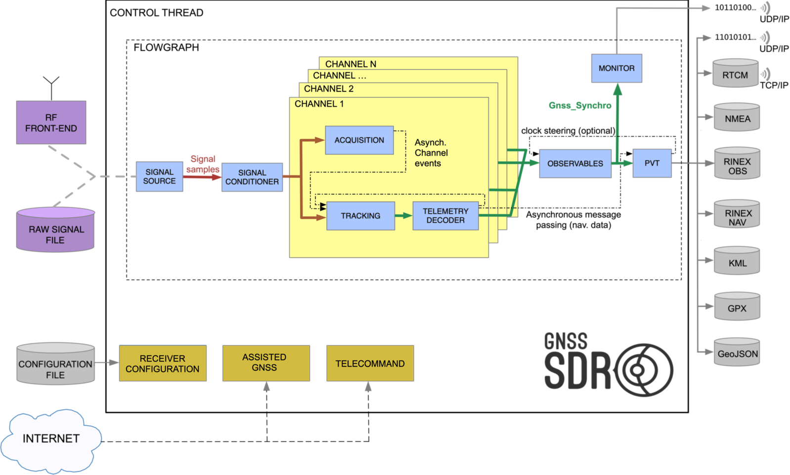
Figure 18: Workflow for GPS Simulator (GNSS)

The sofware receiver runs on a windows laptop and provides interfaces through USB and Ethernet seen in Figure 18 buses to a variety of either commercially available or custom-made RF front-ends, adapting the processing algorithms to different sampling frequencies,

intermediate frequeincies and sample resolutions. The data that was collected from the satellites was stored in a raw file. The software perormed signal acquistion and tracked availble statellite signals, decodded navigation messages and computed the observables need by postioning algorithms which ultimately computed the navigation solution. Figure 19 depicts real-life GNSS simulator running with available satellite from both authentic and spoofed satellites.
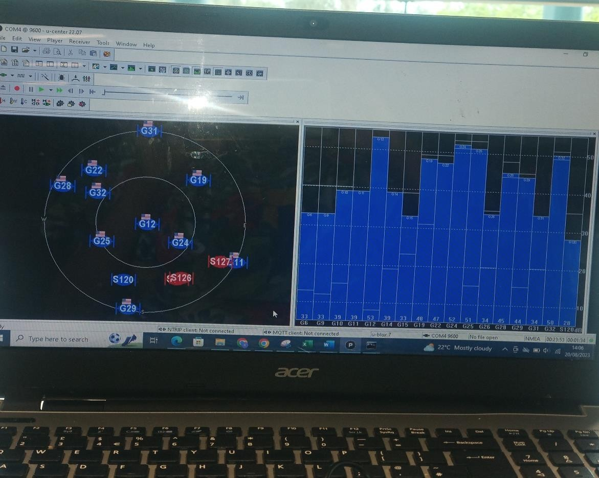
Spoofed Signals from Satellite
Plot from GPS Signals
Authentic GPS Signals from Satellite
Figure 19:GNSS Simulator receiving GPS signals from Different Satellites The GNSS configuration impacts the overall perfomance of the GPS receiver as its is
designed to faciliate the inclusion to the new signal processing. Testing of all the processes is conducted both by the systematic functional validation of every signal software block and by experiemntal validation of both authentic and spoofed signals. The processing output is stored in receiver independent exchange format used by most geodetic processing software and its transmitted through TCP/IP server in real-time.

UAV
The UAV used is potensic T25 model which is a Headless Mode, Altitude Mode, and One Key to Take-off / Land functions making access easier. Greater vision and fluid transmission to take clearer pictures and more steady films, a 2K camera with a 120° FOV and a 75° customizable wide angle is helpful with a GPS navigation mode.

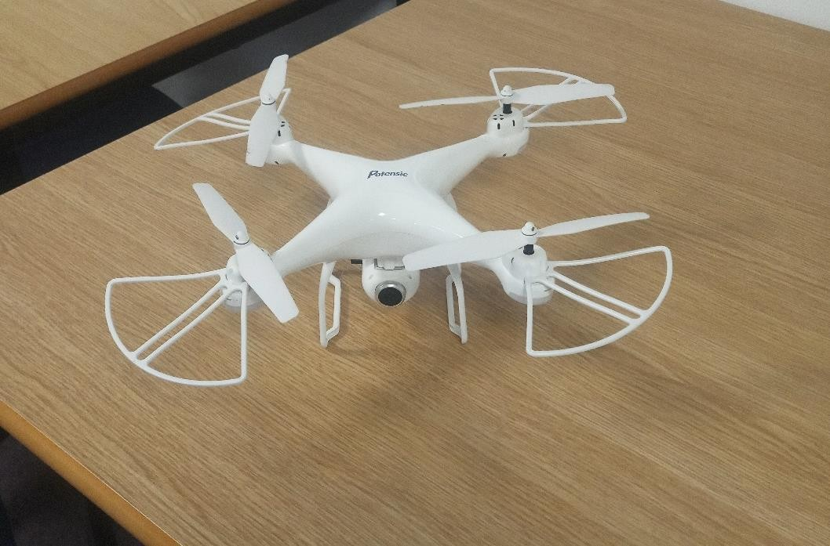
Figure 20: UAV (Potensic T25) Drone used.

System Archictecture
In order to collect data, all the system components must be able to communicate. Figure 21 is the proposed outlook before implementation. The GPS simulator must receive GPS signals from the GPS receiver and transmit the signals which are received to the satellite. The spoofer must receive and sieve out the mixed signals and hence generate them. Figure 22 is the outlook of the real-life implementation with all the system components in communication receiving data from the satellites.

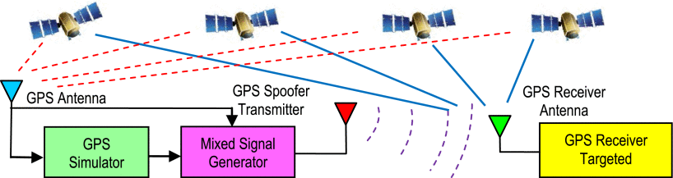

Figure 21: Proposed System Architecture

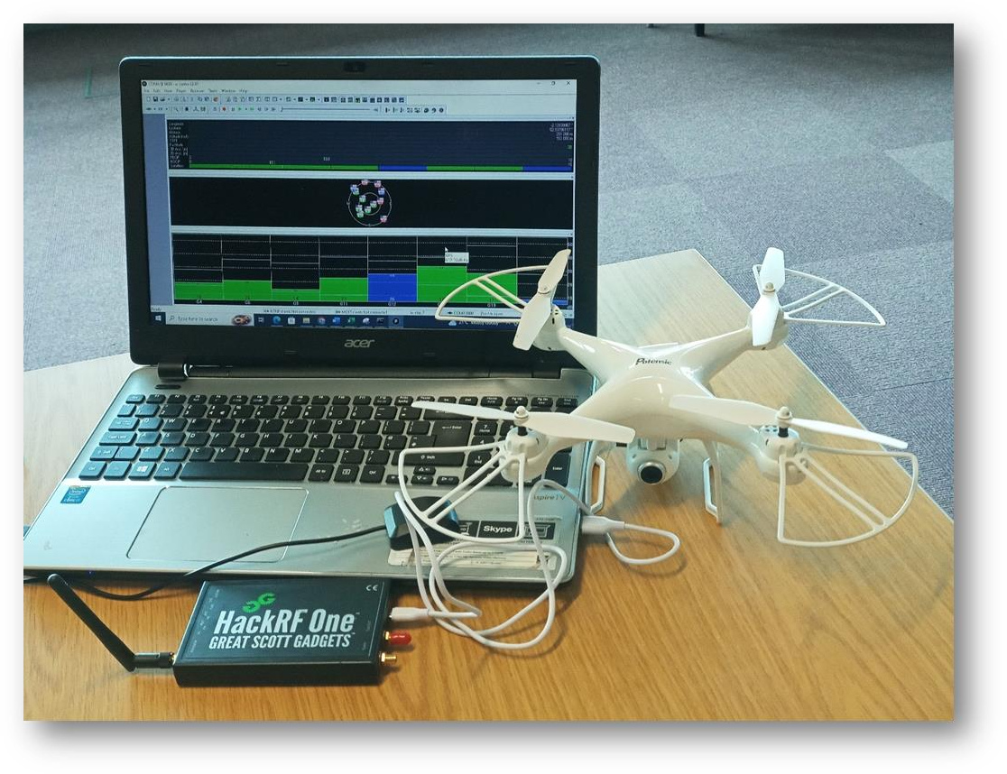
HackRF One
GPS Receiver
Satellites
Drone

Figure 22: Real Outlook of the Generic Framework of the Proposed System

Design and Development of GPS spoofing detection

To improve the accuracy in detecting of real-time GPS spoofing signals of UAVs, this thesis proposes a solution that is accomplished in four stages. In the first phase taking note of the accurate GPS signals of the current location. The latitude and the longitude are set. This is achieved with the GPS receiver in communication with the windows GNSS/GPS simulator started. In the second stage GPS signals are collected with the GPS receiver in communication with other equipment both software and hardware (i.e. (i) the authentic signals have the GPS receiver that does affect the overall output of the signals from the satellites (ii) the spoofed signals have the HackRF with the GPS receiver mouse. In the third stage, the session of the collected GPS signals from the satellites are then stored in a file. In the fourth stage, the stored file is the pre-processed for analysis in Python. The design and implementation solution provided is a whole movement to track accurate real-time GPS spoofing detected signal. The subsequent subsections discuss the design and implementation of GPS spoofing detection algorithm based on machine learning. Figure 23 depicts GPS simulator configuration with parameters set.

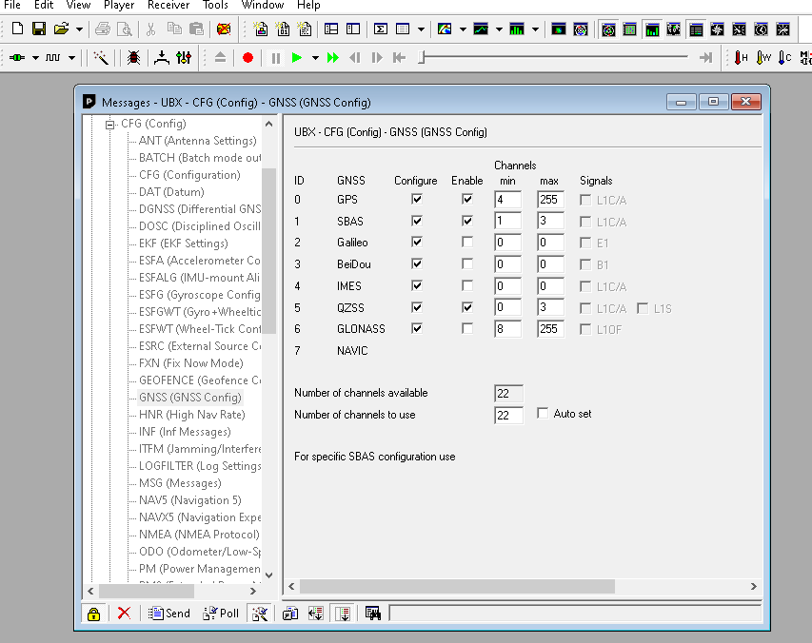

Data Collection
Figure 23: GPS Simulator Configuration

In order to achieve a successful GPS spoofing attack, it must be considered that the practical limitations of an attack which is essentially in the tracking phase, the counterfeit signals will not be acquired by the receiver without force reacquisition and inside a building.

In order to configure the longitude and latitude, we use the command C:\Users\acer\Downloads\Project1>Project1.exe -b 8 -e brdc2140.23n -l 52.633079,- 1,139386,88. The fake, structured GPS signals that the GPS spoofer sends out can be decoded by GPS receivers and used to carry out its operations. The HackRF and the GPS receiver need to be connected to the Windows computer before using the command C:\Program Files\PothosSDR\bin>hackrf_transfer.exe -t gpssim.bin -f 1575420000 -s 2600000 -a 1 -x 0 on the command line. The USB connectivity for the GPS receiver (COMM 9600) is read.

C:\Users\acer\Downloads\Project1>Project1.exe -b 8 -e brdc2140.23n -l 52.633079,- 1,139386,88

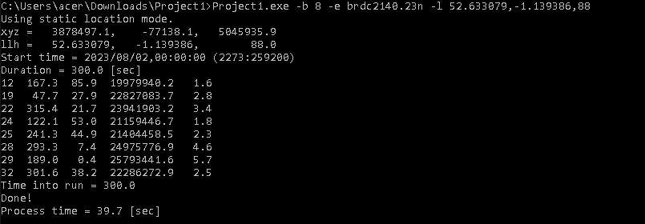
Setting Longitude and Latitude Co-ordinates with a height.
Figure 24: Out Put to start the GPS Receiver

C:\Program Files\PothosSDR\bin>hackrf_transfer.exe -t gpssim.bin -f 1575420000 -s 2600000 -a 1 -x 0
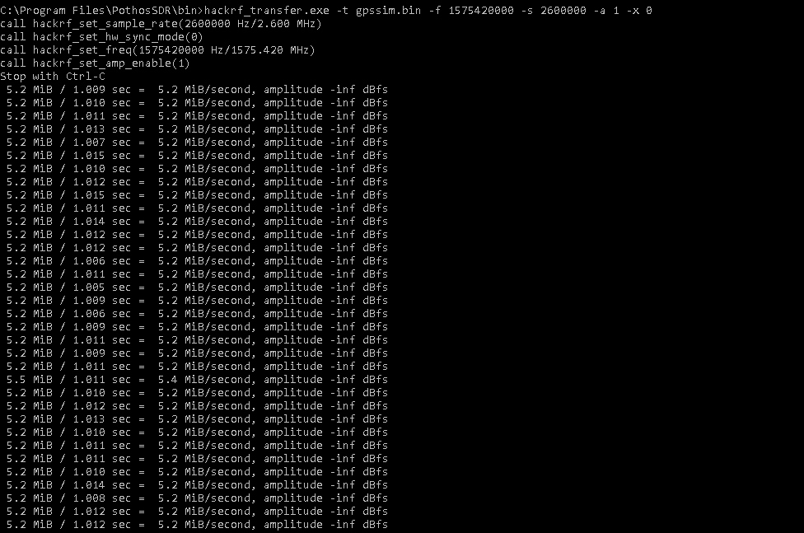
Figure 25: Out Put to start the HackRF.

The following is a summary of the spoofing detection methodology;

- Define the specific satellites, the GPS coordinates, and a height threshold during the acquisition phase.

- Track each signal that is discovered.

- Signals from each PRN are categorised into two groups based on the measured values. The data set with a high correlation is known as the spoofing group, and the uncorrelated set is known as the authentic group. Consider the need that the trajectory be long enough.

- The number of configured observable GNSS satellites is unrestricted for the authentic group. The configurations allow for the setting of each of the several parameters that make up the dataset. This entire setting is under the control of the GPS receiver, and it's critical to ensure that the compatibility is correct. Both the u-center for the GNSS interface and GPS receivers are constantly being improved. The M10 series and version both belong to the category of u- center2, the most recent version, however the VK-162 mouse belongs to version 6 and is compatible with u-center 1. An SV signal is removed by the receiver if it is known that it cannot be received because of its location. It is therefore expected that the size of the authentic group is restricted. A spoofer could provide a signal that is clear while the SV signal is obscured and so invisible to the recipient. In such cases, a spoofing signal may unintentionally be added to the authentic group. But since these signals must be compared to other signals in the spoofing group, it is possible to take them from the authentic group.

- The members of the authentic group should offer the lowest variance navigation solution; therefore, it is possible to reconsider where each member should be placed in the authentic and spoofing groups. Therefore, the GNSS signal may be accompanied by both a spoofing signal and an actual signal in general. If the spoofing signal in the authentic group seems to have only a weak association with its peers in the spoofing group and produces a lower variance navigation solution when swapped with its corresponding signal in the authentic group, then an exchange should be made. Figure 26 depicts the processing technique with a flowchart.


Start
Track all
signals with the set GPS coordinates as threshold.
Monitor the
signal
parameters
Evaluate the
Pairwise Correlation and Set Parameters
Highly
Correlated?
Authentic PRN
Set
Interchange
PRN set members
Position Level
Processing


Spoofing PRN
set
Position Level
Processing

Figure 26: Flowchart for Processing Technique

On the reception of GPS L1, L2, and L3 C/A signals, the experimental measurements are based. Measurements were made with the intention of examining the behaviour of a spoofing signal that was sent from a single source antenna that was linked to the HackRF. Using directional antennas and a controlled power level, the GNSS software simulator signals were transmitted both inside and outside. While the real signals were collected from a rooftop and a park (outdoors in an open space), the spoofing signals were received from the library MD building. Authentic signals quickly decorrelate due to the random motion, while all other signals remain stable. Due to identical propagation channels, spoofing signals are highly linked. All standards must be met by the bands that are being transmitted.

The widespread PRNs, which were acquired from the sky plot, are the genuine PRNs. The sky plot of the real satellites used in the experiment is shown in figure 22. Following that, the complete data record was analysed, which included tracking the correlation peaks of the real and fake signals and extracting the channel gains as a function of time. Figure 22 depicts the signal that has been faked using the hackRF (GPS spoofer).

Data Pre-Processing

The dataset must be transformed in the following stage of the data gathering process. The dataset was gathered in CSV file format. The samples are gathered into various CSV sheets, which are then concatenated to create a single CSV file that contains both authentic and spoofed signals. Data must be cleaned in order to be transformed into a format that is helpful for the project. To properly organise the data, it was transformed into a 2-dimensional array. Using the Python library, simulation and analysis of high-level data were carried out. In the beginning, this library will be used to clean the data by deleting pointless columns, IDs, or tags from the CSV file that was acquired from the dataset repository. Data cleaning involved removing columns and rows that had null values.

Once the data cleaning and filtering process is complete, the final output will be a new file containing different parameters. These feature parameters will serve as the input for the subsequent phase of the thesis which is GPS spoofing detection. The classification of the GPS signals to be grouped into authentic and spoofed signals is the most crucial part of the thesis. The detection algorithm is always affected by the feature parameters feed into the model.

The proposed models are expected to receive input in the form of a CSV file containing a dataset of both authentic and spoofed GPS signals from the selected satellites of L1, L2 and L3 bands. This dataset has been refined in the previous steps and transformed into a structured data frame in Python.

To ensure that the data parsed into the new model is properly filtered before being used for the implementation of the GPS spoofing detection model, a flowchart will be presented below. This flowchart shown in figure 27 will ensure the efficiency of GPS validity, determining whether they are spoofed or authentic.

No matter if they are fake or real, the GPS signals that were recorded in the repository dataset library might not last long. For both genuine GPS spoofing and easily accessible data sources, additional data processing is usually necessary. On the GPS signals collected from the various satellites, a short overview of the dataset was done. The types of GPS signals that will be detected include fake and real signals. Before extracting the real representation of the dataset, this verification is required. The GPS signal will be evaluated through a request using the

Python Beautiful Soup package in order to detect whether the data being called is being faked or authentic.

The inner workings of the entire process, however, are depicted using a flowchart. This is because a filtering system for the GPS signal coordinates must be put in place before GPS spoofing detection can be carried out. Before extracting the data, the dataset of real and fake GPS signal coordinates from the input CSV files is filtered. The GPS spoofing detection models require this filtering procedure to function properly. The flowchart below shows how these stages go from start to finish.

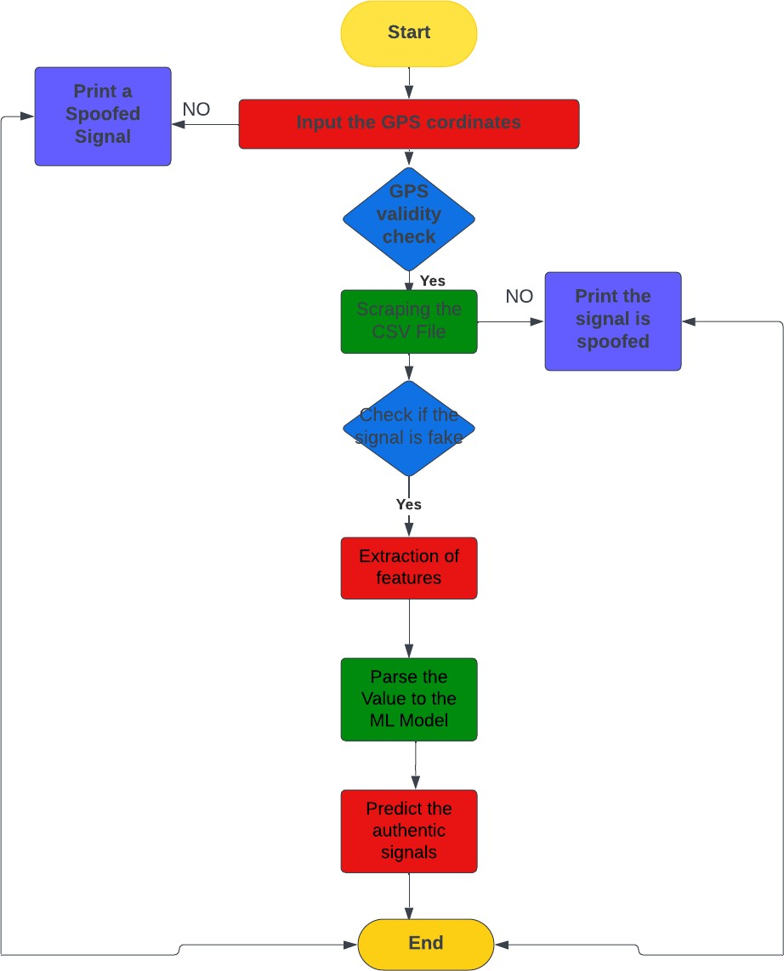

Figure 27: Flowchart for Data Pre-processing

Feature Extraction

It is common practise to use ensemble feature selection methods to increase the sturdiness of feature selection methods. Homogeneous and heterogeneous procedures are the two groups into which these methods fall. When choosing features for an ensemble, homogeneous feature selection employs the same approach with training datasets of various sizes, whereas heterogeneous feature selection primarily uses different feature selection methods with training datasets of the same size. Traditional feature selection methods, such as Spearman's Correlation are used in this study to create a heterogenous feature selection strategy. The feature-selection methods are chosen in order to exclude associated and irrelevant features from the dataset.

By computing the score provided by each feature, Spearman Correlation essentially determines the association and direction between each two features. The formulae is given by the score of ρ is;

6 ∑^{𝑛} (𝑑𝑖)2

ρ = 1 −
𝑖=1

𝑛(𝑛2 − 1)

Where di is the difference between the two ranks of each observation, i is the index of the observation and n is the number of observations. A feature is associated if its coefficient rises beyond 0.9. As a result, from each pair of associated features, we eliminated one feature. In order to determine the relative importance of each feature and estimate each variable's gain relative to the target variable, we also employed information-gain feature selection approaches known as mutual information (Abdullayeva & Valikhanli, 2022) . Each feature's entropy, also known as information gain, is calculated; those with high entropy values are chosen as important features, and those with low entropy values are regarded as having low importance. The dataset for this thesis excludes any characteristic with an entropy of less than 0.1.

Feature Engineering
The feature engineering portion of this model development will employ the retrieved CSV file from the stored data to increase the detection rate of fake GPS signals. This step comes after creating the Python methods that will be used to extract the content-based features from the CSV files created during the data pre-processing stage. Binary and quantitative features make up the two categories into which the content-based features are divided.
A few properties will be tested to see if they are present in the CSV file by the binary features of this model. As an illustration, the tracked signals() attribute present in the file can be a binary feature. There will only be a 1 or a 0 as the output value. One indicates genuine signals, whereas zero indicates fake ones. In order to train the machine learning model, we will employ this binary feature.
Contrarily, the quantitative characteristics will look at variables like the latitude() and longitude() attributes.
Defining the content features of the CSV file that will be used to train the proposed model is the task at hand in this stage of the project. There have been discovered as many as based features. To extract these traits, a method in Python has been built. Though it appears unstructured, the output of the extracted features.

The corresponding dataset is imbalanced and consists of 510530 samples, of which 397825 are real GPS spoofing attack signals and the remaining samples are equally split between the other two categories. A well-structured dataset is required for the training of a machine learning model.
The CSV file's actual content-based features will be extracted in the following step, and it will be ensured that the unstructured data obtained from the written Python code is converted into structured data before being utilised to train the machine learning model.

Feature Extraction of Unstructured Data to Structured Data
Importing the Python libraries BeautifulSoup and pandas allows for the completion of this project stage. The procedure entails taking the following steps to convert the unstructured data into structured data and extract the content features from it:
- Defining a function in the main project file that opens the dataset CSV file folders.
- Creating a function definition for the BeautifulSoup object.
- Creating a vector to execute all the feature functions of the BeautifulSoup object by defining a function that does this.

Creating a Structure data and Labelled Dataset
The following step is to combine all the earlier procedures and steps, then repeat each loop to produce a vector for each parameter. A final CSV file comprising structured and labelled datasets that will be utilised to train the suggested model will be the result of this process. Below is a list of the steps necessary to achieve this:
- The list of real and fake GPS signals from the CSV file should be converted into a data frame. Retrieving only the relevant columns and transforming them into a list using a Python function will enable you to remove unnecessary tags that are not helpful for training the new model.
- Create the column list, which reflects the features that will be taken from the CSV files that have been processed.
- A data frame must be made for a freshly generated CSV file in the following step. Every parameter in the loop set will have structured data in this file, including the outcomes of the URLs and the content that was taken out of each CSV in accordance with those outcomes. The resulting data is organised using the Python pandas module once input data from the preceding CSV file containing real and fake GPS coordinates is fetched. The new CSV file containing structured data is created by this process and will be utilised in the project's next phase to train the machine learning model.
- In the last step of the project, the structured and labelled dataset created in this stage will be used to create the machine learning models.

Machine Learning Framework Algorithms
The algorithms for the machine learning framework that the classifiers use to detect GPS spoofing signals are described in this phase. The fact that the issue at hand is a classification query led to the algorithms being selected. We must select algorithms that will solve the problem if we are to accomplish the aim of this thesis.

Table 5: Algorithm Flow for Machine Learning Classifier

Algorithm Flow for Machine Learning Classifier
- Load GPS data
def dataset(GPSData)
Input: GPS Sample Data (CSV File)
Output: Features_array, Labels_Array

- Split up data into training and test sets
def train_test_split (data, Labels_Array, size, state)
Input: size = percentage of test data used, state = randomness value data, Labels_Array
Output: X_train, X_test, y_train, y_test

- Create the SVM classifier
rf =rfC ()

- Train the model
rf.fit (X_train, y_train)

- Predict the response for the test dataset
y_pred = predict(X_test)

- Evaluate model accuracy using actual and predicted values
accuracy_score (y_test, y_pred)

After the data is collected there is need to process it through a GPS simulator. Both directed and delayed mixed signal generators are converted with IF Down conversion shown in figure
28. The aim for this process is to check if the so to be deployment machine learning model can classify the signals if mixed. The delayed signals are time stamp generated and the conversion is the change in distance.
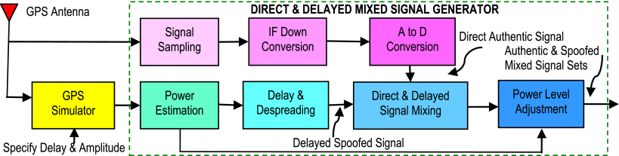

Figure 28: Mixed Signal Generator

When the parameters are set, the machine learning algorithm has to be able to distinguish the signals. Signal and measurement processing begins which parameters are parsed onto for feature extraction. The machine learning algorithm should be the spoofing detector in the signals during the online phase. The spoofed signals are all generated with the HackRF which acts as a Software Defined Radio (SDR). During the offline phase, the machine learning algorithm must perform adjustments in weight specifications in order to train the model. This process happens for all the models in question as seen in figure 29.
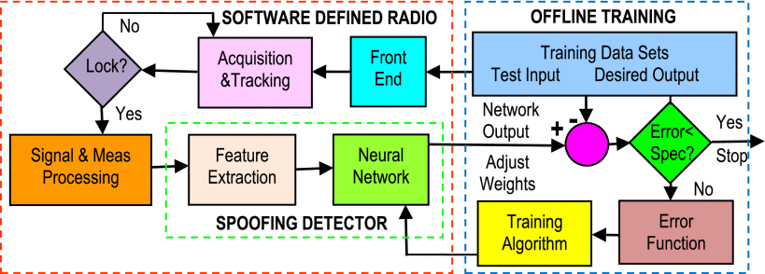

Deployment Strategy
Figure 29: Training Algorithm

The project is currently in the deployment stage, which demonstrates the step-by-step process that will be used to make this project available for usage and for the purpose of result visibility. The open-source python library Streamlit is used by data science and machine learning developers to quickly and easily deploy machine learning related projects without hassle. The library is chosen because of its flexibility to present and visualise data and make it user friendly, and because it is quick and easy to develop using regular and simple python scripts. The steps below show the deployment process for this project in order to make the results visible.
- Import the following: machine learning as ml, packages, streamlit as st, feature extraction as fe, beautifulSoup, request as re, and matplotlib, pyplot as plt.
- The next phase is the creation of the interactive deployment page, which includes a title, project information, features, input buttons, and results.
- The results will have the statistical analysis to present the representation of data, this includes graphical representation like; Pie-Charts, Bar-Charts, etc. Heat map to represent the correlation of the features will be displayed. Evaluation Metrics which are: accuracy, precision, recall of the four machine learning algorithms will be represented in a confusion matrix.

Summary of the Methodology

This chapter goes into further detail on the machine learning-based methodology that has been suggested for detecting GPS spoofing to describe the entire study procedure. To outline the goals and draw limitations for this approach, a general framework has been offered. Then, using low-cost hardware and software, this thesis introduces its first model for gathering GPS signals, both real and fake. The real-time dataset that has been gathered highlights the communication that occurs during data transmission. The four machine models' claims are

covered along with their corresponding algorithms: SVM, Logistic Regression, Decision Trees, XGBOOST and Random Forest. Discussion is held regarding the feature extraction procedure and the specificity of the parse-required parameters. It draws attention to the rationale behind the decision to select and propose certain algorithms. Accurate real-time evaluation metrics' suitability in determining which algorithm works better is presented in chapter 4. Finally, chapter 3 comes to an end with a hint of the validation procedure.

CHAPTER FOUR RESULTS AND DISCUSSIONS

Introduction

In the following section, the outcome of this thesis is validated and presented through a comprehensive performance and accurate detection. To serve this purpose, a machine learning based GPS spoofing detection algorithm is developed to identify GPS spoofed signals for UAVs. During the implementation, feature selection carries a crucial role. The overall project cost with potential hardware at an affordable cost is validated. The collected dataset is carried out real-time, and the features are reduced to de-noise the parameters. Several simulations were done in Python (Google Collab) to evaluate the best performing algorithm considering metrics. Validation is carried out to test the best performing model on a UAV.

Proposed Machine Learning Algorithms

SVM
The decision boundary of a Support Vector Machine (SVM), a binary linear classification, is specifically designed to reduce generalisation error. Support Vector Machines (SVMs) assess data used for classification and regression analysis using related learning methods. It is a very strong and adaptable machine learning model, able to carry out regression, outlier identification, and even linear or nonlinear classification (Rohith Gandhi, 2022).
The SVMs starts with a unique linearly separable idea before classifying. SVM fits the "decision boundary" that is determined by the largest distance between the nearest points for each class if the categorization of observations is "linearly separable." As shown in picture 30, this is known as the "maximum margin hyperplane (MMH)".
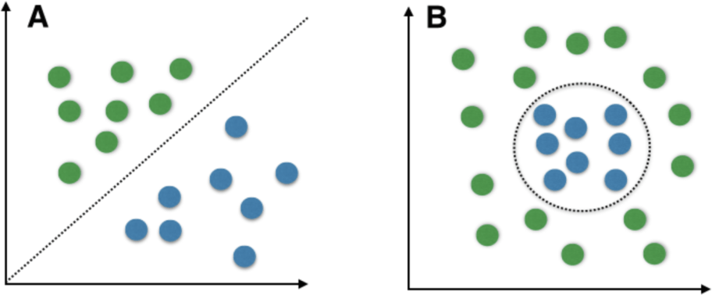

XGBOOST
Figure 30: Classification of SVM

The decision-tree based ensemble machine learning technique XGBoost makes use of a gradient boosting framework. In prediction tasks involving unstructured data (images, text, etc.),

artificial neural networks usually outperform all other algorithms or frameworks. However, it is currently believed that decision tree-based algorithms are best in class for small to medium- sized structured/tabular data. The evolution of tree-based algorithms is depicted in Figure 31.
The XGBoost algorithm was developed as a result of research at the University of Washington. Tianqi Chen and Carlos Guestrin (Vishal Morde, 2021) presented a work at the SIGKDD Conference in 2016 that enthralled the machine learning community. Since its release, this algorithm has drawn recognition for powering several creative business applications in addition to winning first place in multiple Kaggle events. As a result, there is a sizable community of data scientists involved in the XGBoost open-source projects, with about 350 contributors and 3,600 GitHub commits.

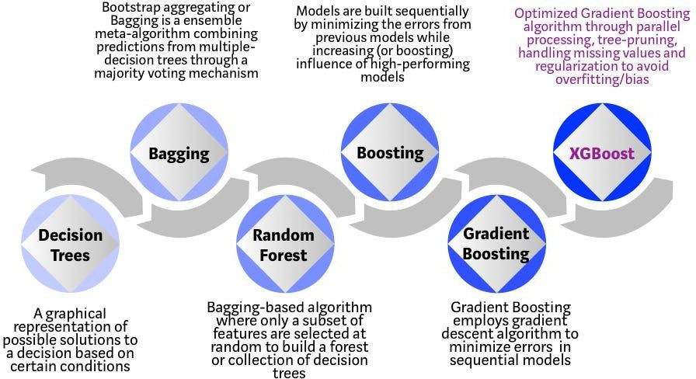

Figure 31: Evolution of XGBOOST
    - Random Forest
A decision tree is a categorization tool that resembles a tree. There is a start node acting as the root, each node defining a condition, and choices between internal nodes acting as outcomes are made at each branch. One of the techniques used in supervised machine learning, known as random forest (RF), is based on the construction of several decision trees. It consists of several decision trees, and throughout training, each tree gains knowledge from the random samples. Decision trees are constructed using random feature sets once the data has been partitioned into numerous subsets. The number of trees and the randomly chosen features to be evaluated at each tree node are two hyperparameters that must be considered (Carolina Bento, 2021). Every time new data is received, RF makes a forecast using the best option produced by the decision tree results. An ensemble model of decision trees, Random Forest performs computations more quickly than other models.

Decision Tree
A decision support tool known as a decision tree employs a tree-like model to represent options and their potential outcomes, including utility, resource costs, and chance event outcomes. One technique to show an algorithm that solely uses conditional control statements is to use this method. It has been found that decision trees are the most effective method for classifying data and making predictions in problems involving GPS spoofing detection. A decision tree is a classifier that is expressed as a recursive partition of the instance space, in accordance with Prince Yadav (2020). It develops a predictive model that links information about a node to inferences about its intended value. The data can be classified using a variety of decision tree methods, including ID3, C4.5, C5, J48, CART, and CHAID. 2020 (Prince Yadav).

Logistic Regression
The logistic regression technique, according to Saishruthi Swaminathan (2020), models the probability of a discrete result given an input variable. The type of outcome that logistic regression models employ the most frequently is a binary outcome, such as true or false, yes or no, and so forth, which can have two alternative values. Multinomial logistic regression can be used to model regression with more than two unique possible outcomes. Logistic regression is a useful analysis method when seeking to determine which category a new sample most closely fits. Since cyber security concerns are classification problems, such as identifying attacks, logistic regression is a useful analytical technique. For example,
  - To determine whether a particular email is spam (1) or (0)
  - Whether the tumour is benign (0) or malignant (1).
Consider a scenario where we must decide whether an email is spam or not. If we use linear regression to address this issue, then a threshold needs to be created in order to accomplish classification. If the actual class is malignant, the projected continuous value is 0.4, and the threshold value is 0.5, then the data point will be classified as non-malignant, which could have significant effects in real time. This example demonstrates that categorization issues do not lend themselves to linear regression. Due of the limitless nature of linear regression, logistic regression enters the picture. They just range from 0 to 1, and nothing else. The choice of the machine learning algorithms depends on various factors, including the nature of the problem, characteristics of the data, computational reasons. The goal of the analysis is a classification problem at hand. The following is the summary for the choice of algorithms ;
  - Effective handling of missing data
  - Built-in cross-validation capability
  - Depth-first tree pruning.
  - Out-of-core computing and cache awareness

Feature Extraction

Using (Aissou et al., Dec 01, 2021)as a guide, the dataset used in this thesis was created and put into use to choose the necessary features. A dataset of authentic and spoofed signals from various locations and different times were gathered through real-time simulations and tests. An Intel Core i5- laptop with 8 G RAM running Windows, a front-end Hack RF with an associated

active GPS antenna, and a GPS receiver made up the hardware utilised in the project. With the help of GNSS, three different spoofing attack types; simplistic, intermediate, and sophisticated were considered as potential targets for GPS attacks. The Doppler Shift Measurement, Receiver Time, and Pseudo Range aspects of the GPS signals are among the specific GPS signal characteristics that each of these attacks affects. In simplistic spoofing attempts, bogus GPS signals that were out of sync with the real signals were generated. There was a signal drift in this instance because the greater Doppler Shift measurements were outside of the typical range of 20 Hz. A greater Signal-to-Noise Ratio value is produced by this sort of attacks because GPS spoofing signals are also broadcast at a higher power level than authentic GPS signals.

Attackers who use intermediate spoofing techniques are aware of the location of UAVs. The resulting GPS signals can be controlled by the intermediary attacker. The Doppler Shift Measurements and Pseudo Range readings are kept within the typical ranges in this kind of attack. The spoofer obtains control of several channels from numerous synchronised antennas in sophisticated attacks. Due to the impact of multipath signals and the motion of the satellites and receiver, this kind of attack is the most dangerous spoofing attack. From various receiver stages, from the tracking loop through the observable block, thirteen features were retrieved. Table 7 lists the features that were extracted from the GPS signals that were received along with brief descriptions of each.

Dataset

The corresponding dataset is imbalanced and consists of 510530 samples, of which 397825 are real GPS spoofing attack signals and the remaining samples are equally split between the other two categories. In Figure 27, a sample of the dataset is displayed.
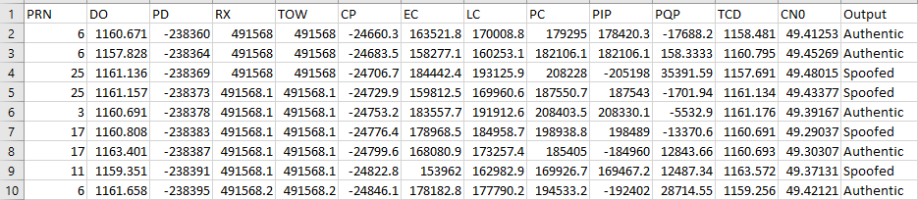

Figure 32: Sample of Dataset

Dataset Pre-processing

The dataset has previously been pre-processed by the missing value identification step, which identified and eliminated any null, unknown, and noisy values (F. Wang et al., 2022). Any category values must then be encoded to numerical values. In our collection, there are just two categorial data values that indicate the signals as attack or normal. In order to accomplish this, we encode real signals as 0 and spoof signals as 1 for a simple attack, 2 for an intermediate attack, and 3 for a sophisticated attack. Table 6 is a description of the features selected.

Table 6: List of Features

Feature | Abbreviation | Description

Satellite Vehicle Number | PRN | Identifying uniquely each satellite in orbit.
Doppler Shift Measurement | DO | A GPS receiver's frequency changes as it moves closer to its source.  A GPS receiver's frequency changes as it moves closer to its source.
Pseudo Range | PD | The time difference between transmission and  reception
Receiver Time | RX | Transmission of the navigational messages in  time
Decoded Time  Information | TOW | Information on the subframe's reception time
Carrier Phase Shift | CP | Beat disparity between the received carrier  and a duplicate carrier created by the receiver
Prompt Correlator | PC | Occurs when the receiver's replica signal is  compatible with the incoming signals.
Late Correlator Output | LC | The prompt correlator is followed by this at  the 1/2 chip spacing.
Early Correlator Output | EC | Occurs at the half-chip space before the prompt correlator.
Prompt In-phase prompt | PIP | Component of the Prompt correlator's amplitude that is in phase.
Prompt Quadrature Prompt | PQP | The quick correlator's quadrature component.
Carrier Loop Doppler  Measurements | TCD | Measured Doppler shift during the correlation  stage
Signal to Noise Ratio | CN0 | Measured at the correlation stage is the  Doppler shift with the strength signal-to-noise ratio

Evaluation Metrics
One of the crucial tasks in the application of machine learning is evaluating the execution of procedures. A precise model that can forecast the previously unobserved data must be developed. The model might perform well by some metrics, but by others, its strength might perform poorly. Therefore, it is crucial to use a variety of evaluation indicators to rate the model. The evaluation metrics are displayed in Table 7.

Table 7: Evaluation Metrics and Formulas

Evaluation  Metrics | Accuracy | Precision | Recall | F1 Score
Formulae | 𝑇𝑃 + 𝑇𝑁  𝑇𝑃 + 𝐹𝑃 + 𝑇𝑁 + 𝐹𝑁 | TP  TP + FP | 𝑇𝑃  𝑇𝑃 + 𝐹𝑁 | 2𝑇𝑃 + 𝑇𝑁  2𝑇𝑃 + 𝐹𝑃 + 𝐹𝑁

A table with four distinct sections that call for actual and anticipated standards is known as a confusion matrix. When a classification model is applied to a collection of test data, it is used to explain how the true values for those test data came to be. Whether the data is accurately

categorised or not may be quickly determined thanks to this. Comparison of expected and actual values must be done. By determining how many data records are correctly and incorrectly classified by the model, it assigns a performance vision. The totals of true positives, true negatives, and false positives are listed in two rows and two columns, respectively.

Table 8: Table 8: Confusion Matrix

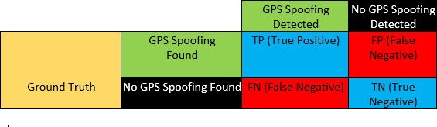

Results
Data Visualization is a very important aspect, it is a process of presenting data in a graphical or pictorial view. Data becomes more engaging and digestible, tells a story and highlights the important parts of a set of data. A bar plot, often known as a bar chart, is a graph that uses rectangular bars with lengths and heights proportionate to the values they represent to depict a category of data. Both horizontal and vertical graphs of the bars are possible. The comparisons between the distinct categories are shown in a bar chart. The precise categories being compared are shown by one of the plot's axes, while the measured values associated with those categories are represented by the other axis. A pie chart is essentially a specific type of chart that uses pie slices to depict the relative sizes of the data. As a result, it generates pie slices to represent data sets and a complete circle to represent the entire space. Figure 33 (left) shows that the GPS signal dispersion is unbalanced. The total number of samples for the real signals is 397825, while there are 36458 simple spoofed attack signals with a value of 1, 44232 intermediate spoofed attack signals, and 32015 advanced spoofed attack signals. The same format is depicted as a pie chart in Figure 33 (right).
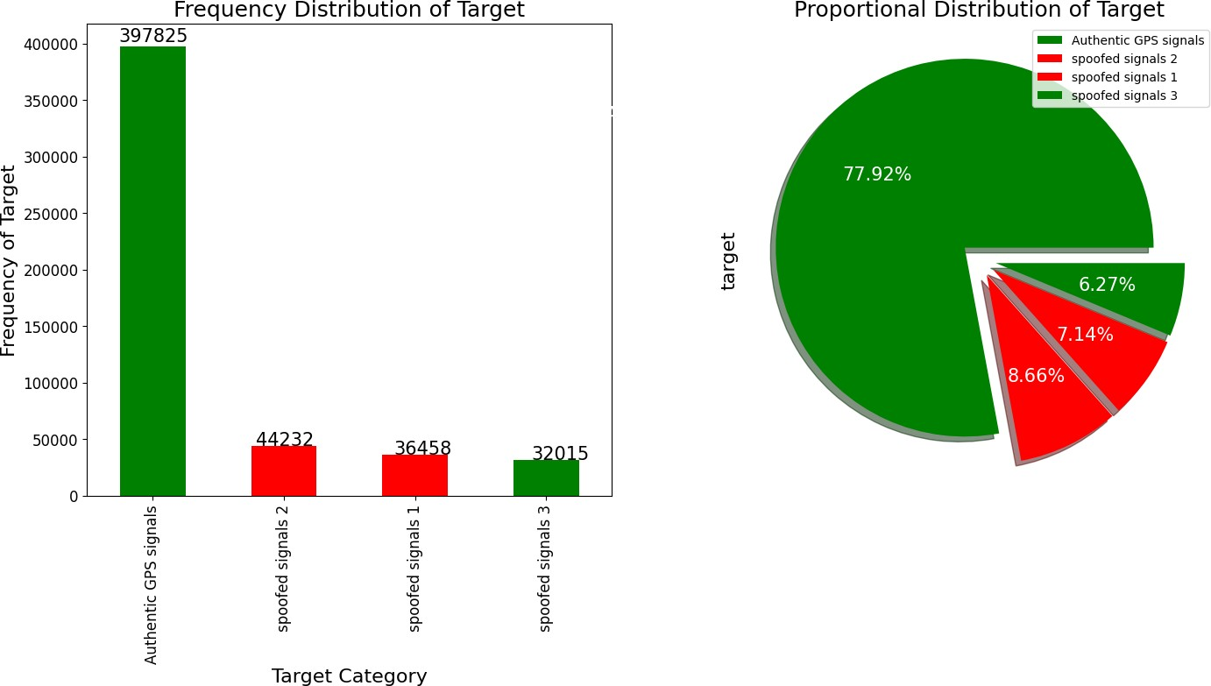

Figure 33: Bar chart and Pie Chart showing Distribution of Data

Feature Analysis
      - Elevation Code
A box plot with a normal distribution curve is a graphical representation of data that combines the features to show how they are distributed in a bell shape format. These plots are used to visualize the distribution of the dataset and provide insights into its central tendency, spread and potential outliers. It is important to provide a comprehensive exploratory data analysis to analyse the key components considering a broader context of data. The feature that is under analysis is the Elevation code (EC) which indicates the satellite’s elevation angle, impacting signal strength and accuracy. Depicting from figure 34 (left) the blue box plot represents the authentic GPS signals shows the median of the data, with data being symmetrically distributed around the mean. It has outliers which are the individual data points outside the whiskers of the box plot. The box plot for the spoofed GPS signals for 1 in orange in colour indicates that the data is more skewed and distributed above the median. The mean, median and mode for the Elevation code are 107973.45, 109815.68 and 106252.73 respectively.
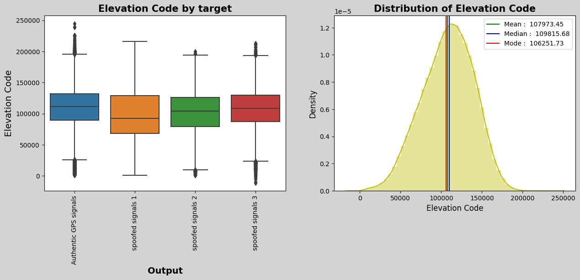
Figure 34: Box Plot and Distribution Curve for Elevation Code

4.5.1.1 Carrier Phase
The feature that is under analysis is the Carrier Phase (CP) which indicates the phase of the GPS carrier signal, impacting signal strength and accuracy positioning. Depicting from figure 35 (left) the orange box plot represents the simplistic GPS spoofed signals shows the median of the data, with a data being asymmetrically distributed around the mean. It has outliers which are the individual data points outside the whiskers of the box plot. The box plot for the spoofed GPS signals class 3 in red in colour indicates that the data is more skewed and distributed below the median. The mean, median and mode for the Carrier Phase are -121689.32, -97415.75 and -129921.33 respectively. The values here are negative values indicating that the carrier phase as feature is negatively skewed in distribution of the GPS carrier signal.
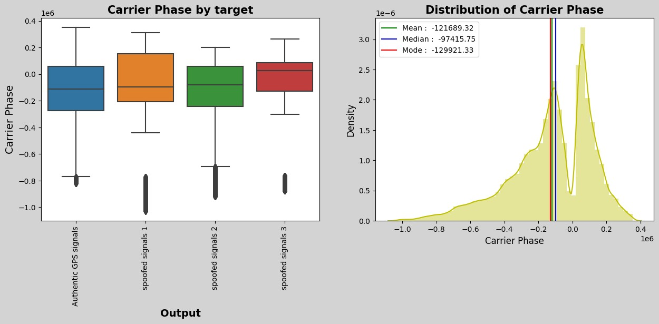
Figure 35: Box Plot and Distribution Curve for Carrier Phase

Density plots also known as kernel density or KDE plots that are used to visualize the distribution of a continuous variable. They were used to help in understanding the underlying data distribution, identify patterns and make informed decisions about pre-processing, feature engineering and model selection. In figure 36, Prompt Quadrature Prompt (PQP) shows and follows a normal distribution with the GPS signals. Feature DO have multiple peaks and follows a multimodal distribution while feature TCD is positively skewed and CN0 is negatively skewed.
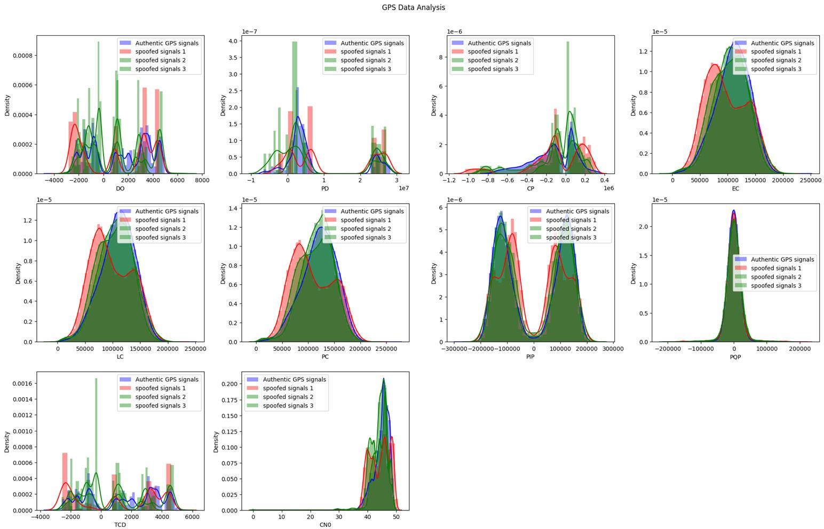
Figure 36: Density Plots of the Features used in GPS spoofing signals.

Pseudo-Random Noise (PRN) is also known as gold codes or spreading codes for the sequences of digital codes that are used in GPS signals. The various purposes are: signal modulation, synchronization and signal identification. Figure 37 shows the distribution of PRN how the GPS signals are modulated and spread. Each GPS satellite broadcasts its navigation and timing information using a unique satellite PRN number. The PRN code spreads the signal’s bandwidth making it more resistant to interference, noise among others. Satellite number 4 has the highest value and percentage in the detection of authentic GPS signals while satellite number 4 has the lowest detection rate in PRN.
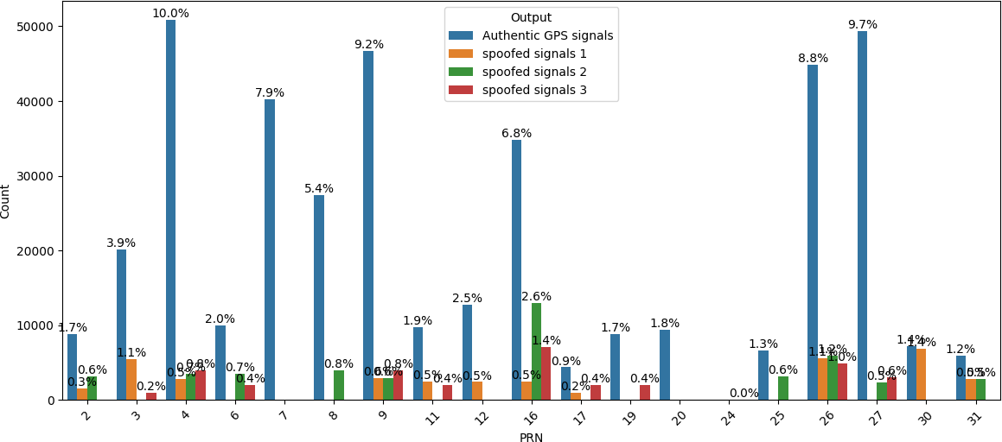

Figure 37: Distribution of PRN against Output

Correlation Check
A heat map is a two-dimensional visualisation of data where colours stand in for values. Correlation A heat map is a two-dimensional representation of the correlation strength (measure of dependence) between the coloured variables that represent the variables. The correlation coefficient is shown by the colour’s fluctuating intensity. A measure of the linear relationship between two variables is correlation. Scatter plots between these two variables can also be used to determine the correlation between two variables. A matrix data structure called a correlation matrix is employed when there are several variables, and we want to determine the correlation between each one of them. The range of correlation values is from -1 to +1. Heatmaps can be plotted in Python using the Seaborn library. It is possible to utilise sns. heatmap(df.corr()) to determine the correlation using the pandas corr () method.
The correlation between the variables on each axis is represented by a square. There is no linear trend between the two variables if the values are closer to zero. The correlation is larger for variables with values close to 1, meaning that if one increases, the other also rises, and the closer to 1, the stronger the association is. Similar results can be obtained with a correlation that is closer to -1, but instead of both variables rising, one will fall as the other does. Since each square in figure 38 correlates each variable to itself (making it a perfect correlation), the diagonals are 1/light grey. For the rest, the stronger the correlation between the two variables, the larger the number and the darker the hue. The plot is also symmetrical about the diagonal since the same two variables are being paired together in those squares.
From the output seen in figure 38 with representation of the heatmap, the features selected to show the association and relationship with the GPS signals. There is a highly correlation between Carrier Phase and the GPS spoofed signals. The carrier phase of the GPS carrier signal used for more accurate positioning. This indicates that the more alternation in the GPS signal, the more the UAVs changes in its output. Another parameter that is highly correlated with a high significant relationship is the Pseudo Random Noise (PRN). UAVs easily adapt to the noise that is being feed with from the GPS signals. PRN is a feature that guides the UAVs’s output, the feed of data with confusing the longitude and latitude influences its output.
On the other end we also see features that have a low significant association/relationship such as Prompt In-phase prompt (PIP). The indication here shows that since the UAV is under attack, the spoofing error of the true position of the UAV is under attack. The UAV increases the trajectory, and the feature has no effect. Early correlator output, this feature has a low significant relationship which happens at the ½ chip spacing before the prompt correlator. We have a correlation value of +1 between output and output which is the GPS spoofing signals both authentic and spoofed. There is always a relationship between each and the same output hence the value of +1.

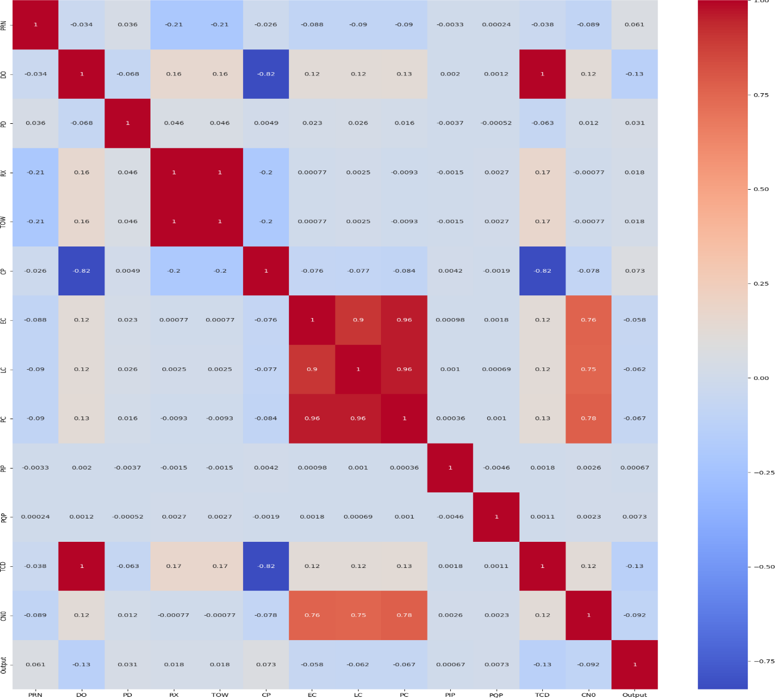

Figure 38: Heatmap Representation of Data

Evaluation of Models
Interpreting accuracy results using a classification report provides a comprehensive overview of the machine learning model’s performance of each class in a multi-class classification problem. The classification report includes metrics such as precision, recall, F1 score for each class. Table 9 depicts the summary of the classification of all the four-performing models.
- Precision is the measure to positively predict the number of true positives of the GPS spoofed signals.
- Recall is the measure of sensitivity to a proportion of correctly predicted GPS spoofed signals of a specific class out of all actual instances of that class.
- F1 score balances the trade-off between precision and recall as both aspects are taken into consideration.
Random Forest Classifier has a precision value of 79.60% indicating that RF classifier has a measure of proportion to correctly predicted GPS spoofed signals instances with a recall of 79.80% and F1 score of 79.70%. The main model to look out for is the XGBOOST, it has the highest precision, recall and F1 SCORE. The higher the precision value, this indicates that when the model predicts the GPS spoofed signals, its usually correct and accurate. Same goes to the recall value, a high recall value indicates that the model is effectively capturing most of the GPS spoofed signals from the UAV.
Table 9: Summary of Classification Model Performance

Model | Training Accuracy | Testing Accuracy | Precision | Recall | F1 | Training Time (s)
Random Forest  Classifier | 99.25 | 89.87 | 79.60 | 79.80 | 79.70 | 238.025219
Logistic  Regression | 77.88 | 77.92 | 25.00 | 27.21 | 21.93 | 14.966792
Decision Tree  Classifier | 99.25 | 91.96 | 84.04 | 84.53 | 84.28 | 19.925636
XGBClassifier | 95.45 | 93.07 | 85.41 | 86.91 | 86.14 | 595.565749

Confusion matrices are another way to depict accuracy of the models in question hence the plotting of figures 40,42,44 and 46 for random forest, decision tree, logistic regression and XGBOOST models respectively.

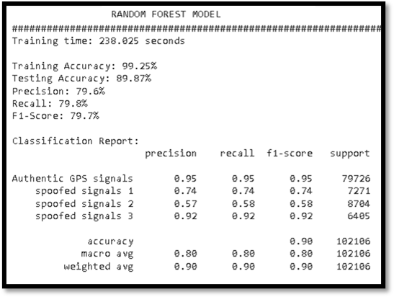  Figure 39: Classification Report for Random Forest Model | 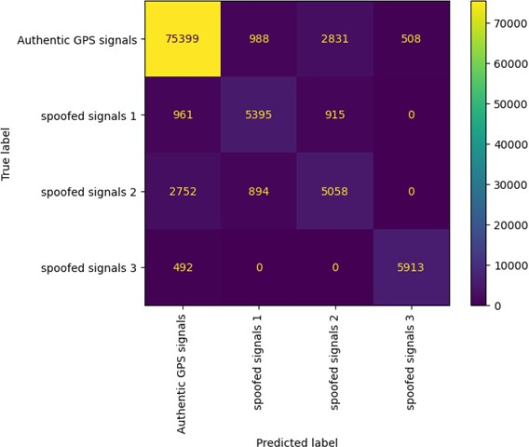  Figure 40: Confusion Matrix for Random Forest Model

The classification report shown in figure 39 provides a comprehensive assessment of the model's performance. The training time for the random forest model is 238.025 seconds. The training accuracy is high at 99.25%, indicating that the model performs well on the training data. However, on the testing data, the accuracy drops slightly to 89.87%, suggesting some degree of overfitting. Precision stands at 79.6%, indicating the proportion of true positive predictions among all positive predictions, while recall is 79.8%, signifying the proportion of actual positives correctly predicted by the model. The F1-Score, which combines precision and recall, is 79.7%. The classification report breaks down performance further for different classes. For "Authentic GPS signals," precision, recall, and F1-score are all high at 0.95, indicating excellent performance. For "spoofed signals 1," precision, recall, and F1-score are 0.74, suggesting good performance but with room for improvement. "Spoofed signals 2" and "spoofed signals 3" also show decent precision, recall, and F1-scores at 0.57, 0.58, and 0.58, and 0.92, 0.92, and 0.92, respectively. In summary, the model demonstrates strong performance in detecting authentic GPS signals but slightly lower performance in identifying certain types of spoofed signals. The macro and weighted averages provide a balanced overview of the model's overall performance, with macro averaging at 0.80 and weighted averaging at 0.90.

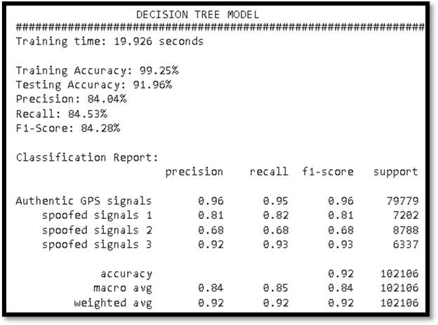  Figure 41: Classification Report for Decision Tree Model | 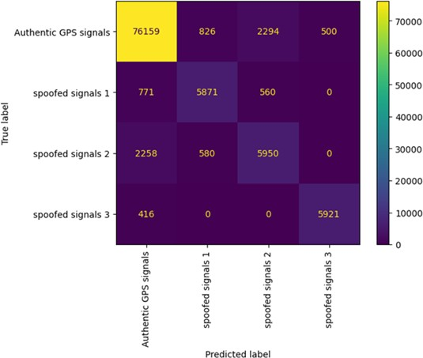  Figure 42: Confusion Matrix for Decision Tree Model

The classification report in figure 41 provides performance metrics for a machine learning model. The model achieved a high training accuracy of 99.25% and a testing accuracy of 91.96%, indicating strong predictive capabilities. Precision, which measures the model's ability to make accurate positive predictions, is 84.04%, while recall, representing the proportion of actual positives correctly predicted, is 84.53%. The F1-Score, a harmonic mean of precision and recall, stands at 84.28%. The report breaks down performance for different classes, including "Authentic GPS signals," "spoofed signals 1," "spoofed signals 2," and "spoofed signals 3." These classes exhibit varying precision and recall values, reflecting the model's ability to distinguish between them. Overall, the model demonstrates a high level of accuracy and effectiveness in classification tasks. Training times for the model are also reported, with 238.025 seconds for one model and 19.926 seconds for another, emphasizing computational efficiency.

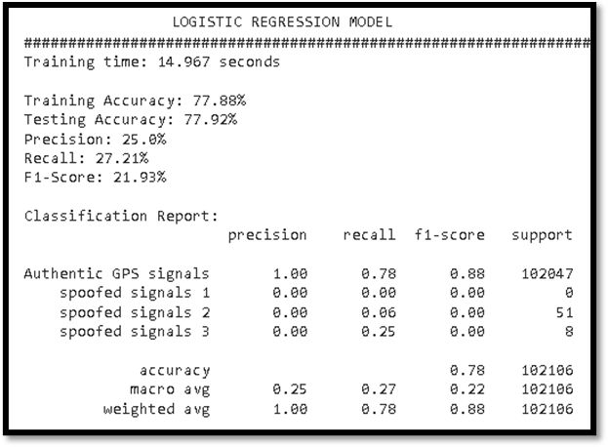  Figure 43: Classification Report for Logistic Regression | 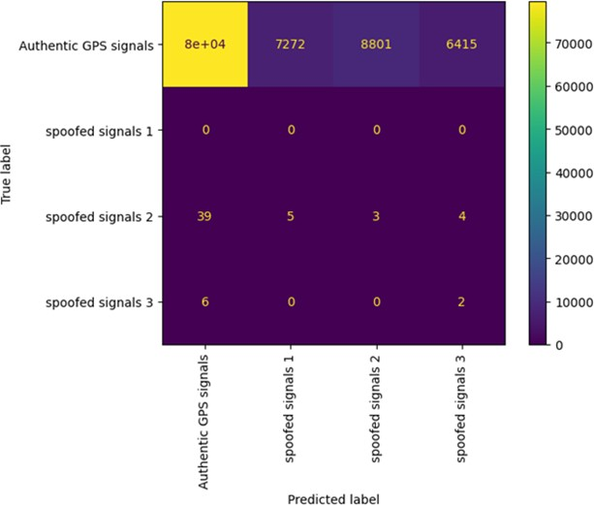  Figure 44: Confusion Matrix for Logistic Regression

The model's training time was 238.025 seconds, while testing took 14.967 seconds seen in figure 43. The training accuracy achieved was 77.88%, with a testing accuracy of 77.92%. Precision was 25.0%, recall was 27.21%, and the F1-Score was 21.93%. The classification report provides a breakdown of performance metrics for different classes. For "Authentic GPS signals," precision was 1.00, recall was 0.78, and the F1-score was 0.88, with 102,047 instances. However, for "spoofed signals 1," "spoofed signals 2," and "spoofed signals 3," precision and recall values were considerably lower, indicating challenges in correctly classifying these classes. The macro-average F1-Score was 0.22, and the weighted average F1-Score was 0.88, considering the entire dataset of 102,106 samples.

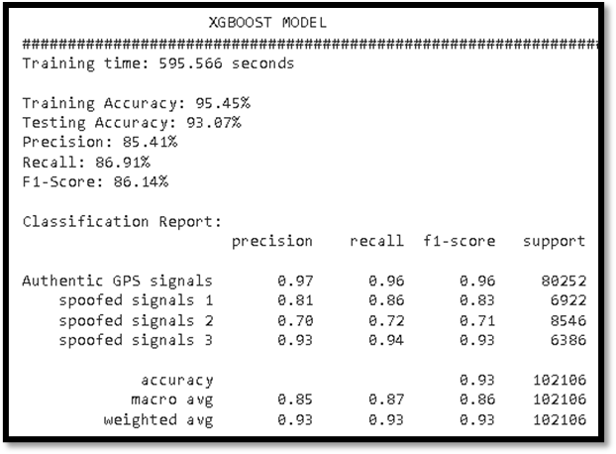  Figure 45: Classification Report for XGBOOST | 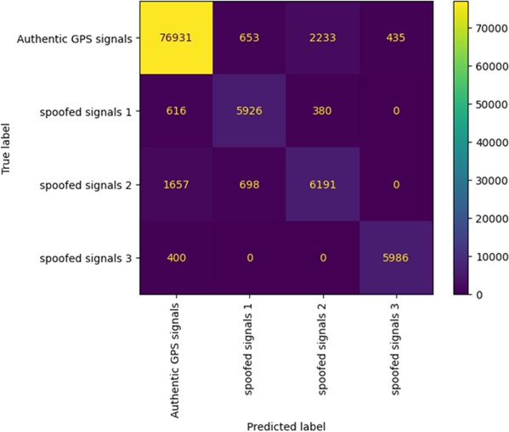  Figure 46: Confusion Matrix for XGBOOST

The classification report in figure 45 provides performance metrics for a machine learning model. It achieved a training accuracy of 95.45% and a testing accuracy of 93.07%, indicating a good fit to the data. Precision, which measures the model's ability to make accurate positive predictions, stands at 85.41%. Recall, indicating the model's ability to capture actual positive cases, is 86.91%. The F1-score, a balance between precision and recall, is 86.14%. In terms of class-specific metrics, the model demonstrates high precision and recall for authentic GPS signals (0.97 and 0.96, respectively), indicating its ability to correctly identify them. For different spoofed signal categories, precision and recall vary but remain relatively high. Overall, the model exhibits strong performance in distinguishing between authentic and spoofed GPS signals, achieving an accuracy of 95.45%.
R-squared (R2) score is a statistical measure that represents the proportion of the variance in the dependent variable that is predictable from the independent variables in the model. It’s commonly used as an evaluation metric to assess how well the model fits the observed data. The R2 score ranges from 0 to 1, with higher values indicating a better fit. From figure 47 XGBOOST shows that it is a perfect fit model for the GPS spoofing detection data. The model perfectly predicts the dependent variable based on the independent variables. Logistic regression model

indicates that it is a moderate fit for the data. It indicates that a reasonable portion of the variability in the dependent variable is taken into consideration. While it’s not perfect, it still suggests that the model has captured some meaningful patterns in the data.
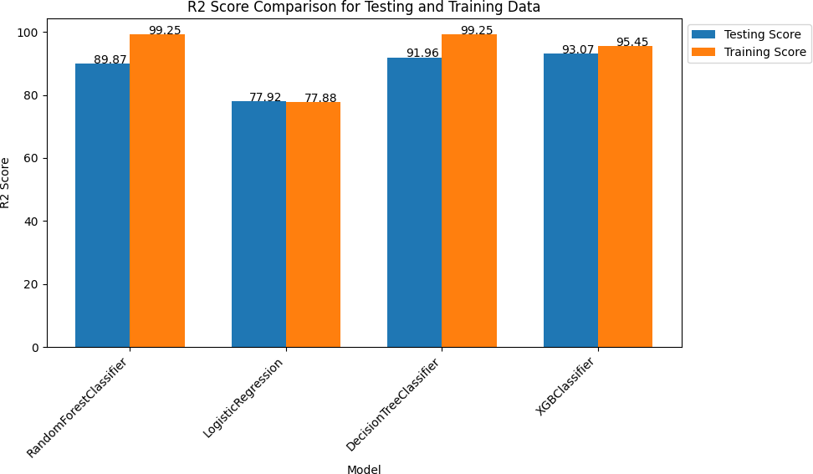

Summary
Figure 47: R2 Score Comparison for Testing and Training Data

In this section we performed analysis and simulation for GPS spoofing detection based on machine learning algorithms. As compared the existing literature, cryptography and inertial navigation systems require calculations with limited proof of how effective the model does progress. They also do not present which features should be put into extraction during feature engineering. According to our findings, the best preforming model is the XGBOOST performing at an accuracy rate of detection of 95.45%. The precision rate is 85.41% which shows that its detecting GPS spoofed

signals at that rate and recall is 86.91% in grouping and classifying the GPS spoofed instances. The parameters passed into the models are denoised in format and train splitting is uniform all throughout the models. The next chapter is the conclusion, future recommendations, limitations of the study and contributions to knowledg

CHAPTER FIVE CONCLUSIONS

Introduction
The thesis is concluded in this chapter. A summary of the machine learning-based proposed method for detecting GPS spoofing is provided. In this discussion, the problem statement that was raised previously in chapter 1 is resolved. The arguments for the suggested system are also covered in this chapter, along with how it advances knowledge. In order to strengthen the current study and get beyond its drawbacks, certain recommendations are also given.

Summary
In the past ten years, there has been a noticeable increase in interest in detecting GPS spoofing assaults on commercial UAVs, which has resulted in substantial advancement in several technologies. In order to discover and detect these vulnerabilities, several strategies have been developed; however, this area of research still must address several obstacles and restrictions, such as significant misdetection and false alarm rates. In this work, we employed a one-stage feature selection method to exclude linked and subpar performing features. Comparison of four models; XGBOOST, Logistic regression, Random Forest and Decision Trees were used. The results show that XGBOOST performs better with a training accuracy of 95.45%, testing accuracy of 93.07%, precision of 85.41%, recall of 86.91%, F1 Score of 86.14% with a training time of 595.56(s). The rest of the models were; Random Forest which had a training accuracy of 99.25%, testing accuracy of 89.87%, precision of 79.60%, recall of 79.80%, F1 Score of 79.70% with a training time of 238.02(s); Logistic Regression had a training accuracy of 77.88%, testing accuracy of 77.92%, precision of 25.00%, recall of 27.21%, F1 Score of 21.93% with a training time of 14.96(s); Decision Trees had a training accuracy of 99.25%, testing accuracy of 91.96%, precision of 84.04%, recall of 84.53%, F1 Score of 84.53% with a training time of 19.93(s).

Limitations of this study
This thesis illustrates the potential results that could be obtained by applying the suggested machine learning-based methods for GPS spoofing detection over current cryptography- and inertial navigation-based systems. Even though the feature parameters utilised in analytical simulations for feature engineering are lowered from 3-dimensional to 2-dimensional, models like Support Vector machines still require more processing time, which is a drawback to the suggested study. The simulation portion also takes a minimum epoch for the algorithms' testing and training, which is a restriction. Even though it has a limited selection of operating systems, the hardware equipment's implementation costs are reasonable and target a wide range of performance. Additionally, technology can be employed in only open spaces rather than just enclosed buildings to collect GPS signals to the GPS receiver which limited data collection.

Contributions to knowledge
This research has contributed to the knowledge by its vast study of previous attempts through comparing of four machine learning algorithms. The specific contributions of this research are:

    - Enhanced Spoofing Detection Accuracy: The research compared four performing models; XGBOOST, Logistic Regression, Decision Trees, Random Classifier yet most researchers use one model. The dataset used in performed on three different attacks: Simplified Attack, Intermediate Attack and Sophisticated Attack. Most of the researchers using XGBOOST perform one type of attack. The de-noising of features with passing specific parameters enhanced the spoofing detecting accuracy in both training and testing accuracy of the XGBOOST.
    - Dataset Creation: Contribution to collection of datasets using HackRF and VK-162 mouse. Simulation of the dataset using GNSS, and data stored in a file. The data collected was in raw format. The dataset collected with comparison from different locations to altered latitudes and longitude improved data creation and collection.
    - Performance Evaluation: Simulation analysis to compare models with parameter characteristics. Elevation Code (EC), Power Code (PC), Carrier Phase (CP), Pseudo Random Noise (PRN) were compared to show normal distribution.

5.5 Future work & Recommendations
The proposed study has shown how the concept of detecting GPS spoofing leveraging machine learning algorithms. The use of HackRF as a GPS spoofer device in communication with the VK-162 (GPS receiver) to collect and ensemble GPS signals is a traditional approach. The generation and collecting of data from different locations with altered longitude and latitude to deceive the UAV is yet a robust and needs to be extensively put to study. Integration of Multiple Sensors can enhance the robustness of GPS spoofing detection and mitigation systems, future research could focus on integrating data from multiple sensors, such as inertial sensors. Combining data from different sensors can provide more accurate and reliable information about the UAV’s position and orientation. Finally advanced machine learning methods including deep learning and reinforcement learning have the potential to improve the accuracy of GPS spoofing detection algorithms. Use of convolutional neural networks (CNNs), recurrent neural networks (RNNs) to extract meaningful patterns from sensor data is highly recommended for future works at an affordable cost.

APPENDIX
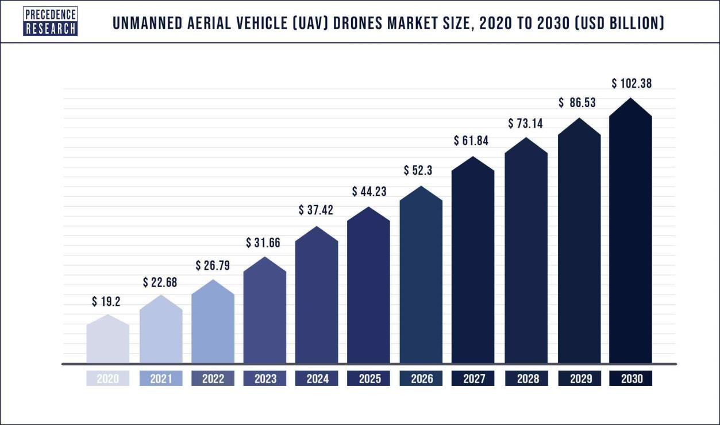

Appendix A: Projection of Potential Growth for UAVs

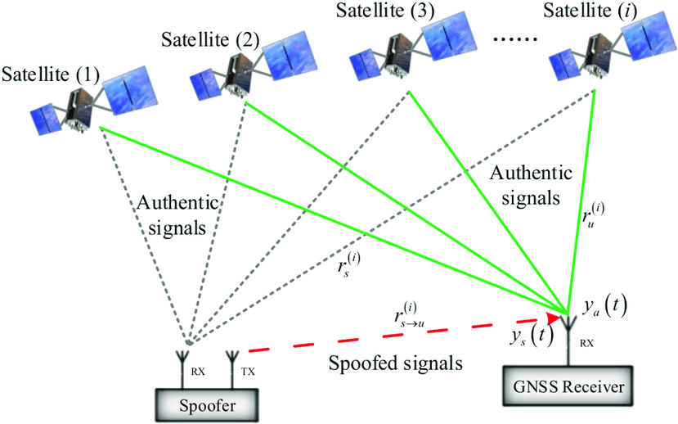

Appendix B: GNSS Receiver in communication with GPS spoofer

The Code that was used for the analysis is available on this link.
https://colab.research.google.com/drive/1oRWAdkdIzW1zcCsGwnp7rbse6cLHonu0?usp=sh aring

REFERENCES

Abdullayeva, F. and Valikhanli, O. (2022) 'Development of a method for detecting GPS spoofing attacks on unmanned aerial vehicles', Informasiya texnologiyaları
problemləri, 13(1), pp. 3-8 Available at: 10.25045/jpit.v13.i1.01.
Aissou, G., Benouadah, S., El Alami, H. and Kaabouch, N. (Jan 26, 2022) Instance-based Supervised Machine Learning Models for Detecting GPS Spoofing Attacks on
UAS. Piscataway: IEEE, pp. 0208.
Aissou, G., Slimane, H.O., Benouadah, S. and Kaabouch, N. (Dec 01, 2021) Tree-based Supervised Machine Learning Models For Detecting GPS Spoofing Attacks on
UAS. Piscataway: IEEE, pp. 0649.
Andres, S., Bernal, S., Maennel, O.M., Co-Supervisor:, R. and Matulevičius (2016) Detection solution analysis for simplistic spoofing attacks in commercial mini and micro–UAVs Master's Thesis (30 EAP).

Arteaga, S.P., Hernandez, L.A.M., Perez, G.S., Orozco, A.L.S. and Villalba, L.J.G. (2019) 'Analysis of the GPS Spoofing Vulnerability in the Drone 3DR Solo', IEEE access, 7, pp. 51782-51789 Available at: 10.1109/ACCESS.2019.2911526.

Arthur, M.P. (Aug 2019) Detecting Signal Spoofing and Jamming Attacks in UAV Networks using a Lightweight IDS. IEEE, pp. 1.
Agyapong, R.A., Nabil, M., Nuhu, A., Rasul, M.I. and Homaifar, A. (Dec 05, 2021) Efficient Detection of GPS Spoofing Attacks on Unmanned Aerial Vehicles Using Deep
Learning. Piscataway: IEEE, pp. 01.
Auvsi (2020) ECONOMIC REPORT. Available at: https://www.auvsi.org/our- impact/economic report#:~:text=AUVSI's%20findings%20show%20that%20in,economic%20impact%20of%2 0%2482%20billion. (Accessed: August 11, 2023).
Blum Josh (2020) Pothosware/PothosCore. Available
at: https://github.com/pothosware/PothosCore/wiki/Downloads#windows-installer (Accessed: July 8, 2023).
Carolina Bento (2021) Random Forests Algorithm explained with a real-life example and some Python code. Available at: https://towardsdatascience.com/random-forests-algorithm- explained-with-a-real-life-example-and-some-python-code-affbfa5a942c (Accessed: August 14, 2023).

Cao, J. (2020) Practical GPS Spoofing Attacks on Consumer Drones. Chapman, A. ECE Senior Capstone Project GPS Spoofing.
Condomines, J., Zhang, R. and Larrieu, N. (2019) 'Network intrusion detection system for UAV ad-hoc communication: From methodology design to real test validation', Ad hoc networks, 90, pp. 101759 Available at: 10.1016/j.adhoc.2018.09.004.

Cheng, H., Xie, Z., Wu, L., Yu, Z. and Li, R. (2019) 'Data prediction model in wireless sensor networks based on bidirectional LSTM', EURASIP Journal on Wireless Communications and Networking, 2019(1), pp. 1-12 Available at: 10.1186/s13638-019-1511- 4.
Dang, Y., Benzaid, C., Yang, B. and Taleb, T. (Oct 2021) Deep Learning for GPS Spoofing Detection in Cellular-Enabled UAV Systems. Piscataway: IEEE, pp. 501.
Dang, Y., Benzaid, C., Taleb, T., Yang, B. and Shen, Y. (2022) Transfer Learning based GPS Spoofing Detection for Cellular-Connected UAVs. Piscataway: IEEE, pp. 629.

Davidovich, B., Nassi, B. and Elovici, Y. (2022) 'Towards the Detection of GPS Spoofing Attacks against Drones by Analysing Camera’s Video Stream', Sensors (Basel, Switzerland), 22(7), pp. 2608 Available at: 10.3390/s22072608.

Demars, C.D., Roggemann, M.C., Webb, A.J. and Havens, T.C. (2018) Target Localization and Tracking by Fusing Doppler Differentials from Cellular Emanations with a Multi- Spectral Video Tracker MDPI AG.

Diao, D., Wang, X., Yang, C., Wang, Y. and Ma, J. (2020) GPS Spoofing Detection via SNR ACM.

Eldosouky, A., Ferdowsi, A. and Saad, W. (2020) 'Drones in Distress: A Game-Theoretic Countermeasure for Protecting UAVs Against GPS Spoofing', IEEE internet of things journal, 7(4), pp. 2840-2854 Available at: 10.1109/JIOT.2019.2963337.

E. Schmidt, N. Gatsis and D. Akopian (2020) A GPS Spoofing Detection and Classification Correlator-Based Technique Using the LASSO.
Feng, Z., Guan, N., Lv, M., Liu, W., Deng, Q., Liu, X. and Yi, W. (2020) 'Efficient drone hijacking detection using two-step GA-XGBoost', Journal of systems architecture, 103, pp. 101694 Available at: 10.1016/j.sysarc.2019.101694.
Feng, Z., Guan, N., Lv, M., Liu, W., Deng, Q., Liu, X. and Yi, W. (2019) 'An Efficient UAV Hijacking Detection Method Using Onboard Inertial Measurement Unit', ACM transactions on embedded computing systems, 17(6), pp. 1-19 Available at: 10.1145/3289390.
F. Gallardo and A. P. Yuste (2020) SCER Spoofing Attacks on the Galileo Open Service and Machine Learning Techniques for End-User Protection.
F. Wang, B. Yang, Y. Wang and M. Wang (2022) Learning From Noisy Data: An Unsupervised Random Denoising Method for Seismic Data Using Model-Based Deep Learning.
Gasimova, A., Ahajjam, M.A., Shamaileh, K.A., Devabhaktuni, V. and Kaabouch, N. (Jan 01, 2022) A Comparative Analysis of Supervised and Unsupervised Models for Detecting GPS Spoofing Attack on UAVs. Piscataway: The Institute of Electrical and Electronics Engineers, Inc. (IEEE).
GNSS SDR (2023) GNSS SDR. Available at: https://gnss-sdr.org/docs/overview/ (Accessed: July 5, 2023).

GPSPATRON (2022) GPS Spoofer with HackRF and Android Phone - Shockingly
easy! Available at: https://www.youtube.com/watch?v=g-bdK7tRpBI (Accessed: August 4, 2023).
GPS-SDR-SIM. (2023) Available at: https://github.com/osqzss/gps-sdr-sim (Accessed: July 13, 2023).
Guo, Y., Wu, M., Tang, K., Tie, J. and Li, X. (2019) 'Covert Spoofing Algorithm of UAV Based on GPS/INS-Integrated Navigation', IEEE transactions on vehicular
technology, 68(7), pp. 6557-6564 Available at: 10.1109/TVT.2019.2914477.
Horovitz, S., Zexer, I. and Ganot, B. (2022) UAVDome - Safe UAV Transportation IEEE.
Humphreys, T. (2012) STATEMENT ON THE VULNERABILITY OF CIVIL UNMANNED AERIAL VEHICLES AND OTHER SYSTEMS TO CIVIL GPS SPOOFING Submitted to the
Subcommittee on Oversight, Investigations, and Management of the House Committee on Homeland Security.
Jansen, K., Tippenhauer, N. and Pöpper, C. (Dec 05, 2016) Multi-receiver GPS spoofing detection. ACM, pp. 237.
J. Aru Saputro, E. Egistian Hartadi and M. Syahral (2020) Implementation of GPS Attacks on DJI Phantom 3 Standard Drone as a Security Vulnerability Test. pp. 95.
Kang, C.H., Kim, S.Y. and Park, C.G. (2017) Adaptive complex‐EKF‐based DOA estimation for GPS spoofing detection Institution of Engineering and Technology (IET).
Kapoor, R., Ramasamy, S., Gardi, A. and Sabatini, R. (2017) 'UAV Navigation using Signals of Opportunity in Urban Environments: A Review', Energy Procedia, 110, pp. 377-383 Available at: 10.1016/j.egypro.2017.03.156.
Kerns, A.J., Shepard, D.P., Bhatti, J.A. and Humphreys, T.E. (2021) 'Unmanned Aircraft Capture and Control Via GPS Spoofing', Journal of field robotics, 31(4), pp. 617-636 Available at: 10.1002/rob.21513.

Khan, S.Z., Mohsin, M. and Iqbal, W. (2021) 'On GPS spoofing of aerial platforms: a review of threats, challenges, methodologies, and future research directions', PeerJ. Computer science, 7, pp. e507 Available at: 10.7717/peerj-cs.507.

Khoei, T.T., Aissou, G., Al Shamaileh, K., Devabhaktuni, V.K. and Kaabouch, N.
(2023) Supervised Deep Learning Models for Detecting GPS Spoofing Attacks on Unmanned Aerial Vehicles IEEE.

Kiranyaz, S., Avci, O., Abdeljaber, O., Ince, T., Gabbouj, M. and Inman, D.J. (2021) '1D convolutional neural networks and applications: A survey', Mechanical systems and signal processing, 151, pp. 107398 Available at: 10.1016/j.ymssp.2020.107398.

K. Jansen, M. Schäfer, D. Moser, V. Lenders, C. Pöpper and J. Schmitt (2018) Crowd-GPS- Sec: Leveraging Crowdsourcing to Detect and Localize GPS Spoofing Attacks. pp. 1018.
Kwon, K. and Shim, D. (2020) 'Performance Analysis of Direct GPS Spoofing Detection Method with AHRS/Accelerometer', Sensors, 20(4), pp. 954 Available at: 10.3390/s20040954.

Kumar, K., Kumar, S., Kaiwartya, O., Sikandar, A., Kharel, R. and Mauri, J.L. (2020) 'Internet of Unmanned Aerial Vehicles: QoS Provisioning in Aerial Ad-Hoc Networks', Sensors (Basel, Switzerland), 20(11), pp. 3160. doi: 10.3390/s20113160.
Laura Wood (2021) Commercial Drones Global Market Report 2021 Featuring DJI, Parrot SA, Aerovironmen, PrecisionHawk and Draganfly - ResearchAndMarkets.com. Available at: https://www.businesswire.com/news/home/20210806005222/en/Commercial-Drones-Global- Market-Report-2021-Featuring-DJI-Parrot-SA-Aerovironmen-PrecisionHawk-and- Draganfly---ResearchAndMarkets.com (Accessed: June 11, 2023).
Li, G., Ma, J., Zhan, Q., Wu, D., Wei, X., Wang, X. and Zuo, J. (2021) Detection Technology of Satellite Navigation Spoofing Signal ACM.
Magiera, J. and Katulski, R. (2021) Detection and Mitigation of GPS Spoofing Based on Antenna Array Processing Universidad Nacional Autonoma de Mexico.
Majidi, M., Erfanian, A. and Khaloozadeh, H. (2020) 'Prediction-discrepancy based on innovative particle filter for estimating UAV true position in the presence of the GPS spoofing attacks', IET radar, sonar &amp; navigation, 14(6), pp. 887-897 Available at: 10.1049/iet-rsn.2019.0520.

Mekdad, Y., Aris, A., Babun, L., Fergougui, A.E., Conti, M., Lazzeretti, R. and Uluagac,
A.S. (2023) 'A survey on security and privacy issues of UAVs', Computer networks (Amsterdam, Netherlands: 1999), 224, pp. 109626 Available at: 10.1016/j.comnet.2023.109626.

Meng, L., Yang, L., Ren, S., Tang, G., Zhang, L., Yang, F. and Yang, W. (2021) 'An Approach of Linear Regression-Based UAV GPS Spoofing Detection', Wireless communications and mobile computing, 2021, pp. 1-16 Available at: 10.1155/2021/5517500.
Meng, Q., Li-Ta, H., Xu, B., Luo, X. and El-Mowafy, A. (2019) 'A GPS Spoofing Generator Using an Open-Sourced Vector Tracking-Based Receiver', Sensors, 19(18), pp. 3993. doi: 10.3390/s19183993.
MOST 6 EXPENSIVE DRONES. (2023) Available at: https://productz.com/en/intuitive- aerial-aerigon-mk-ii/p/A9zR (Accessed: July 11, 2023).

Moustafa, N. and Jolfaei, A. (2020) 'Autonomous detection of malicious events using machine learning models in drone networks', Proceedings of the 2nd ACM MobiCom Workshop on Drone Assisted Wireless Communications for 5G and Beyond, Available at: 10.1145/3414045.3415951.

M. R. Manesh, J. Kenney, W. C. Hu, V. K. Devabhaktuni and N. Kaabouch (2019) Detection of GPS Spoofing Attacks on Unmanned Aerial Systems. pp. 1.

NASA (2023) CDDIS EARTHDATA. Available at: https://cddis.nasa.gov/ (Accessed: July 20, 2023).
Nassar, A., Amer, K., ElHakim, R. and ElHelw, M. (Jun 2018) A Deep CNN-Based Framework For Enhanced Aerial Imagery Registration with Applications to UAV Geolocalization. IEEE, pp. 1594.

Nayfeh, M., Li, Y., Shamaileh, K.A., Devabhaktuni, V. and Kaabouch, N. (2023) 'Machine Learning Modeling of GPS Features with Applications to UAV Location Spoofing Detection and Classification', Computers &amp; security, 126, pp. 103085 Available at: 10.1016/j.cose.2022.103085. Nessa Anwar (2023) CHINA ECONOMY

Nessa Anwar (2023) CHINA ECONOMY
World’s largest drone maker is unfazed — even if it’s blacklisted by the U.S. Available at: https://www.cnbc.com/2023/02/08/worlds-largest-drone-maker-dji-is-unfazed-by- challenges-like-us-
blacklist.html#:~:text=DJI%20currently%20dominates%20more%20than,to%20%2455.8%2 0billion%20by%202030. (Accessed: June 26, 2023).

Noh, J., Kwon, Y., Son, Y., Shin, H., Kim, D., Choi, J. and Kim, Y. (2019) 'Tractor Beam', ACM transactions on privacy and security, 22(2), pp. 1-26 Available at: 10.1145/3309735.

O&#39; Hanlon, B.W., Psiaki, M.L., Bhatti, J.A., Shepard, D.P. and Humphreys, T.E. (2020) 'Real-Time GPS Spoofing Detection via Correlation of Encrypted Signals', Navigation, 60(4), pp. 267-278 Available at: 10.1002/navi.44.

Panice, G., Luongo, S., Gigante, G., Pascarella, D., Di Benedetto, C., Vozella, A. and Pescape, A. (Sep 2017) An SVM-based detection approach for GPS spoofing attacks to UAV. Chinese Automation and Computing Society in the UK - CACSUK, pp. 1.

Pardhasaradhi, B. and Cenkeramaddi, L.R. (2022) 'GPS Spoofing Detection and Mitigation for Drones Using Distributed Radar Tracking and Fusion', IEEE sensors journal, 22(11), pp. 11122-11134 Available at: 10.1109/JSEN.2022.3168940.

Prince Yadav (2020) Decision Tree in Machine Learning. Available at: https://towardsdatascience.com/decision-tree-in-machine-learning- e380942a4c96 (Accessed: August 14, 2023).
Rohith Gandhi (2022) Support Vector Machine — Introduction to Machine Learning Algorithms. Available at: https://towardsdatascience.com/support-vector-machine- introduction-to-machine-learning-algorithms-934a444fca47 (Accessed: August 14, 2023).
Rao, H., Wang, S., Hu, X., Tan, M., Huang, D., Cheng, J. and Hu, B. (2020) Self-Supervised Gait Encoding with Locality-Aware Attention for Person Re-Identification. Ithaca: Cornell
Renyu, Z., Kiat, S.C., Kai, W. and Heng, Z. (Dec 2018) Spoofing Attack of Drone. IEEE, pp. 1239.
Rugo, A., Ardagna, C.A. and Ioini, N.E. (2023) 'A Security Review in the UAVNet Era: Threats, Countermeasures, and Gap Analysis', ACM computing surveys, 55(1), pp. 1-35 Available at: 10.1145/3485272.
The Danger of Drones. (2020) Available at: https://dronewars.net/the-danger-of- drones/ (Accessed: June 26, 2023).
University Library, arXiv.org. Available
at: https://search.proquest.com/docview/2436697362 (Accessed: August 3 2023).

R. Calvo-Palomino, A. Bhattacharya, G. Bovet and D. Giustiniano (2020) Short: LSTM- based GNSS Spoofing Detection Using Low-cost Spectrum Sensors. pp. 273.
Saishruthi Swaminathan (2020) Logistic Regression — Detailed Overview. Available at: https://towardsdatascience.com/logistic-regression-detailed-overview- 46c4da4303bc (Accessed: August 14, 2023).
Sathaye, H., Lamountain, G., Closas, P. and Ranganathan, A. (2022) 'SemperFi: Anti- spoofing GPS Receiver for UAVs', Proceedings 2022 Network and Distributed System Security Symposium, Available at: 10.14722/ndss.2022.23071.
Schmidt, D., Radke, K., Camtepe, S., Foo, E. and Ren, M. (2022) 'A Survey and Analysis of the GNSS Spoofing Threat and Countermeasures', ACM computing surveys, 48(4), pp. 1-31 Available at: 10.1145/2897166.

Shafique, A., Mehmood, A. and Elhadef, M. (2021) 'Detecting Signal Spoofing Attack in UAVs Using Machine Learning Models', IEEE access, 9, pp. 93803-93815 Available at: 10.1109/ACCESS.2021.3089847.

Shrestha, R., Omidkar, A., Roudi, S.A., Abbas, R. and Kim, S. (2021) 'Machine-Learning- Enabled Intrusion Detection System for Cellular Connected UAV Networks', Electronics (Basel), 10(13), pp. 1549 Available at: 10.3390/electronics10131549.

Shoufan, A. (Oct 2017) Continuous authentication of UAV flight command data using behaviometrics. IEEE, pp. 1.
Sidorov, D., Dach, R., Polle, B., Prange, L. and Jäggi, A. (2020) 'Adopting the empirical CODE orbit model to Galileo satellites', Advances in space research, 66(12), pp. 2799-2811. doi: 10.1016/j.asr.2020.05.028.
Silver, B., Mazur, M., Wisniewski, A. and Babicz, A. communications-review-july-2017.
S. Ismail, T. T. Khoei, R. Marsh and N. Kaabouch (2021) A Comparative Study of Machine Learning Models for Cyber-attacks Detection in Wireless Sensor Networks. pp. 313.
S. Semanjski, A. Muls, I. Semanjski and W. De Wilde (2019) Use and Validation of Supervised Machine Learning Approach for Detection of GNSS Signal Spoofing. pp. 1.

Subbarayalu, V. and Vensuslaus, M.A. (2023) 'An Intrusion Detection System for Drone Swarming Utilizing Timed Probabilistic Automata', Drones (Basel), 7(4), pp. 248 Available at: 10.3390/drones7040248.

Su, J., He, J., Cheng, P. and Chen, J. (2020) 'A Stealthy GPS Spoofing Strategy for Manipulating the Trajectory of an Unmanned Aerial Vehicle**This work is supported by National Science Foundation of China under Grant U1401253 and National Key R&D Program Under Grant 2016YFB0800204.', IFAC-PapersOnLine, 49(22), pp. 291-296 Available at: 10.1016/j.ifacol.2016.10.412.

Sung, Y., Park, S., Kim, D. and Kim, S. (2022) 'GPS Spoofing Detection Method for Small UAVs Using 1D Convolution Neural Network', Sensors (Basel, Switzerland), 22(23), pp. 9412 Available at: 10.3390/s22239412.

S. Vatansever and I. Butun (2017) A broad overview of GPS fundamentals: Now and future. pp. 1.

S. Wang, J. Wang, C. Su and X. Ma (2020) Intelligent Detection Algorithm Against UAVs' GPS Spoofing Attack. pp. 382.
S. Xu, H. Rao, H. Peng, X. Jiang, Y. Guo, X. Hu and B. Hu (2021) Attention-Based Multilevel Co-Occurrence Graph Convolutional LSTM for 3-D Action Recognition.
Talaei Khoei, T., Ismail, S. and Kaabouch, N. (2022) 'Dynamic Selection Techniques for Detecting GPS Spoofing Attacks on UAVs', Sensors (Basel, Switzerland), 22(2), pp. 662 Available at: 10.3390/s22020662.
Talaei Khoei, T., Ismail, S., Shamaileh, K.A., Devabhaktuni, V.K. and Kaabouch, N. (2023) 'Impact of Dataset and Model Parameters on Machine Learning Performance for the Detection of GPS Spoofing Attacks on Unmanned Aerial Vehicles', Applied sciences, 13(1), pp. 383 Available at: 10.3390/app13010383.
Tech Minds (2022) GPS Spoofing With The HackRF On Windows. Available
at: https://www.youtube.com/watch?v=3NWn5cQM7q4 (Accessed: August 4, 2023).
T. Ebinuma "gps-sim-sdr," in github.com. Available at: https://github.com/osqzss/gps-sim- sdr (Accessed: August 1, 2023).
u-center (2023) u-center. Available at: https://www.u-blox.com/en/product/u- center (Accessed: August 4, 2023).

Unmanned Aerial Vehicle (UAV) Drones Market Size 2022-2030. (2022) Available at: https://www.precedenceresearch.com/unmanned-aerial-vehicle-drones-market (Accessed: June 26, 2023).

Vishal Morde (2021) XGBoost Algorithm: Long May She Reign! Available
at: https://towardsdatascience.com/https-medium-com-vishalmorde-xgboost-algorithm-long- she-may-rein-edd9f99be63d (Accessed: August 14, 2023).

VK-162 G-MOUSE USB GPS Module. (2023) Available at: https://store.siqma.com/vk-162- gmouse-usb-gps.html#:~:text=Description%3A%20VK- 162%20GMOUSE%20USB%20External%20GPS%20Navigation%20Module,family%20but
%20not%20android%20and%20IOS%20operating%20systems. (Accessed: August 6, 2023).

V. V. Patel, M. V. Liarokapis and A. M. Dollar (2022) Open Robot Hardware: Progress, Benefits, Challenges, and Best Practices.
Wei, X., Sun, C., Lyu, M., Song, Q. and Li, Y. (2022) 'ConstDet: Control Semantics-Based Detection for GPS Spoofing Attacks on UAVs', Remote sensing (Basel, Switzerland), 14(21), pp. 5587 Available at: 10.3390/rs14215587.

Whelan, J., Almehmadi, A. and El-Khatib, K. (2022) 'Artificial intelligence for intrusion detection systems in Unmanned Aerial Vehicles', Computers &amp; electrical engineering, 99, pp. 107784 Available at: 10.1016/j.compeleceng.2022.107784. Nessa Anwar (2023) CHINA ECONOMY

Xiao, K., Zhao, J., He, Y., Li, C. and Cheng, W. (2019) 'Abnormal Behavior Detection Scheme of UAV Using Recurrent Neural Networks', IEEE access, 7, pp. 110293-110305 Available at: 10.1109/ACCESS.2019.2934188.
Xiao, K., Zhao, J., He, Y. and Yu, S. (May 2019) Trajectory Prediction of UAV in Smart City using Recurrent Neural Networks. IEEE, pp. 1.
Xue, N., Niu, L., Hong, X., Li, Z., Hoffaeller, L. and Pöpper, C. 'Deepsim: Gps spoofing detection on uavs using satellite imagery matching', Annual Computer Security Applications Conference, Available at: 10.1145/3427228.3427254.

Yaacoub, J., Noura, H., Salman, O. and Chehab, A. (2020) 'Security analysis of drones systems: Attacks, limitations, and recommendations', Internet of Things, 11, pp. 100218 Available at: 10.1016/j.iot.2020.100218.

Y. Dang, C. Benzaïd, Y. Shen and T. Taleb (2020) GPS Spoofing Detector with Adaptive Trustable Residence Area for Cellular based-UAVs. pp. 1.
Y. Dang, C. Benzaïd, B. Yang, T. Taleb and Y. Shen (2022) Deep-Ensemble-Learning-Based GPS Spoofing Detection for Cellular-Connected UAVs.
Yoon, H., Wan, W., Kim, H., Hovakimyan, N., Sha, L. and Voulgaris, P.G. (2019) 'Towards Resilient UAV: Escape Time in GPS Denied Environment with Sensor Drift', IFAC- PapersOnLine, 52(12), pp. 423-428 Available at: 10.1016/j.ifacol.2019.11.280.
Zhang, Y., Huang, Y., Wang, L. and Yu, S. (2019) 'A comprehensive study on gait biometrics using a joint CNN-based method', Pattern Recognition, 93, pp. 228-236 Available at: 10.1016/j.patcog.2019.04.023.
Zhao, H., Xu, J., Zhang, X., Cai, G., Dong, Z. and Wen, J. (2022) 'Unbiased Top-k Learning to Rank with Causal Likelihood Decomposition', Available at: 10.48550/arxiv.2204.00815.
Zhi, Y., Fu, Z. and Sun, X. (2020) 'Security and Privacy Issues of UAV: A Survey. Mobile Netw Appl 25', , pp. 95–101.

